# DATA VISUALIZATION- R PROGRAMMING/ POWER BI

# LAB MANUAL

# (R22 REGULATION)

# 

# DEPARTMENT OF COMPUTER SCIENCE & ENGINEERING(DATA SCIENCE)

# VAAGDEVI COLLEGE OF ENGINEERING

# BOLLIKUNTA, WARANGAL

R22 B.Tech. CSE (Data Science) Syllabus JNTU Hyderabad

SKILL DEVELOPMENT COURSE (DATA VISUALIZATION - R PROGRAMMING/ POWER BI)

B.Tech. II Year I Sem. L T P C

0 0 2 1

Course Objectives:

● Effective use of Business Intelligence (BI) technology (Tableau) to apply data visualization

● To discern patterns and relationships in the data.

● To build Dashboard applications.

● To communicate the results clearly and concisely.

● To be able to work with different formats of data sets.

Course Outcomes: At the end of the course a student should be able to

● Understand How to import data into Tableau.

● Understand Tableau concepts of Dimensions and Measures.

● Develop Programs and understand how to map Visual Layouts and Graphical Properties.

● Create a Dashboard that links multiple visualizations.

● Use graphical user interfaces to create Frames for providing solutions to real world

● problems.

Lab Problems:

1. Understanding Data, What is data, where to find data, Foundations for building Data Visualizations,

Creating Your First visualization?

2. Getting started with Tableau Software using Data file formats, connecting your Data to Tableau,

creating basic charts(line, bar charts, Tree maps),Using the Show me panel.

3. Tableau Calculations, Overview of SUM, AVR, and Aggregate features, Creating custom calculations

and fields.

4. Applying new data calculations to your visualizations, Formatting Visualizations, Formatting Tools

and Menus, Formatting specific parts of the view.

5. Editing and Formatting Axes, Manipulating Data in Tableau data, Pivoting Tableau data.

6. Structuring your data, Sorting and filtering Tableau data, Pivoting Tableau data.

7. Advanced Visualization Tools: Using Filters, Using the Detail panel, using the Size panels,

customizing filters, Using and Customizing tooltips, Formatting your data with colors.

8. Creating Dashboards &amp; Storytelling, creating your first dashboard and Story, Design for different

displays, adding interactivity to your Dashboard, Distributing &amp; Publishing your Visualization.

9. Tableau file types, publishing to Tableau Online, Sharing your visualizations, printing, and Exporting.

10. Creating custom charts, cyclical data and circular area charts, Dual Axis charts.

REFERENCE BOOKS:

1. Microsoft Power BI cookbook, Brett Powell, 2nd edition.

2. R Programming for Data Science by Roger D. Peng (References)

3. The Art of R Programming by Norman Matloff Cengage Learning India.

R22 B.Tech. CSE (Data Science) Syllabus JNTU Hyderabad

SKILL DEVELOPMENT COURSE (DATA VISUALIZATION - R PROGRAMMING/ POWER BI)

B.Tech. II Year I Sem. L T P C

0 0 2 1

Course Objectives:

● Effective use of Business Intelligence (BI) technology (Tableau) to apply data visualization

● To discern patterns and relationships in the data.

● To build Dashboard applications.

● To communicate the results clearly and concisely.

● To be able to work with different formats of data sets.

Course Outcomes: At the end of the course a student should be able to

● Understand How to import data into Tableau.

● Understand Tableau concepts of Dimensions and Measures.

● Develop Programs and understand how to map Visual Layouts and Graphical Properties.

● Create a Dashboard that links multiple visualizations.

● Use graphical user interfaces to create Frames for providing solutions to real world

● problems.

Lab Problems:

1. Understanding Data, What is data, where to find data, Foundations for building Data Visualizations,

Creating Your First visualization?

2. Getting started with Tableau Software using Data file formats, connecting your Data to Tableau,

creating basic charts(line, bar charts, Tree maps),Using the Show me panel.

3. Tableau Calculations, Overview of SUM, AVR, and Aggregate features, Creating custom calculations

and fields.

4. Applying new data calculations to your visualizations, Formatting Visualizations, Formatting Tools

and Menus, Formatting specific parts of the view.

5. Editing and Formatting Axes, Manipulating Data in Tableau data, Pivoting Tableau data.

6. Structuring your data, Sorting and filtering Tableau data, Pivoting Tableau data.

7. Advanced Visualization Tools: Using Filters, Using the Detail panel, using the Size panels,

customizing filters, Using and Customizing tooltips, Formatting your data with colors.

8. Creating Dashboards &amp; Storytelling, creating your first dashboard and Story, Design for different

displays, adding interactivity to your Dashboard, Distributing &amp; Publishing your Visualization.

9. Tableau file types, publishing to Tableau Online, Sharing your visualizations, printing, and Exporting.

10. Creating custom charts, cyclical data and circular area charts, Dual Axis charts.

REFERENCE BOOKS:

1. Microsoft Power BI cookbook, Brett Powell, 2nd edition.

2. R Programming for Data Science by Roger D. Peng (References)

3. The Art of R Programming by Norman Matloff Cengage Learning India.

R22 B.Tech. CSE (Data Science) Syllabus JNTU Hyderabad

SKILL DEVELOPMENT COURSE (DATA VISUALIZATION - R PROGRAMMING/ POWER BI)

B.Tech. II Year I Sem. L T P C

0 0 2 1

Course Objectives:

● Effective use of Business Intelligence (BI) technology (Tableau) to apply data visualization

● To discern patterns and relationships in the data.

● To build Dashboard applications.

● To communicate the results clearly and concisely.

● To be able to work with different formats of data sets.

Course Outcomes: At the end of the course a student should be able to

● Understand How to import data into Tableau.

● Understand Tableau concepts of Dimensions and Measures.

● Develop Programs and understand how to map Visual Layouts and Graphical Properties.

● Create a Dashboard that links multiple visualizations.

● Use graphical user interfaces to create Frames for providing solutions to real world

● problems.

Lab Problems:

1. Understanding Data, What is data, where to find data, Foundations for building Data Visualizations,

Creating Your First visualization?

2. Getting started with Tableau Software using Data file formats, connecting your Data to Tableau,

creating basic charts(line, bar charts, Tree maps),Using the Show me panel.

3. Tableau Calculations, Overview of SUM, AVR, and Aggregate features, Creating custom calculations

and fields.

4. Applying new data calculations to your visualizations, Formatting Visualizations, Formatting Tools

and Menus, Formatting specific parts of the view.

5. Editing and Formatting Axes, Manipulating Data in Tableau data, Pivoting Tableau data.

6. Structuring your data, Sorting and filtering Tableau data, Pivoting Tableau data.

7. Advanced Visualization Tools: Using Filters, Using the Detail panel, using the Size panels,

customizing filters, Using and Customizing tooltips, Formatting your data with colors.

8. Creating Dashboards &amp; Storytelling, creating your first dashboard and Story, Design for different

displays, adding interactivity to your Dashboard, Distributing &amp; Publishing your Visualization.

9. Tableau file types, publishing to Tableau Online, Sharing your visualizations, printing, and Exporting.

10. Creating custom charts, cyclical data and circular area charts, Dual Axis charts.

REFERENCE BOOKS:

1. Microsoft Power BI cookbook, Brett Powell, 2nd edition.

2. R Programming for Data Science by Roger D. Peng (References)

3. The Art of R Programming by Norman Matloff Cengage Learning India.

# DATAVISUALIZATION-RPROGRAMMING/POWERBI

**B.Tech.IIYearISem. L T P C**

**0 0 2 1**

**CourseObjectives:**

* EffectiveuseofBusinessIntelligence(BI)technology(Tableau)toapplydatavisualization
* Todiscernpatternsandrelationshipsinthe data.
* TobuildDashboardapplications.
* Tocommunicatetheresultsclearlyandconcisely.
* Tobeabletoworkwithdifferentformatsofdatasets.

**CourseOutcomes:**Attheendofthecourseastudentshouldbeable to

* UnderstandHowtoimportdataintoTableau.
* UnderstandTableauconceptsofDimensionsandMeasures.
* DevelopProgramsandunderstandhowtomapVisualLayoutsandGraphicalProperties.
* CreateaDashboardthatlinksmultiplevisualizations.
* UsegraphicaluserinterfacestocreateFramesforprovidingsolutionstoreal world
* problems.

## LabProblems:

1. Understanding Data,What is data, where tofind data, Foundationsfor buildingDataVisualizations, Creating Your First visualization?
2. Gettingstartedwith TableauSoftwareusingData file formats,connectingyourDatato Tableau, creating basic charts(line, bar charts, Tree maps),Using the Show me panel.
3. TableauCalculations,OverviewofSUM,AVR,andAggregatefeatures,Creatingcustomcalculations and fields.
4. Applying new data calculations to your visualizations, Formatting Visualizations, Formatting Tools and Menus, Formatting specific parts of the view.
5. EditingandFormattingAxes,ManipulatingDatainTableaudata,PivotingTableaudata.
6. Structuringyourdata,SortingandfilteringTableaudata,PivotingTableaudata.
7. AdvancedVisualizationTools:UsingFilters,UsingtheDetailpanel,usingtheSizepanels,customizing filters, Using and Customizing tooltips, Formatting your data with colors.
8. CreatingDashboards&amp;Storytelling,creatingyourfirstdashboardandStory,Designfordifferent displays, adding interactivity to your Dashboard, Distributing &amp; Publishing your Visualization.
9. Tableaufiletypes,publishingtoTableauOnline,Sharingyourvisualizations,printing,andExporting.
10. Creatingcustomcharts,cyclicaldataandcircularareacharts,DualAxischarts.

# REFERENCEBOOKS:

* 1. MicrosoftPowerBIcookbook,BrettPowell,2ndedition.
  2. RProgrammingforDataSciencebyRogerD.Peng(References)
  3. TheArtofRProgrammingbyNormanMatloffCengageLearningIndia.

R22 B.Tech. CSE (Data Science) Syllabus JNTU Hyderabad

SKILL DEVELOPMENT COURSE (DATA VISUALIZATION - R PROGRAMMING/ POWER BI)

B.Tech. II Year I Sem. L T P C

0 0 2 1

Course Objectives:

● Effective use of Business Intelligence (BI) technology (Tableau) to apply data visualization

● To discern patterns and relationships in the data.

● To build Dashboard applications.

● To communicate the results clearly and concisely.

● To be able to work with different formats of data sets.

Course Outcomes: At the end of the course a student should be able to

● Understand How to import data into Tableau.

● Understand Tableau concepts of Dimensions and Measures.

● Develop Programs and understand how to map Visual Layouts and Graphical Properties.

● Create a Dashboard that links multiple visualizations.

● Use graphical user interfaces to create Frames for providing solutions to real world

● problems.

Lab Problems:

1. Understanding Data, What is data, where to find data, Foundations for building Data Visualizations,

Creating Your First visualization?

2. Getting started with Tableau Software using Data file formats, connecting your Data to Tableau,

creating basic charts(line, bar charts, Tree maps),Using the Show me panel.

3. Tableau Calculations, Overview of SUM, AVR, and Aggregate features, Creating custom calculations

and fields.

4. Applying new data calculations to your visualizations, Formatting Visualizations, Formatting Tools

and Menus, Formatting specific parts of the view.

5. Editing and Formatting Axes, Manipulating Data in Tableau data, Pivoting Tableau data.

6. Structuring your data, Sorting and filtering Tableau data, Pivoting Tableau data.

7. Advanced Visualization Tools: Using Filters, Using the Detail panel, using the Size panels,

customizing filters, Using and Customizing tooltips, Formatting your data with colors.

8. Creating Dashboards &amp; Storytelling, creating your first dashboard and Story, Design for different

displays, adding interactivity to your Dashboard, Distributing &amp; Publishing your Visualization.

9. Tableau file types, publishing to Tableau Online, Sharing your visualizations, printing, and Exporting.

10. Creating custom charts, cyclical data and circular area charts, Dual Axis charts.

REFERENCE BOOKS:

1. Microsoft Power BI cookbook, Brett Powell, 2nd edition.

2. R Programming for Data Science by Roger D. Peng (References)

3. The Art of R Programming by Norman Matloff Cengage Learning India.

# WEEK-1

#### What are the basic steps for creating my first visualization?

1. Open web authoring or the desktop app to create a viz.
2. Connect to a data source.
3. Drag and drop dimensions and measures to explore the data.
4. Once you’ve created one or more vizzes, you can also create a dashboard that will display multiple vizzes in a single view.
5. When you’re ready to save and share your work, publish it to your Tableau Public profile.

# WEEK-2

DOWNLOAD TABLEAU PUBLIC

The Free Personal Edition of Tableau Public can be downloaded from Tableau public. You need to register with your details to be able to download.

After downloading, the installation is a very straightforward process in which you need to accept the license agreement and provide the target folder for installation. The following steps and screenshots describe the entire setup process.

START THE INSTALLATION WIZARD

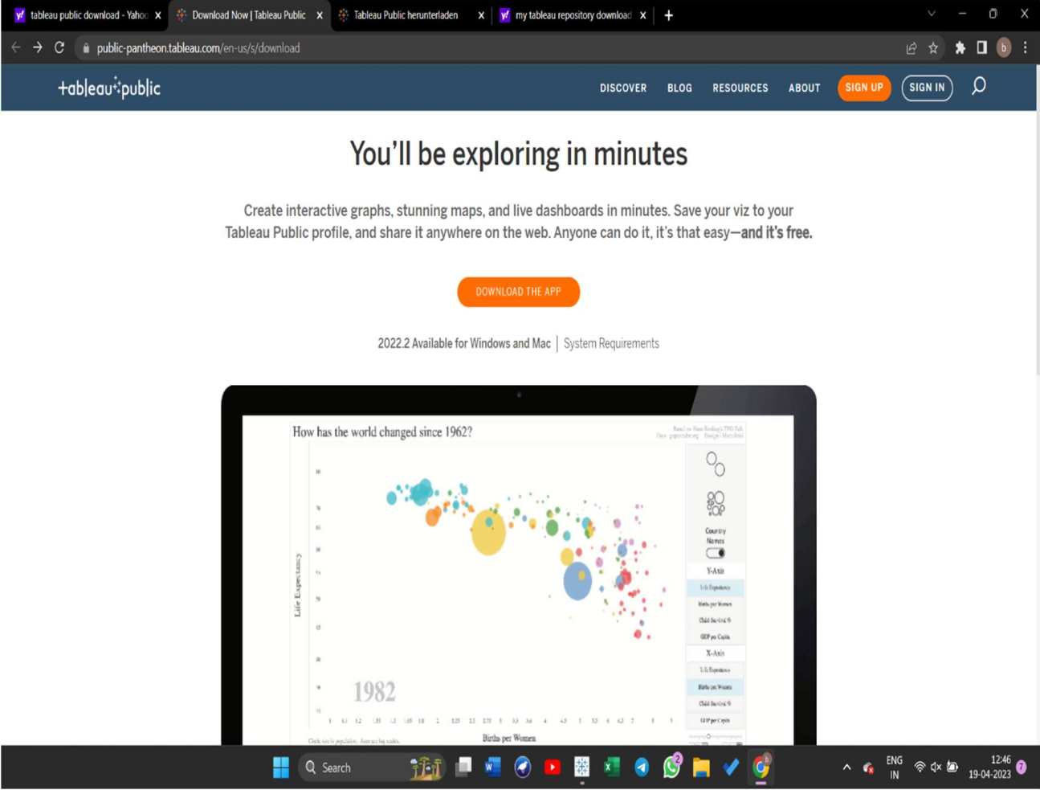

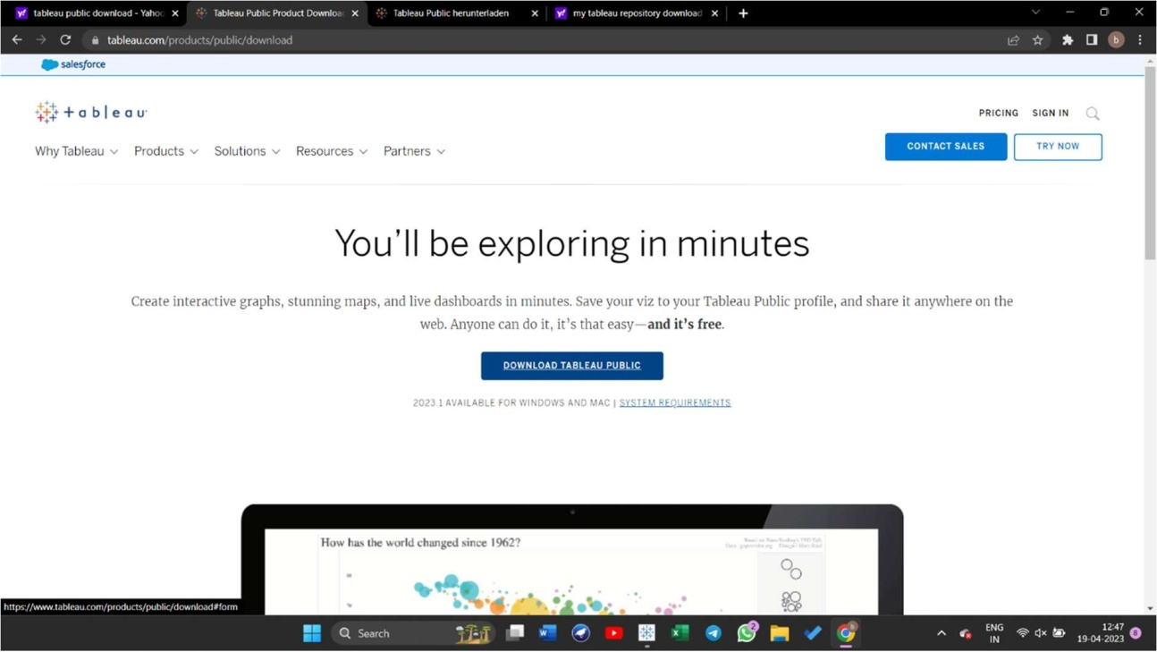

PROVIDE YOUR DETAILS

Provide your name and organization details. Then, click "Next".

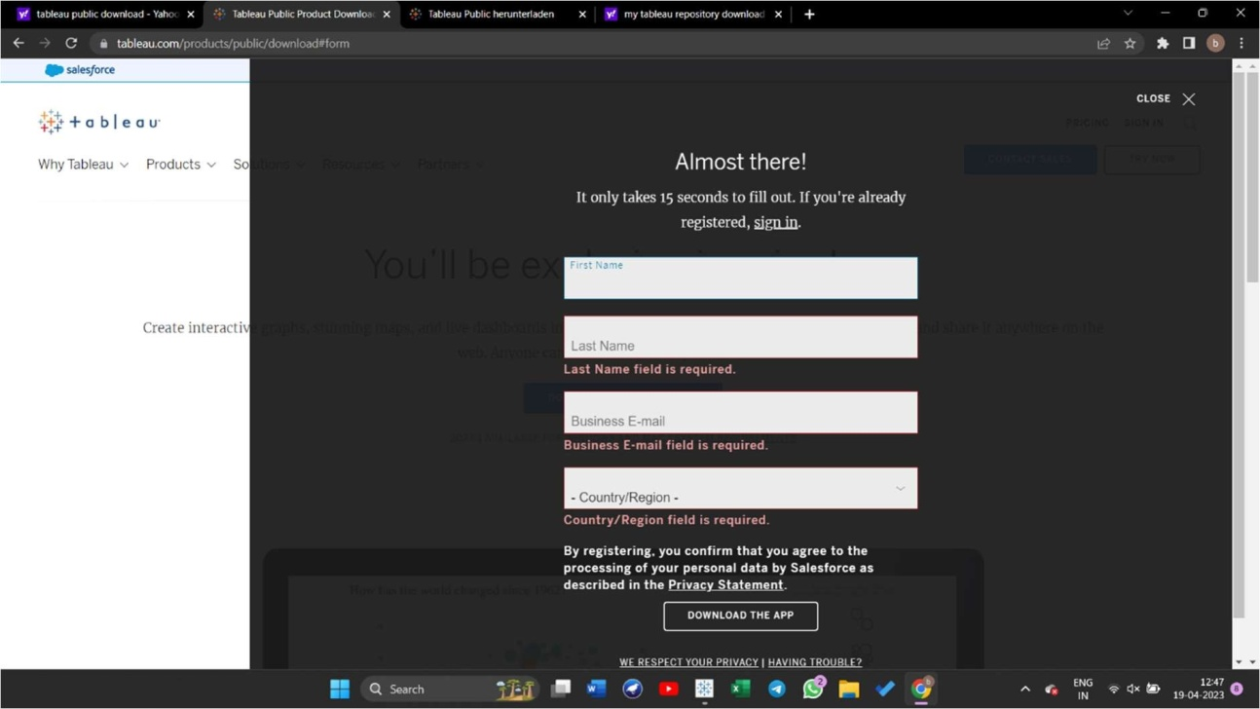

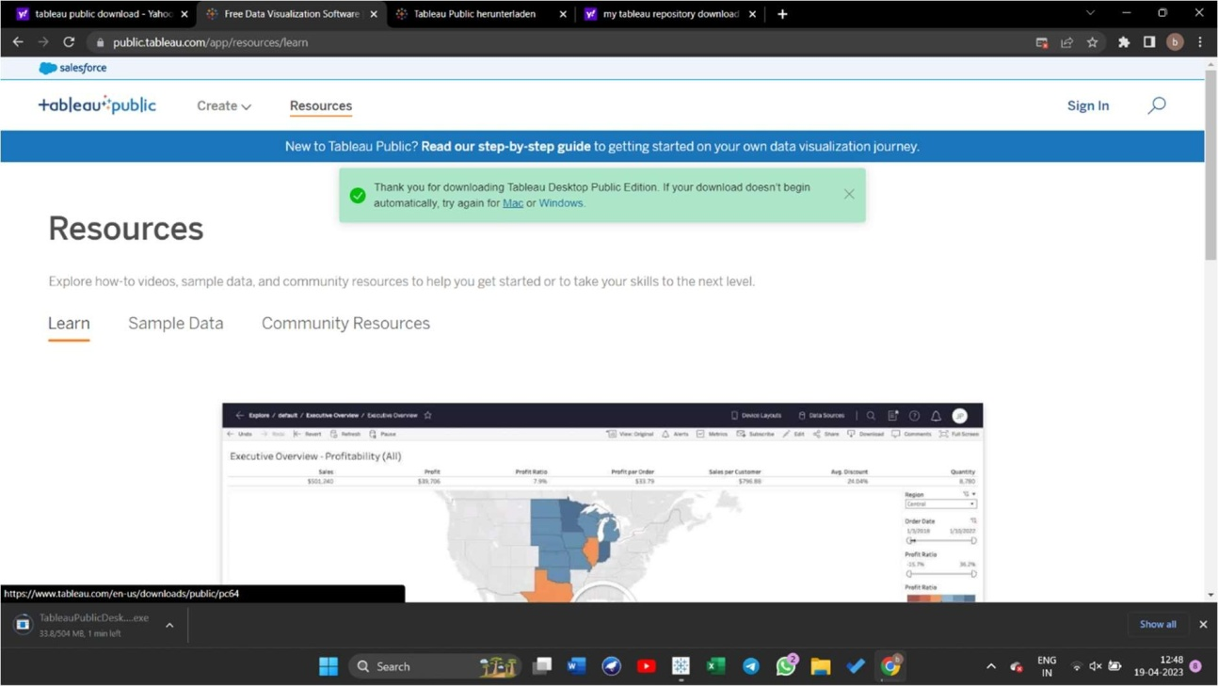

Accept all the terms and conditions.

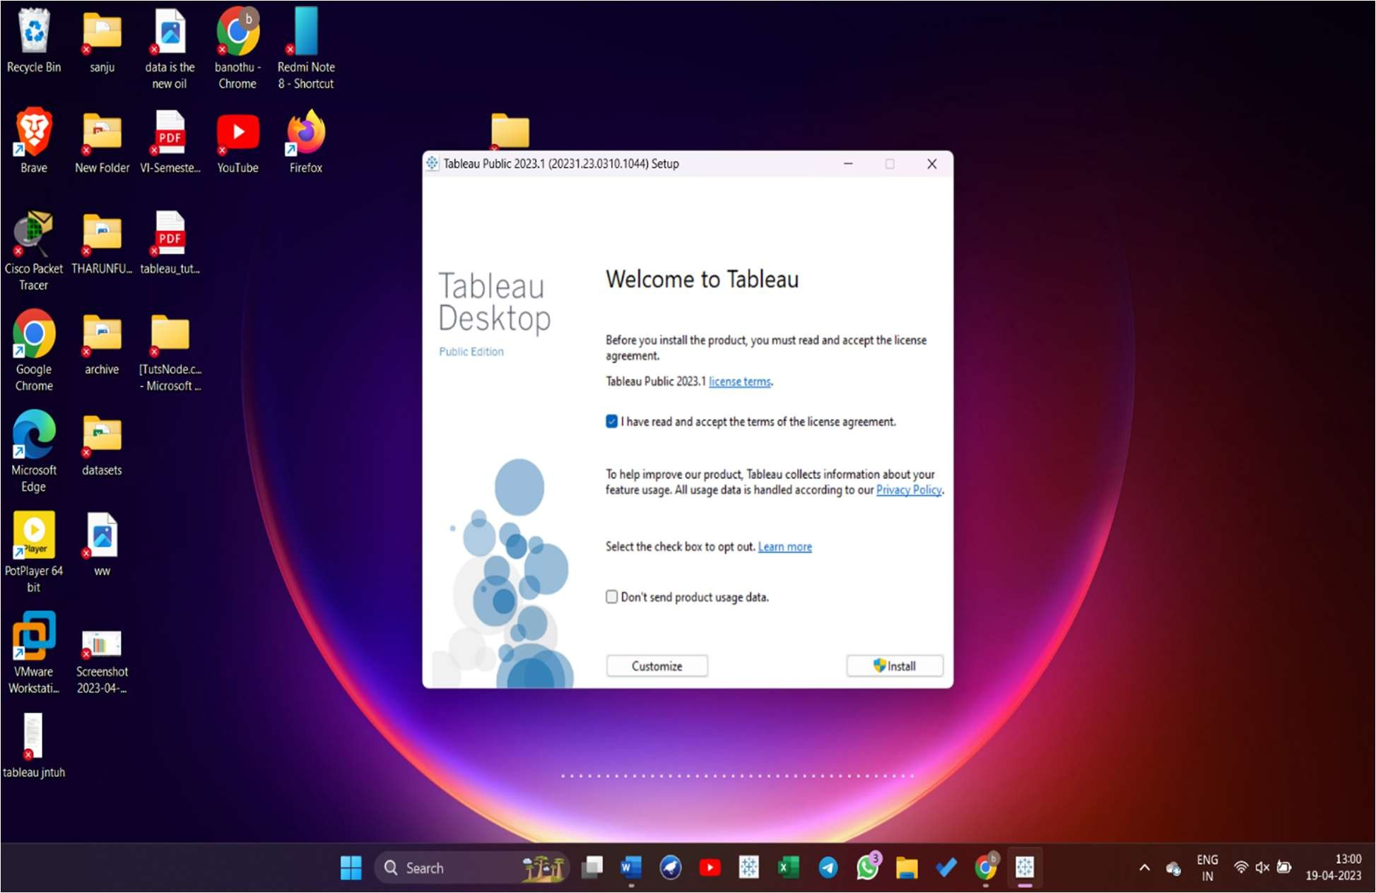

# VERIFY INSTALLATION

You can verify the installation by going to the Windows start menu. Click the Tableau icon. The following screen appears.

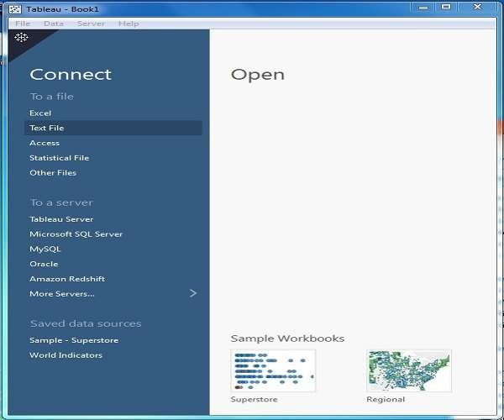

You are now ready to learn Tableau.

Tableau - Get Started

you will learn some basic operations in Tableau to get acquainted with its interface. There are three basic steps involved in creating any Tableau data analysis report.

These three steps are −

* + Connect to a data source − It involves locating the data and using an appropriate type of connection to read the data.
  + Choose dimensions and measures − This involves selecting the required columns from the source data for analysis.
  + Apply visualization technique − This involves applying required visualization methods, such as a specific chart or graph type to the data being analyzed.

For convenience, let’s use the sample data set that comes with Tableau installation named sample – superstore.xls. Locate the installation folder of Tableau and go to My Tableau Repository. Under it, you will ﬁnd the above ﬁle at Datasources\9.2\en_US-US.

## CONNECT TO DATASOURCE

On opening Tableau, you will get the start page showing various data sources. Under the header “Connect”, you have options to choose a file or server or saved data source. Under Files, choose excel. Then navigate to the file “Sample

– Superstore.xls” as mentioned above. The excel file has three sheets named Orders, People and Returns. Choose Orders.

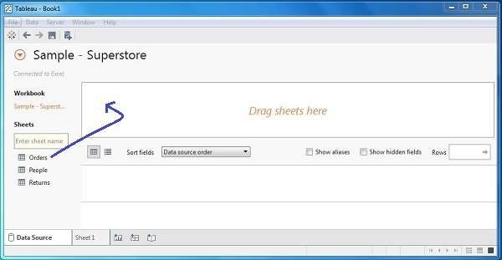

CHOOSE THE DIMENSIONS AND MEASURES

Next, choose the data to be analyzed by deciding on the dimensions and measures. Dimensions are the descriptive data while measures are numeric data. When put together, they help visualize the performance of the dimensional data with respect to the data which are measures. Choose Category and Region as the dimensions and Sales as the measure. Drag and drop them as shown in the following screenshot. The result shows the total sales in each category for each region.

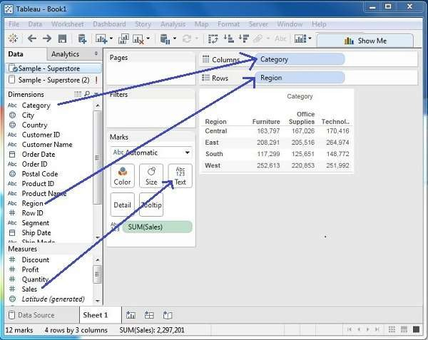

## APPLY VISUALIZATION TECHNIQUES

In the previous step, you can see that the data is available only as numbers. You have to read and calculate each of the values to judge the performance.

However, you can see them as graphs or charts with different colors to make a quicker judgment.

We drag and drop the sum (sales) column from the Marks tab to the Columns shelf. The table showing the numeric values of sales now turns into a bar chart automatically.

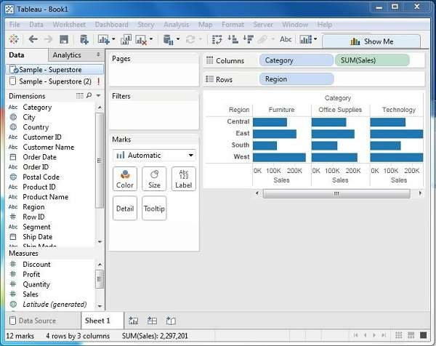

You can apply a technique of adding another dimension to the existing data. This will add more colors to the existing bar chart as shown in the following screenshot.

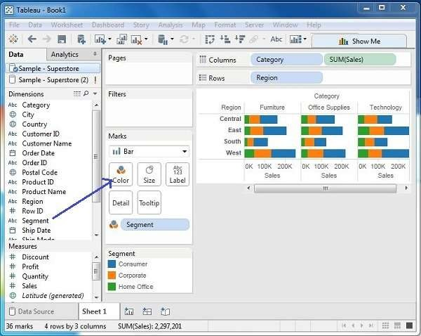

BAR CHART

A bar chart represents data in rectangular bars with the length of the bar proportional to the value of the variable. Tableau automatically produces a bar chart when you drag a dimension to the Row shelf and measure to the Column shelf. We can also use the bar chart option present in the Show Me button. If the data is not appropriate for bar chart, then this option will be automatically greyed out.

In Tableau, various types of bar charts can be created by using a dimension and a measure.

SIMPLE BAR CHART

From the Sample-Superstore, choose the dimension, take profit to the columns shelf and Sub-Category to the rows shelf. It automatically produces a horizontal bar chart as shown in the following screenshot. In case, it does not, you can choose the chart type from the Show Me tool to get the following result.

Build a Bar Chart

Use bar charts to compare data across categories. You create a bar chart by placing a dimension on the Rows shelf and a measure on the Columns shelf, or vice versa.

A bar chart uses the Bar mark type. Tableau selects this mark type when the data view matches one of the two field arrangements shown below. You can add additional fields to these shelves.

For more information about the Bar mark type, see B ar mark.

**Note**: At the end of the procedure is an extra step you can take to display totals at the tops of the bars.

Creates Vertical Bars Creates Horizontal Bars

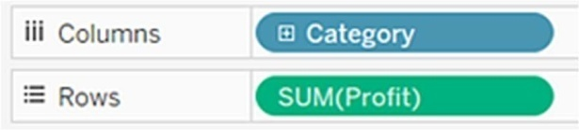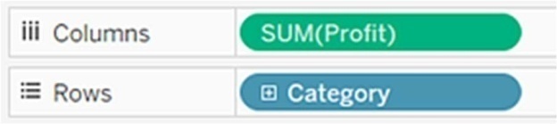

To create a bar chart that displays total sales over a four-year period, follow these steps:

1. Connect to the Sample - Superstore data source.

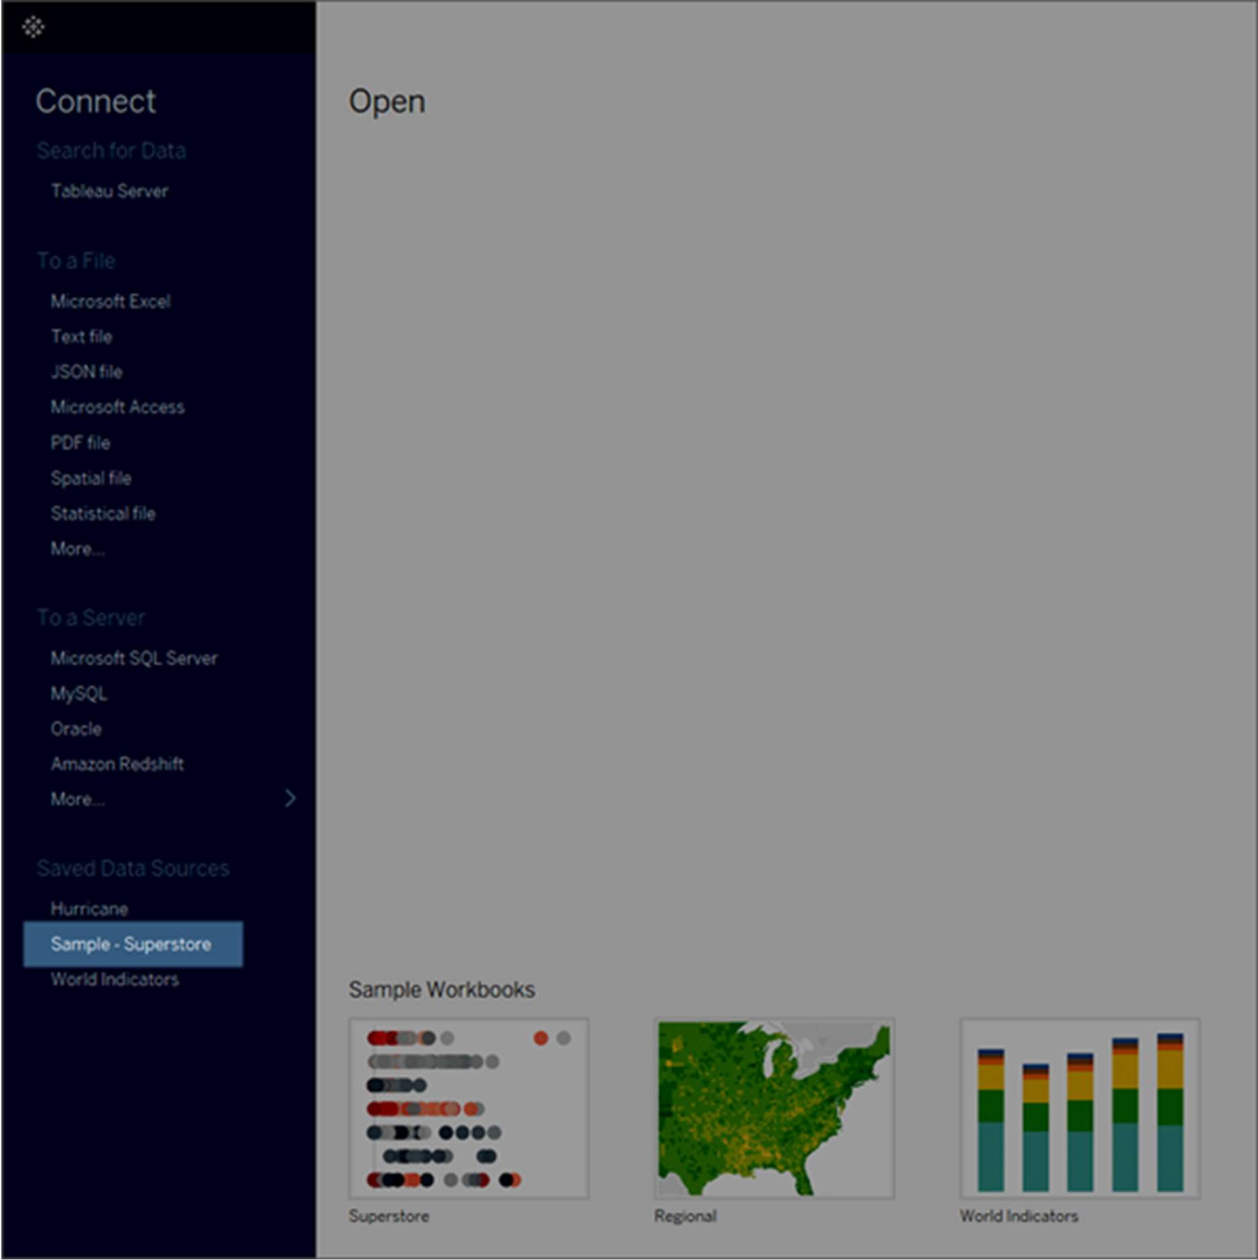

**Note:** In Tableau 2020.2 and later, the Data pane no longer shows Dimensions and Measures as labels. Fields are listed by table or folder.

1. Drag the Order Date dimension to Columns and drag the Sales measure to Rows.

Notice that the data is aggregated by year and column headers appear. The Sales measure is aggregated as a sum and an axis is created, while the column headers move to the bottom of the view. Tableau

uses Line as the mark type because you added the date dimension.

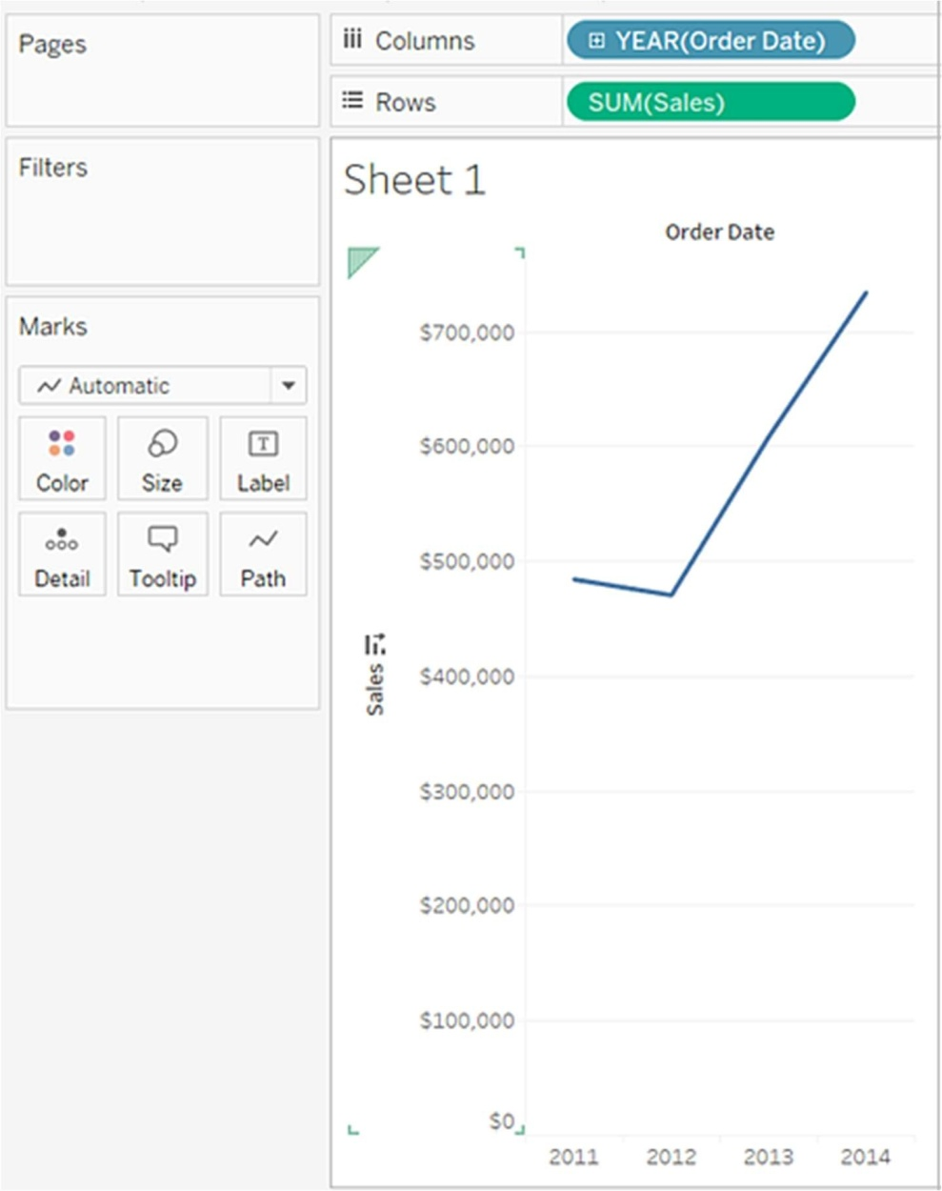

1. On the Marks card, select Bar from the drop-down list.

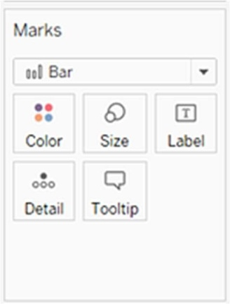

The view changes to a bar chart.

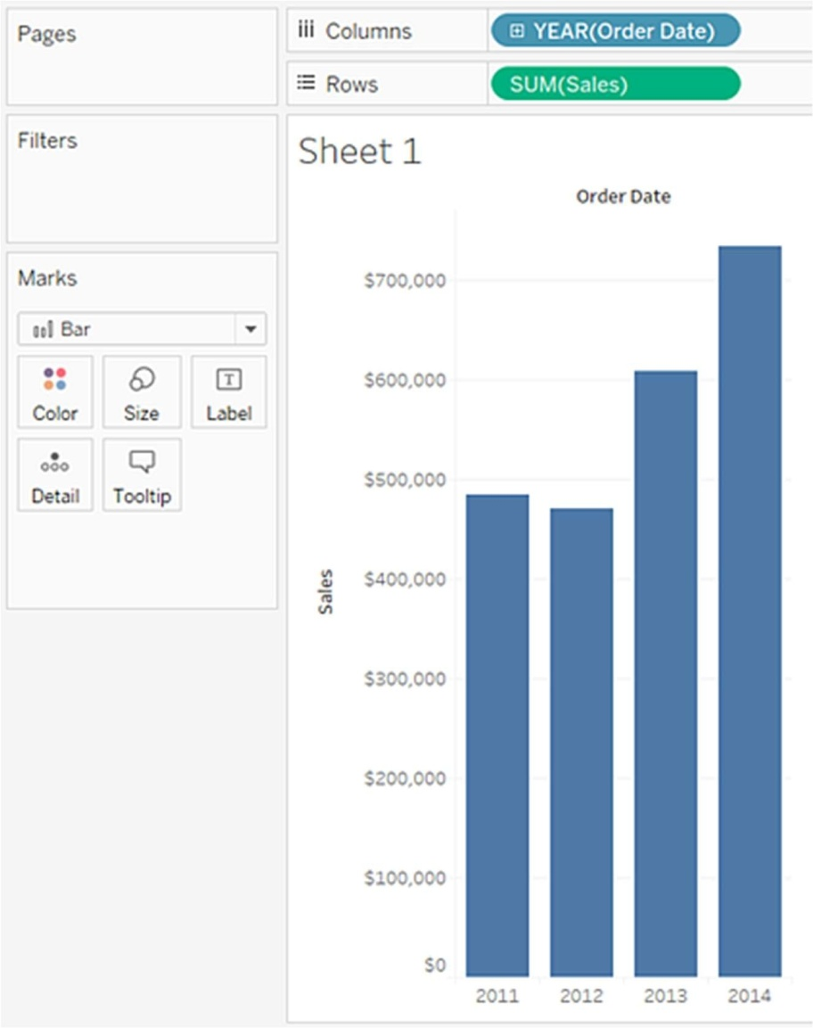

The marks (which are bars in this case) are vertical because the axis is vertical. The length of each mark represents the sum of the sales for that year. The actual numbers you see here might not match the numbers you see—the sample data changes from time to time.

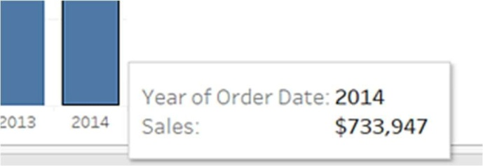

1. Drag the Ship Mode dimension to Color on the Marks card.

The view shows how different shipping modes have contributed to total sales over time. The ratios look consistent from year to year.

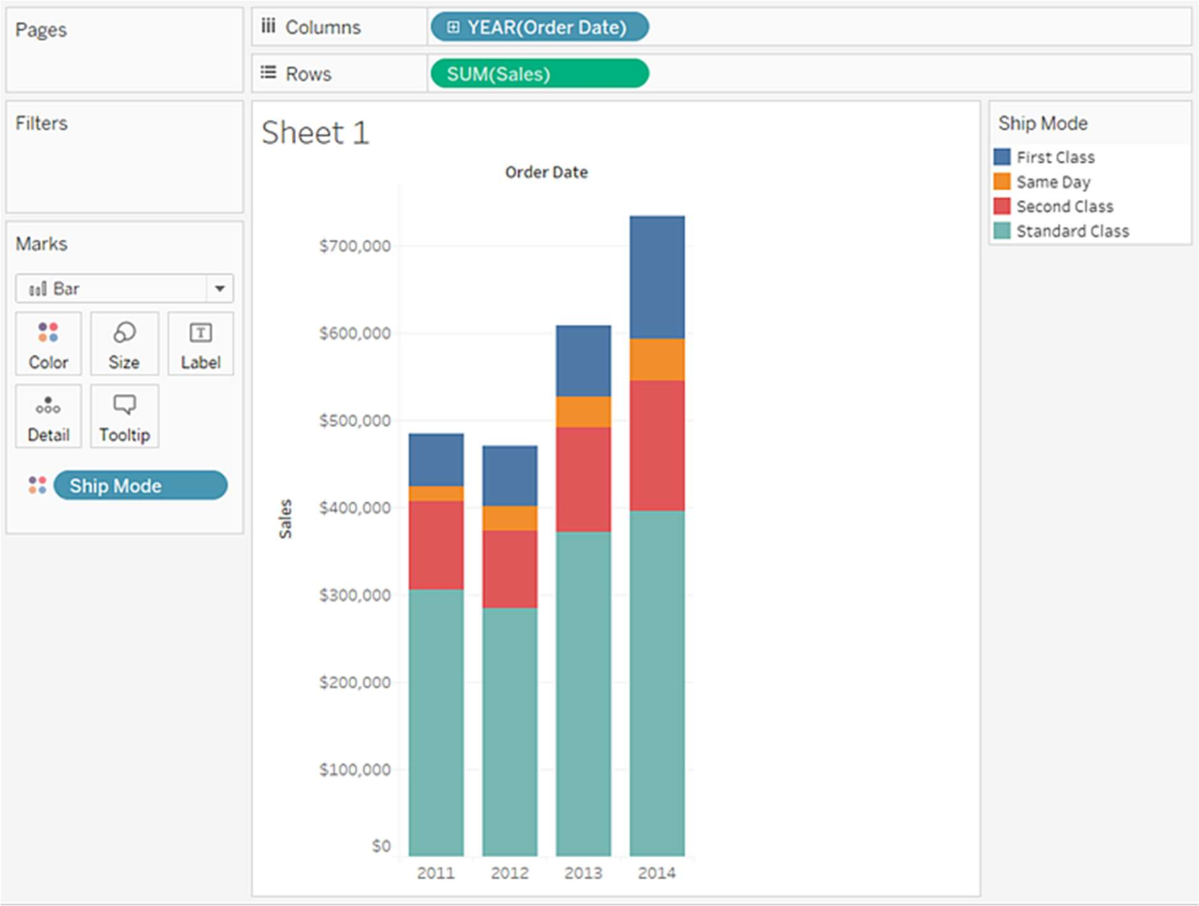

1. Drag the Region dimension to Rows, and drop it to the left of Sales to produce multiple axes for sales by region.

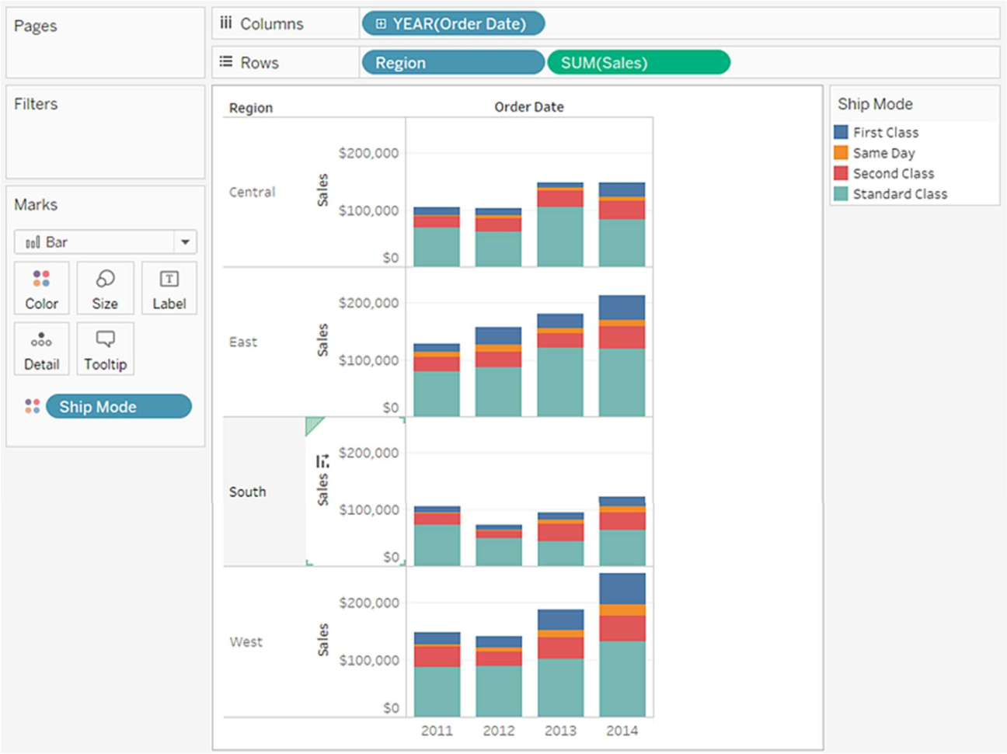

1. To view data in the West region only, you can ﬁlter out the other regions. To do this, drag the Region dimension again, this time from the Data pane to the Filters shelf.

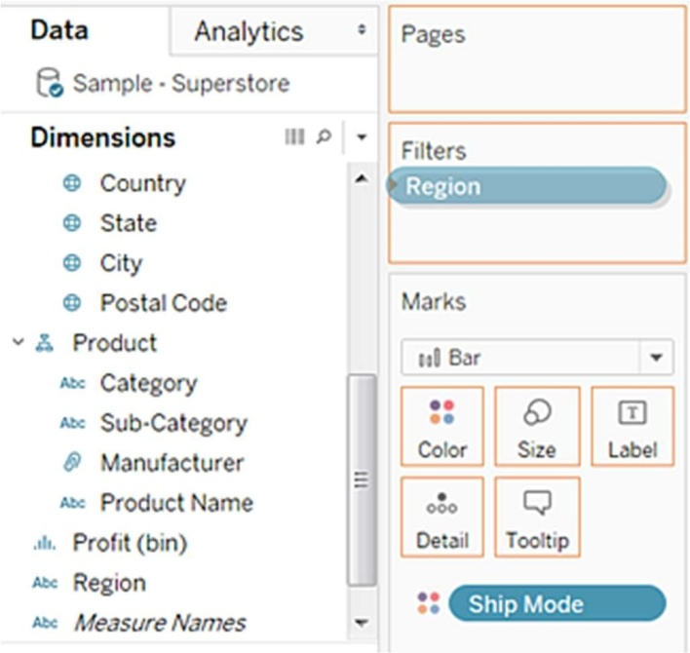

1. In the Filter [Region] dialog box, clear the Central, East, and South check boxes, and then click OK.

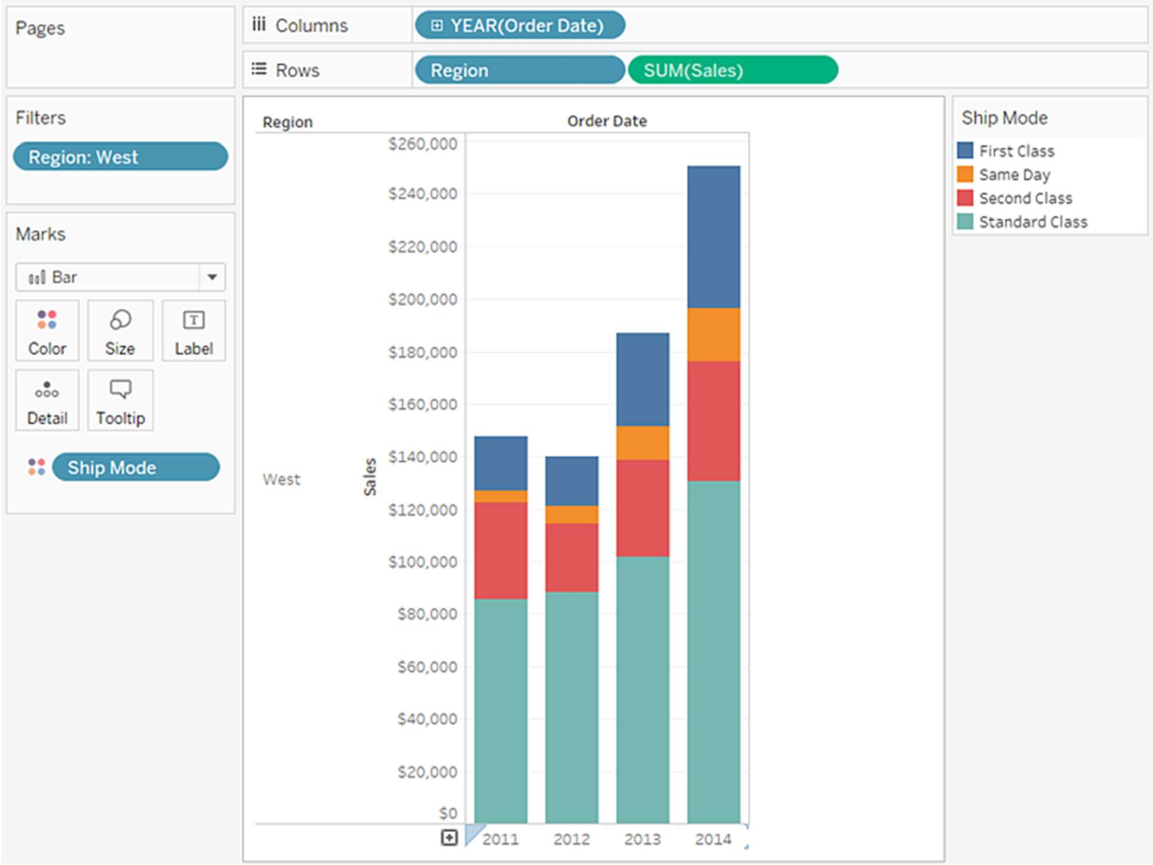

LINE CHART

In a line chart, a measure and a dimension are taken along the two axes of the chart area. The pair of values for each observation becomes a point and the joining of all these points create a line showing the variation or relationship between the dimensions and measures choosen.

Choose one dimension and one measure to create a simple line chart. Drag the dimension Ship Mode to Columns Shelf and Sales to the Rows shelf. Choose the Line chart from the Marks card. You will get the following line chart, which shows the variation of Sales for different Ship modes.

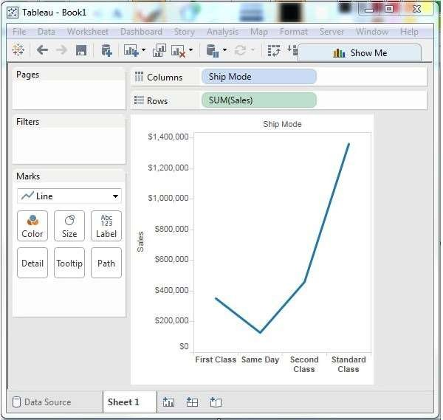

LINE CHART WITH LABELS

Each of the points making the line chart can be labeled to make the values of the measure visible. In this case, drop another measure Proﬁt Ratio into the labels pane in the Marks card. Choose average as the aggregation and you will get the following chart showing the labels.

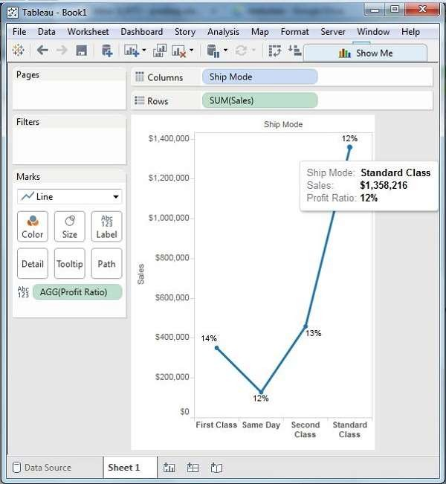

# TREE MAP

## The tree map displays data in nested rectangles. The dimensions define the structure of the tree map and measures define the size or color of the individual rectangle. The rectangles are easy to visualize as both the size and shade of the color of the rectangle reflect the value of the measure.

A Tree Map is created using one or more dimension with one or two measures.

CREATING TREE MAP

Using the Sample-superstore, plan to find the size of profits for each Ship mode values. To achieve this objective, following are the steps.

Step 1 − Drag and drop the measure profit two times to the Marks Card. Once to the Size shelf and again to the Color shelf.

Step 2 − Drag and drop the dimension ship mode to the Label shelf. Choose the chart type Tree Map from Show Me. The following chart appears.

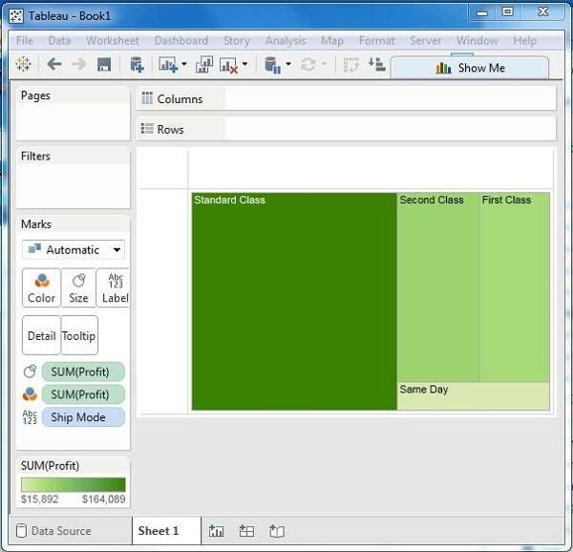

# WEEK-3

TABLE CALCULATIONS

Numeric calculations in Tableau are done using a wide range of inbuilt functions available in the formula editor.

In this chapter, we will see how to apply calculations to the fields. The calculations can be as simple as subtracting the values of two fields or applying an aggregate function to a single field.

Following are the steps to create a calculation field and use numeric functions in it.

CREATE CALCULATED FIELD

1. In Tableau, select Analysis > Create Calculated Field.
2. In the Calculation Editor that opens, do the following:
   * Enter a name for the calculated field. In this example, the field is called, Discount Ratio.
   * Enter a formula. This example uses the following formula:

IIF([Sales] !=0, [Discount]/[Sales],0)

This formula checks if sales is not equal to zero. If true, it returns the discount ratio (Discount/Sales); if false, it returns zero.

p: To see a list of available functions, click the triangle icon on the right-side of the Calculation Editor.

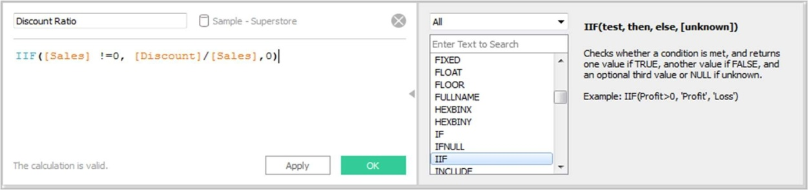

Each function includes syntax, a description, and an example for your reference. Double-click a function in the list to add it to the formula.

For more tips, see Tips for Working with Calculated Fields in Tableau.

1. When finished, click OK.

The new calculated field is added to Measures in the Data pane because it returns a number. An equal sign (=) appears next to the data type icon. All calculated fields have equal signs (=) next to them in the Data pane.

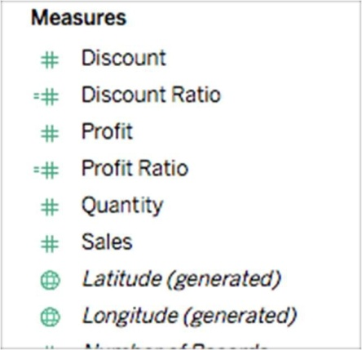

# CALCULATION EDITOR

The above step opens a calculation editor which lists all the functions that is available in Tableau. You can change the dropdown value and see only the functions related to numbers.

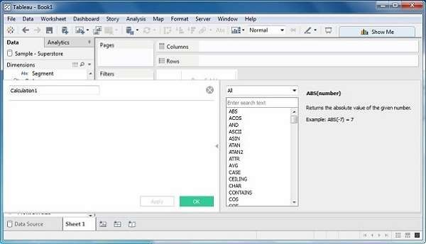

# CUSTOM CALCULATED FIELDS

To ﬁnd the difference between proﬁt and total sales for different sub category of the products, create a formula subtracting the proﬁts from the sales as shown in the following screenshot. Also, name this ﬁeld as cost.

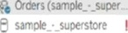

 





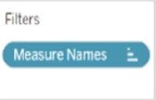



- d X







# APPLYING AGGREGATE FUNCTION

In a similar manner as above, you can create a calculated ﬁeld using aggregate function. Here, create AVG(sales) values for different ship mode. Write the formula in the calculation editor as shown in the following screenshot.

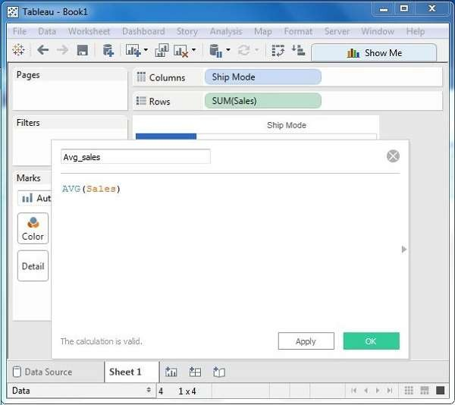

## On clicking OK and dragging the Avg_Sales field to the Rows shelf, you will get the following view.

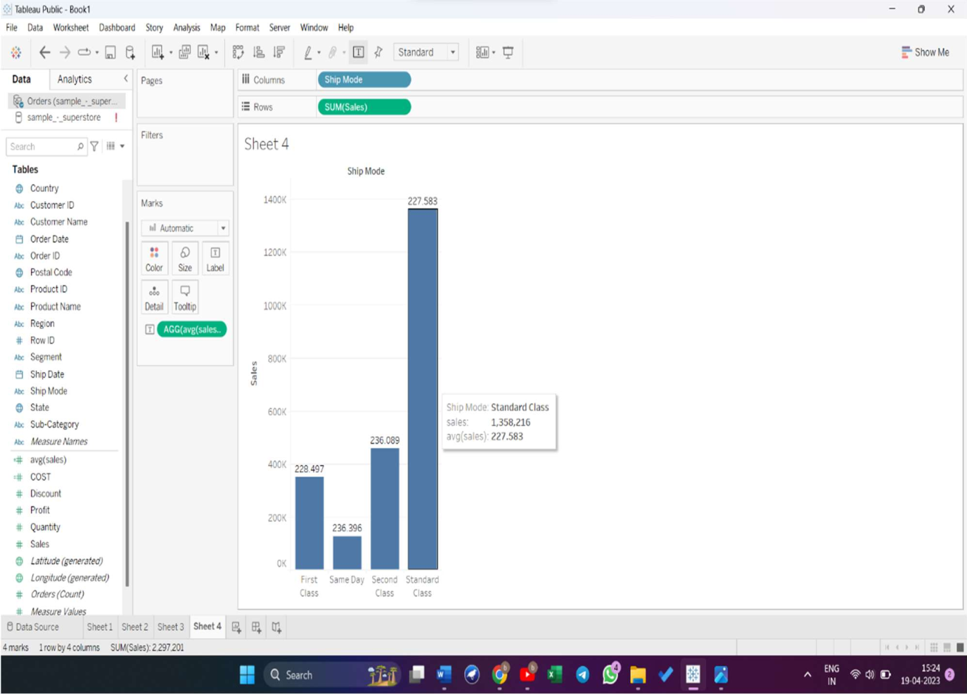

SUM OPERATION

SUM(), just like AVG(), MIN() etc. is an aggregation method, i.e. instruction to Tableau to add, average, etc. the values.

Say you have some sales data (Tableau's sample data) and you want to show sum of sales for each market. Tableau will do the SUM() in the background and show the 'totals'.

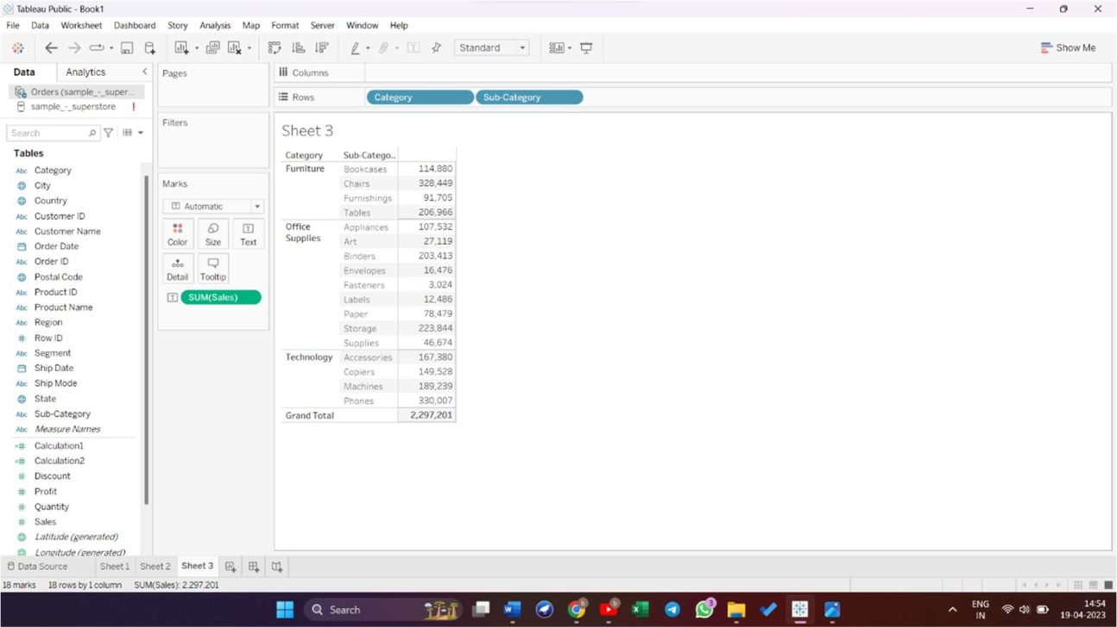

MIN AND MAX AGGREGATE FUNCTIONS

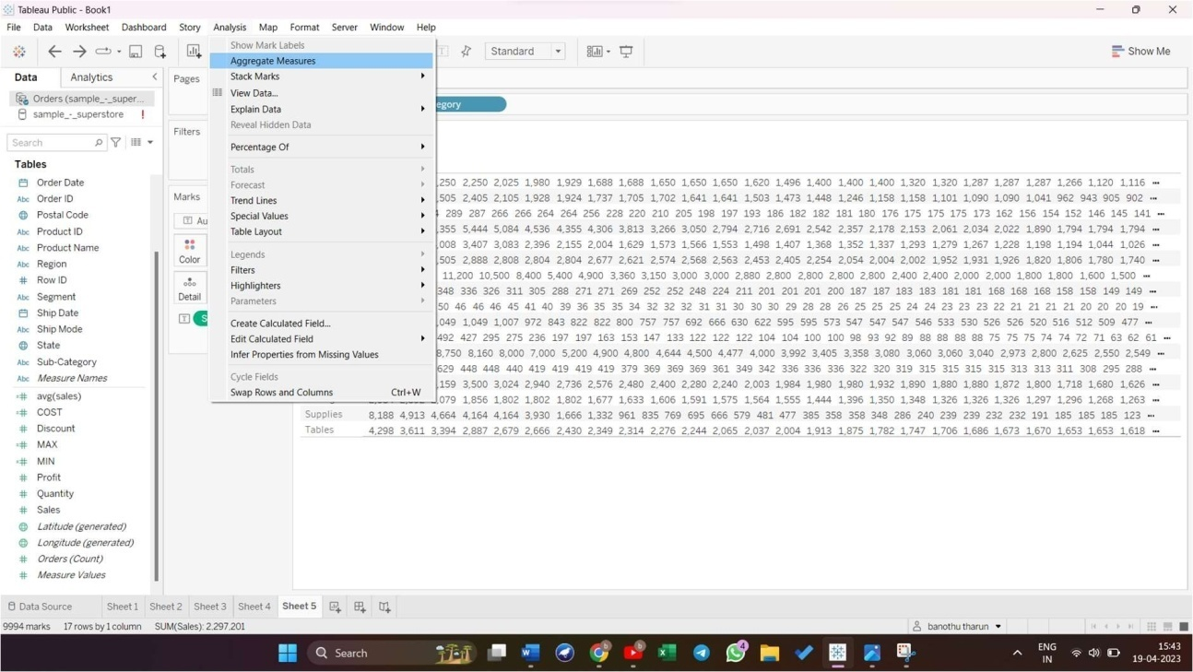

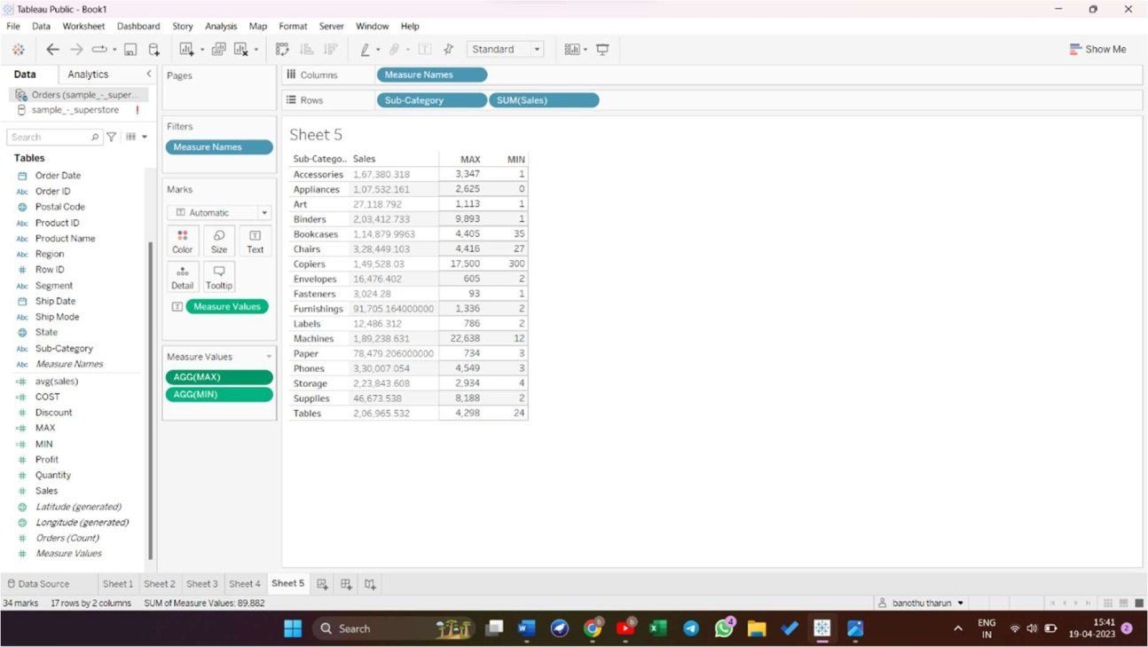

TABLE CALCULATION

These are the calculations which are applied to the values in the entire table. For example, for calculating a running total or running average, we need to apply a single method of calculation to an entire column. Such calculations cannot be performed on some selected rows.

Table has a feature called Quick Table Calculation, which is used to create such calculations. The steps to be applied in Quick Table calculation are as follows −

Step 1 − Select the measure on which the table calculation has to be applied and drag it to column shelf.

Step 2 − Right-click the measure and choose the option Quick Table Calculation.

Step 3 − Choose one of the following options to be applied on the measure.

* Running Total
* Difference
* Percent Difference
* Percent of Total
* Rank
* Percentile
* Moving Average
* Year to Date (YTD) Total
* Compound Growth Rate
* Year over Year Growth
* Year to Date (YTD) Growth

# RUNNING TOTAL

Running total calculates the cumulative total of a measure across a table. Let’s experience it with real example. First lets connect to the sample data with Tableau, aher we connect this is how it looks.

1. Drag and Drop the Date to rows shelf. Make sure discrete is selected. After that bring Amount to worksheet.
2. Now let’s bring SUM(SALES) to rows shelf and keep it in front of Date. Now, we can see for each year, the total of sales made.
3. Next , click on sales > quick table calculation > running total ,from there I will do a running total. This will show how sales are growing over time.

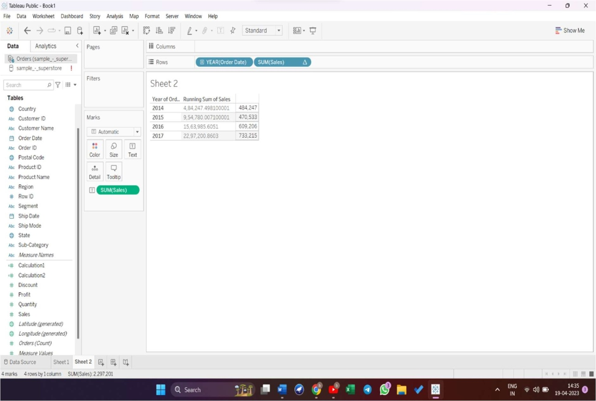

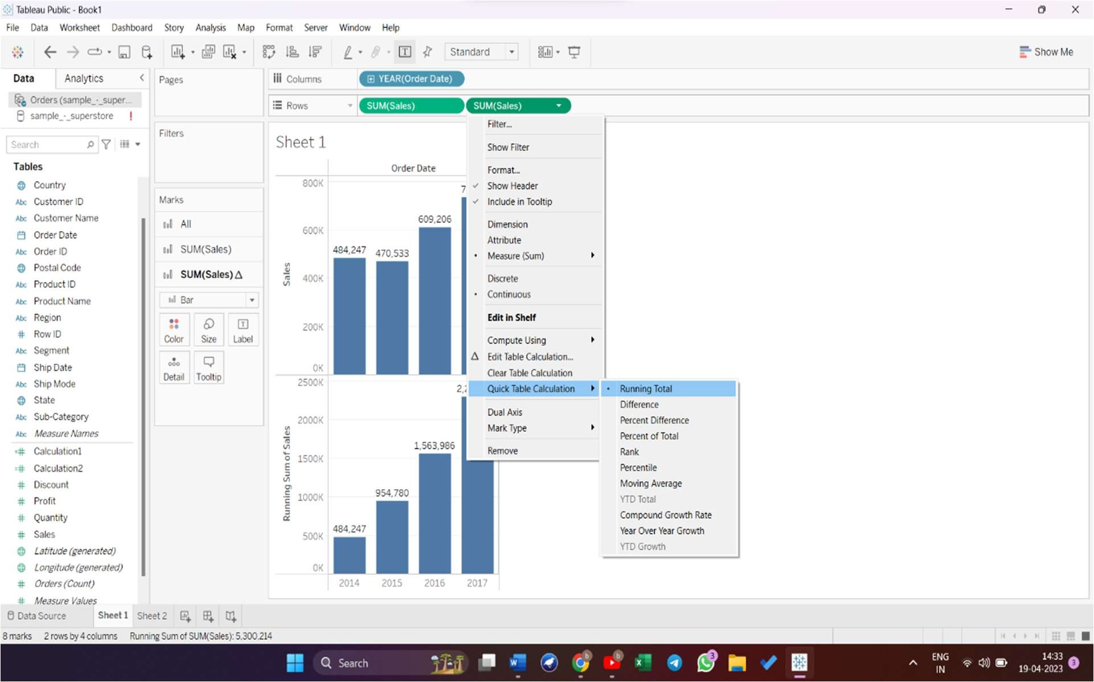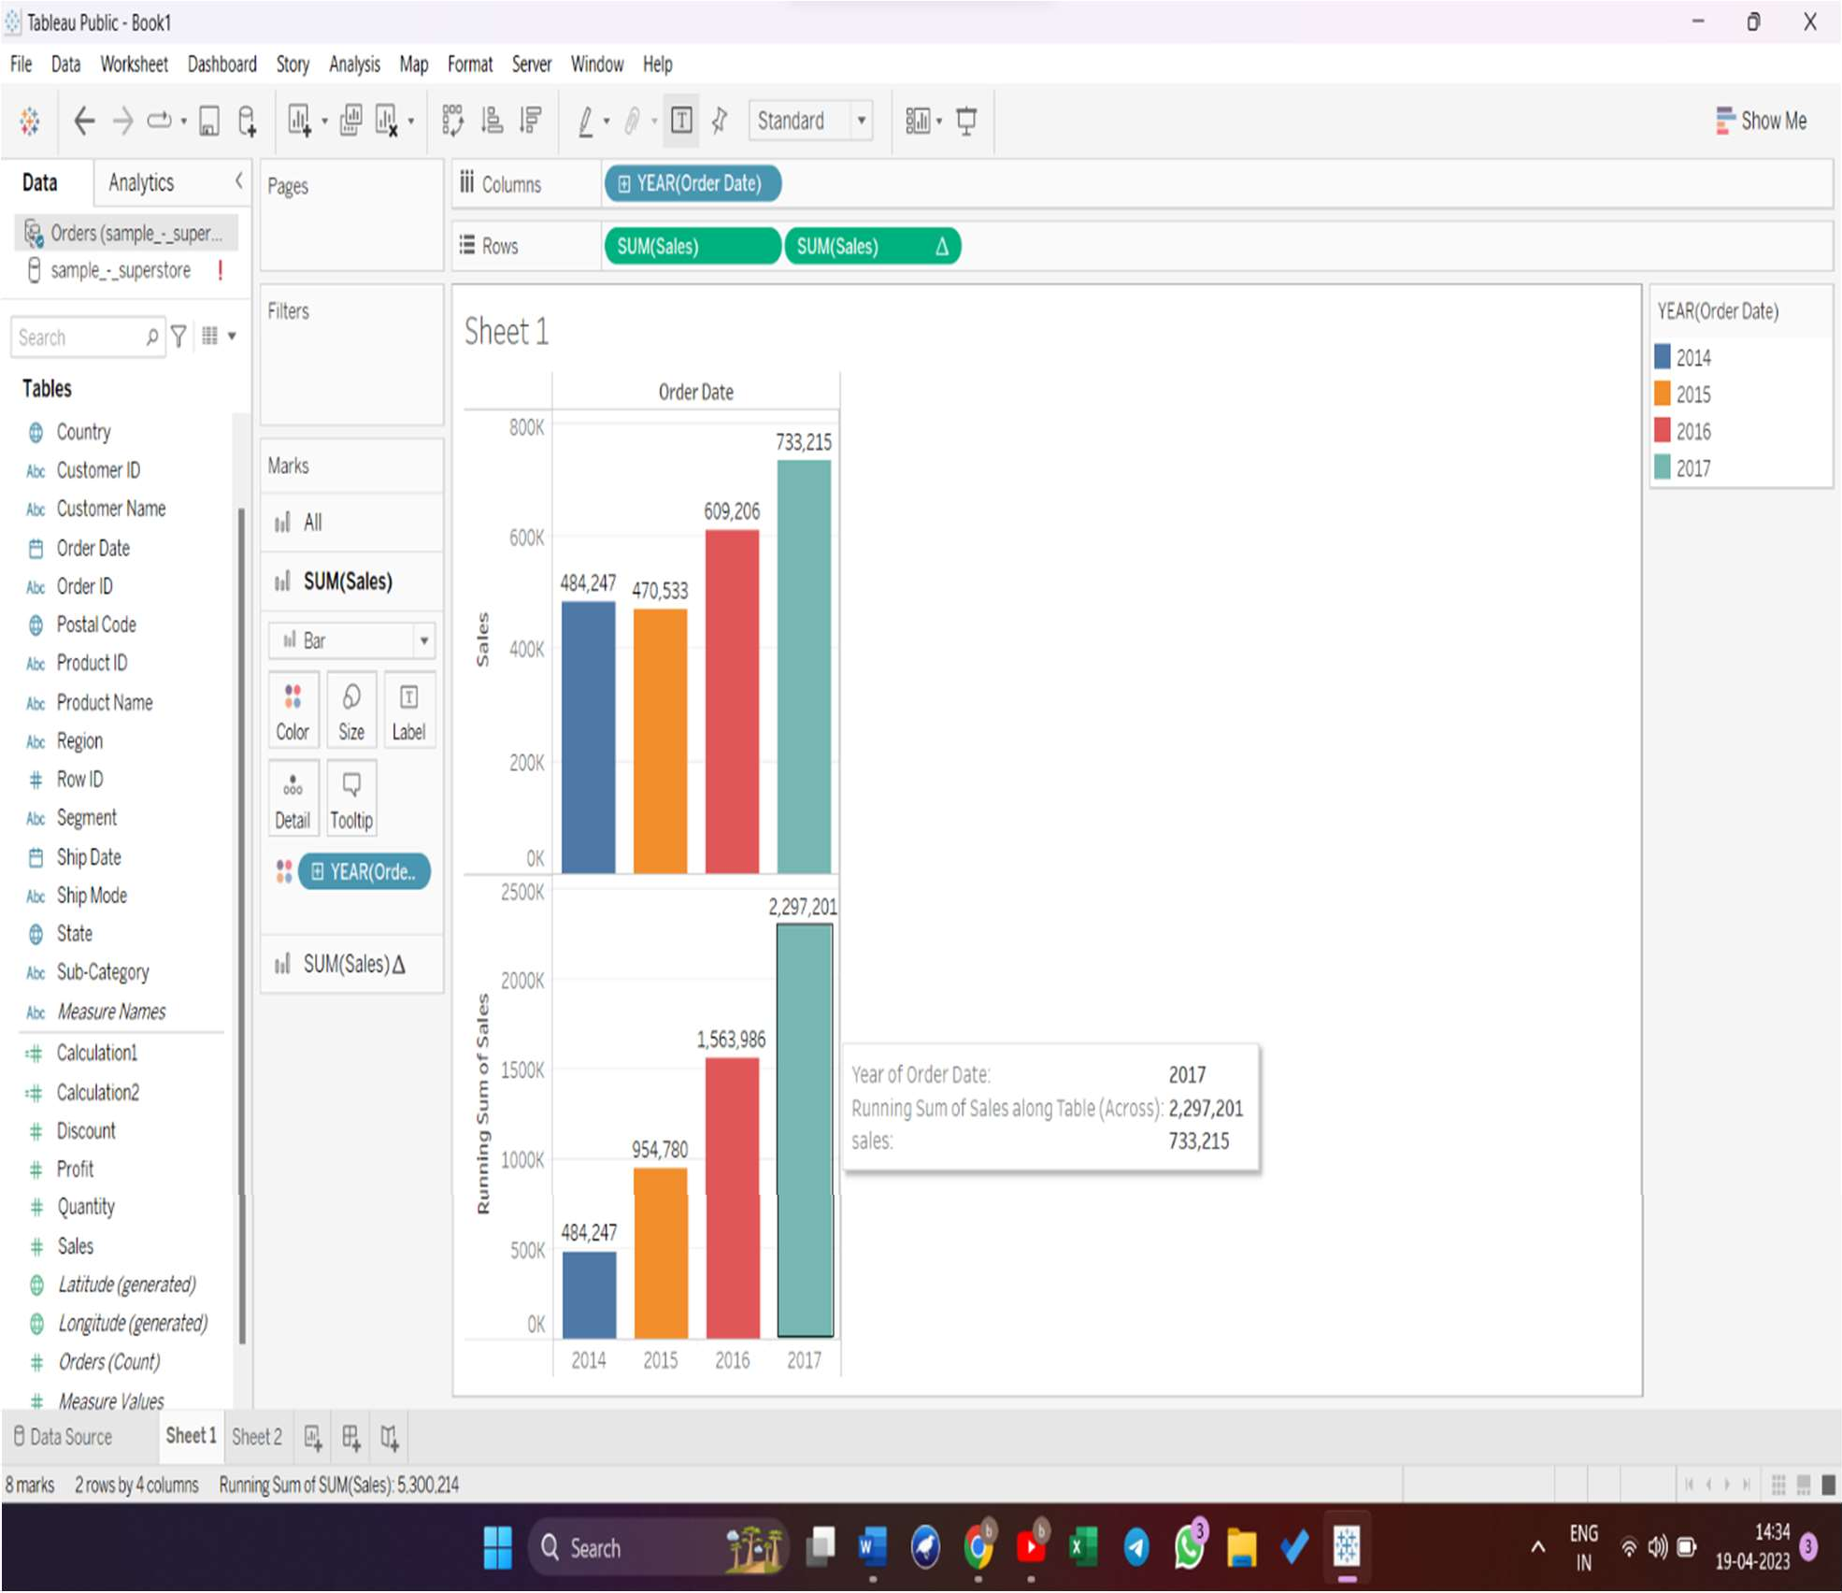

# WEEK-4

APPLYING NEW DATA CALCULATIONS TO VISUALIZATION

Let’s experience it with real example. First lets connect to the sample data with Tableau, aher we connect this is how it looks.

1. From measure values, click on analysis >create table calculations > create a AVG(SALES) calculated field > click apply > OK. From there we will see the avg(sales) field in measure values.
2. Drag and Drop the (avg(sales) to rows shelf.
3. Now, bring order date to column shelf. Now, we can see for each year, the average sales made.

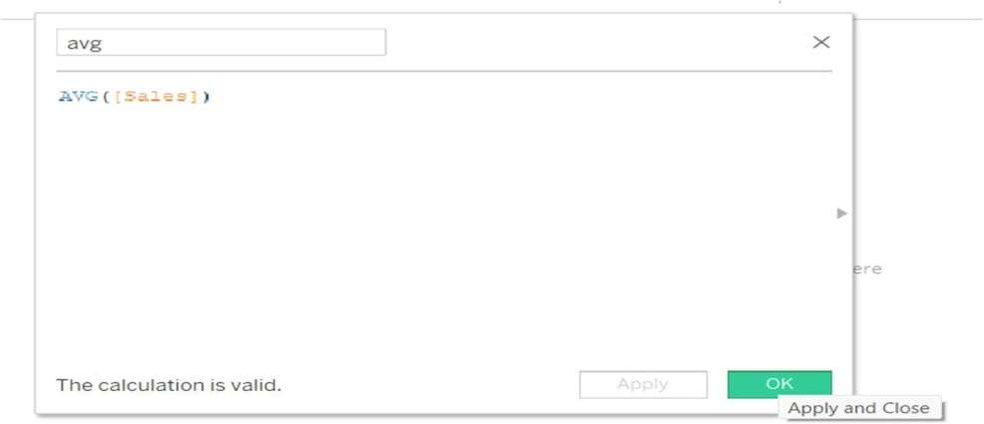

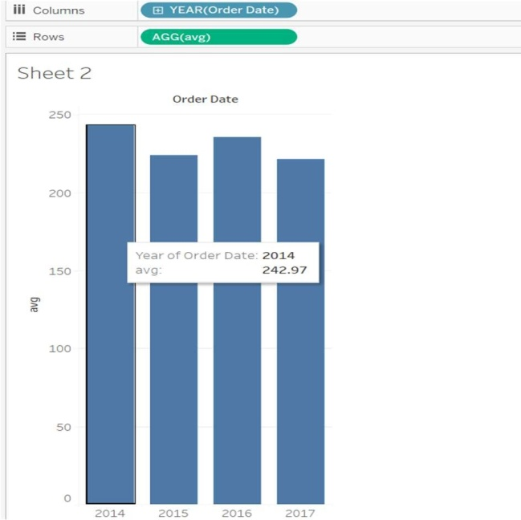

# FORMATTING YOUR VISUALIZATION

Tableau has a very wide variety of formatting options to change the appearance of the visualizations created. You can modify nearly every aspect such as font, color, size, layout, etc. You can format both the content and containers like tables, labels of axes, and workbook theme, etc.

The following diagram shows the Format Menu which lists the options. In this chapter, you will touch upon some of the frequently used formatting options.

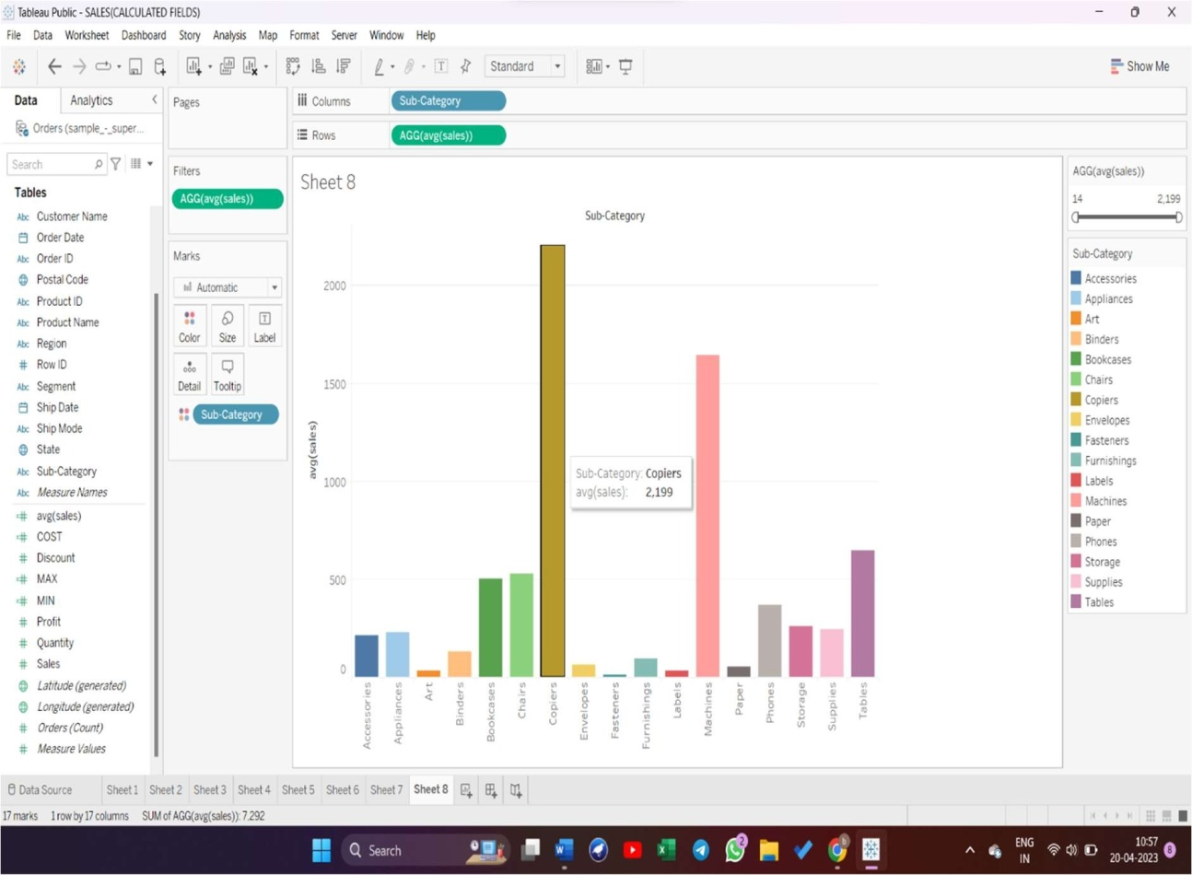

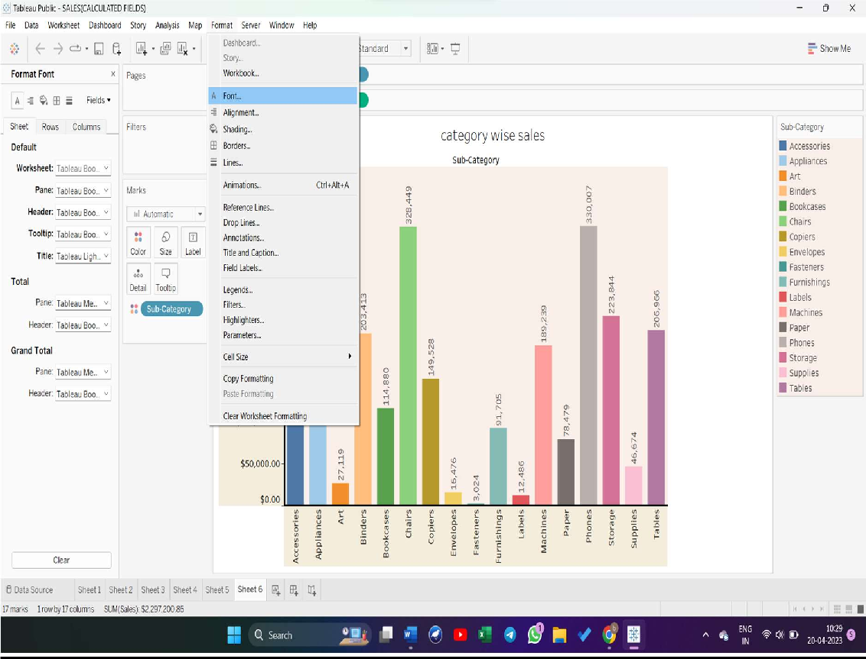

# FORMATTING THE AXIS

You can create a simple bar chart by dragging and dropping the dimension Sub-Category into the Columns Shelf and the measure sales into the Rows shelf. Click the vertical axis and highlight it. Then right-click and choose format.

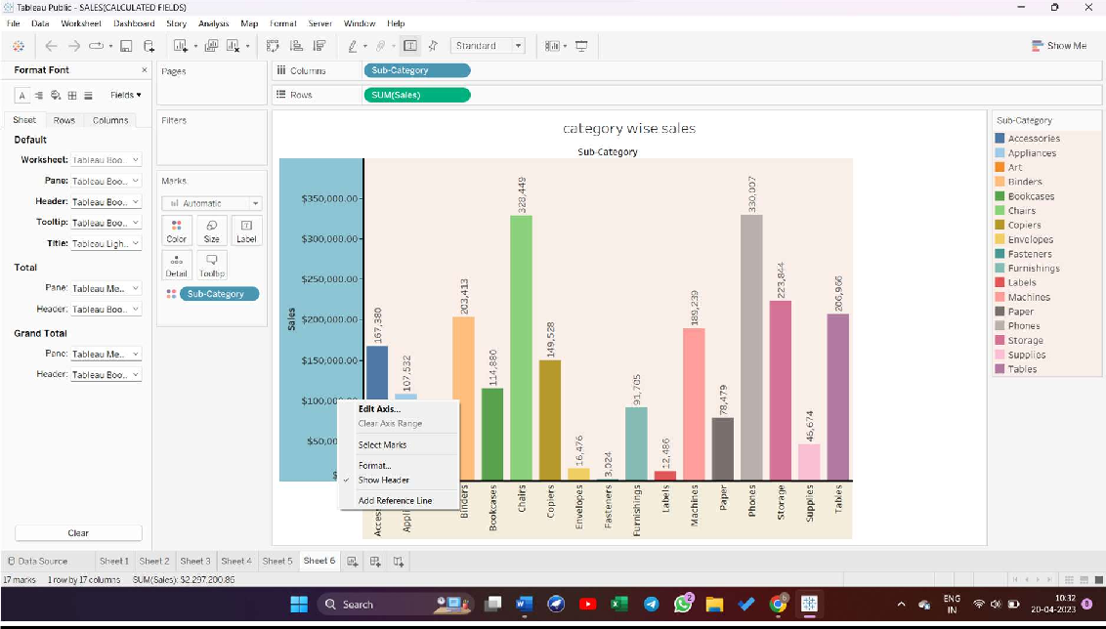

# CHANGE THE FONT

Steps to change font:

## Click on format > font >

1. Now you can change colour, font size, shading of font for worksheet, pane, header, toolkit, title.

Click the font drop-down in the Format bar, which appears on the left. Choose the font type. as shown in the following screenshot.

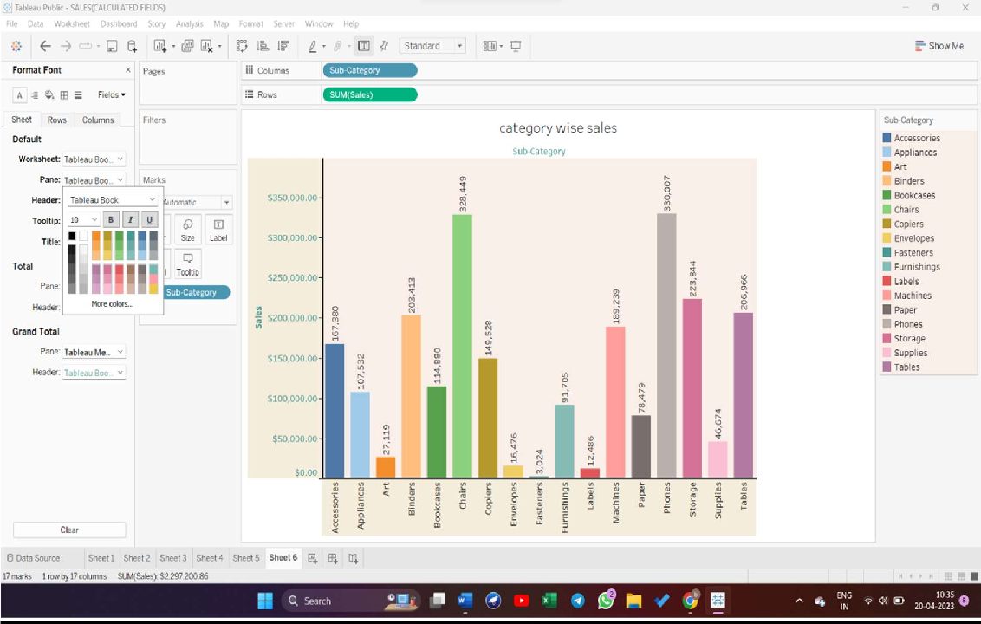

# CHANGE THE SHADE AND ALIGNMENT

You can also change the orientation of the values in the axes as well as the shading color as shown in the following screenshot.

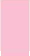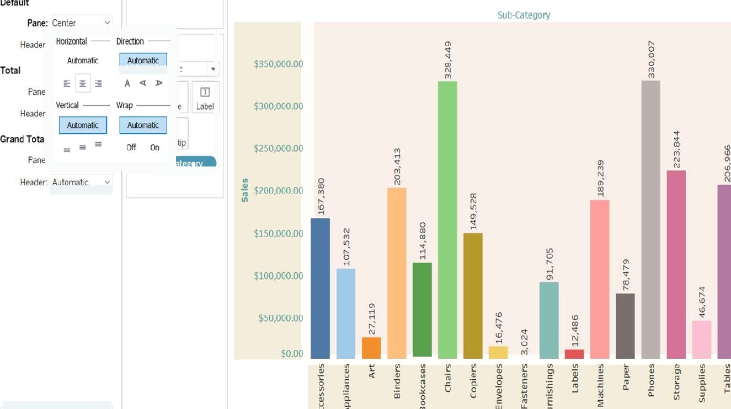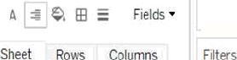

category wise sales



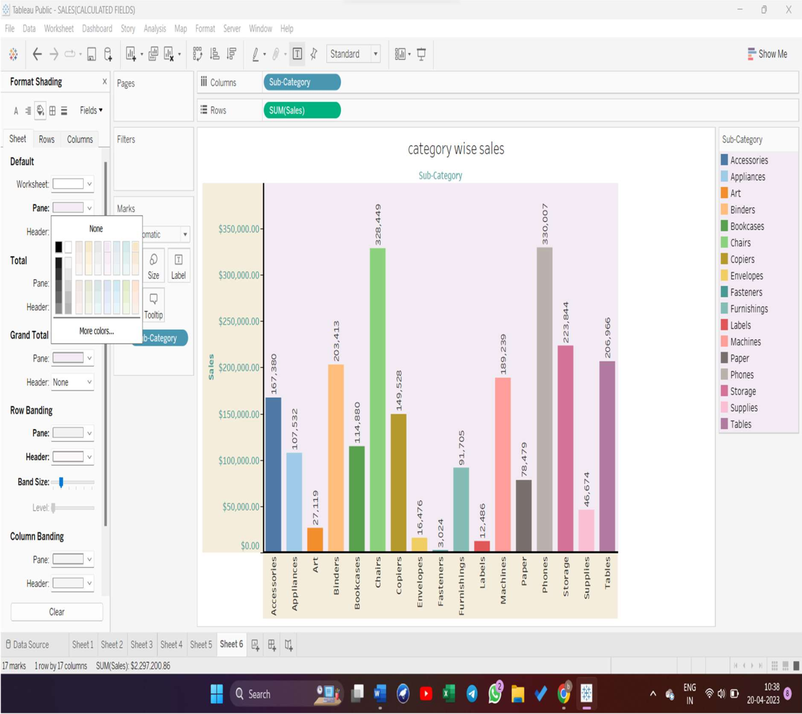

# FORMAT THE BORDERS

Consider a crosstab chart with Category in the Columns shelf and State in the Rows shelf. Now, you can change the borders of the crosstab table created by using the formatting options. Right-click on crosstab chart and choose Format.

The Format Borders appear in the left pane. Choose the options as shown in the following screenshot.

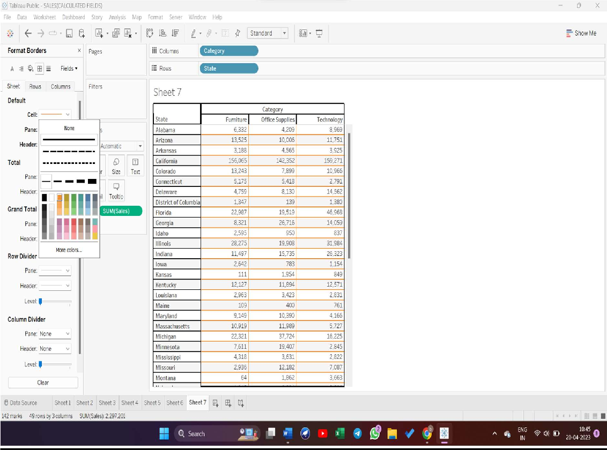

# PARTS OF VIEW

This section describes the basic elements of views that you can create in Tableau. You can show or hide parts of the view as needed (described below). Every view has a table in some form, which may include rows, columns, headers, axes, panes, cells, and marks. Views can optionally include tooltips, titles, captions, field labels, and legends.

# THE VIEW AREA

Data views are displayed in a table on every worksheet. A table is a collection of rows and columns, and consists of the following components: Headers, Axes, Panes, Cells, and Marks. In addition to these, you can choose to show or hide Titles, Captions, Field Labels, and Legends.

# .

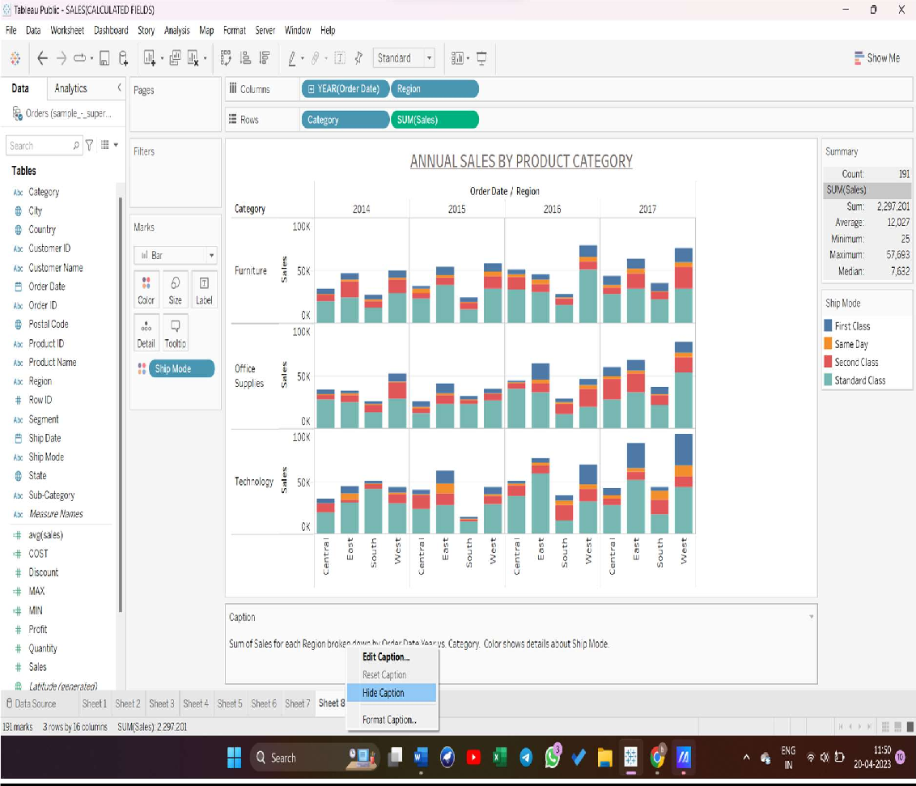

1. F ield Labels - The label of a discrete field added to the row or column shelf that describes the members of that field. For example, Category is a discrete field that contains three members; Furniture, Office Supplies and Technology.
2. T itles - The name that you give your worksheet, dashboard, or story. Titles display automatically for worksheets and stories and you can turn them on to display them in your dashboards.
3. Marks - The data that represents the intersection of the fields (dimensions and measures) included in your view. Marks can be represented using lines, bars, shapes, maps and so on.
4. L egends - A key that describes how the data is encoded in your view. For example if you use shapes or colors in your view, the legend describes what each shape or color represents.
5. Axes - Created when you add a measure (fields that contain quantitative, numerical information) to the view. By default, Tableau generates a continuous axis for this data.
6. H eaders - The member name of a field.
7. C aptions - Text that describes the data in the view. Captions can be automatically generated and can be toggled on and off.

Also see information on Cells and P anes.

##### F ORMATTING SOME PARTS OF VIEW

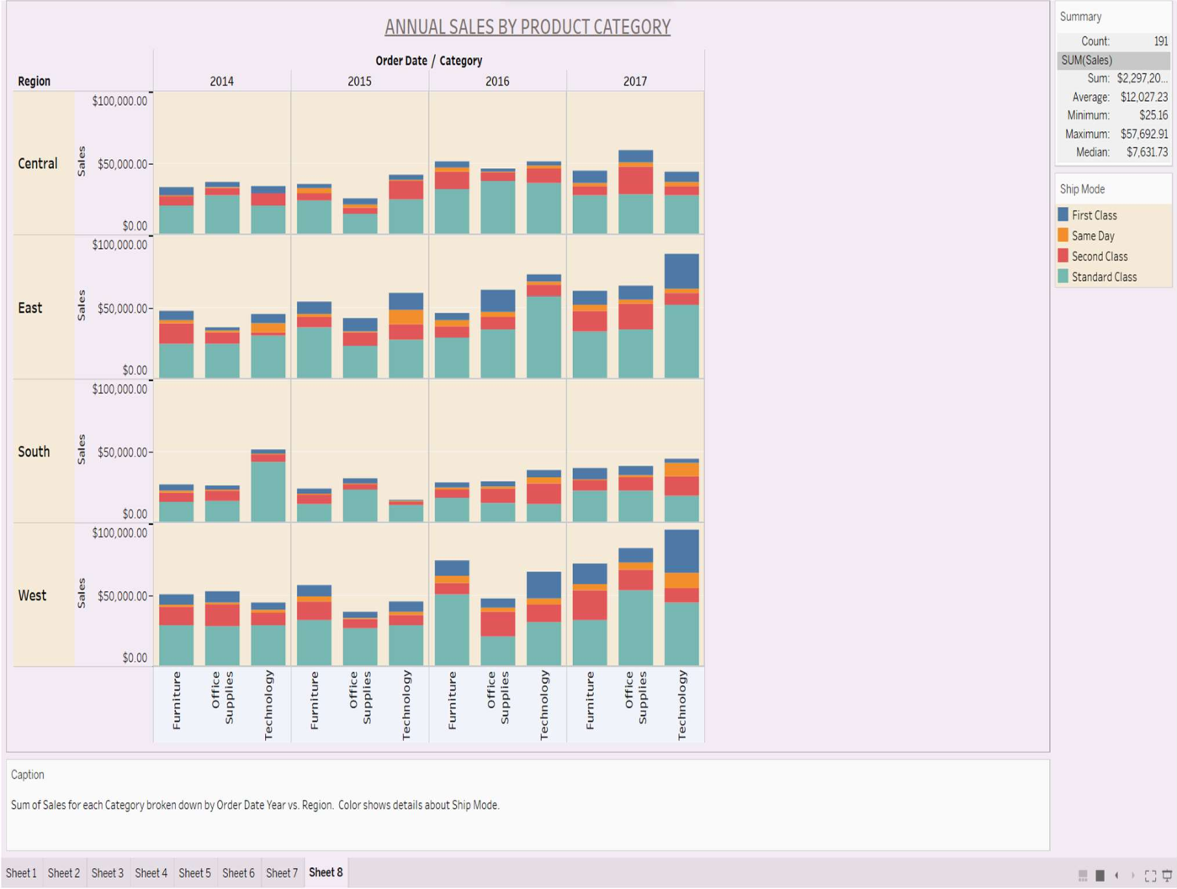

WEEK-5

EDITING AND FORMATTING AXES

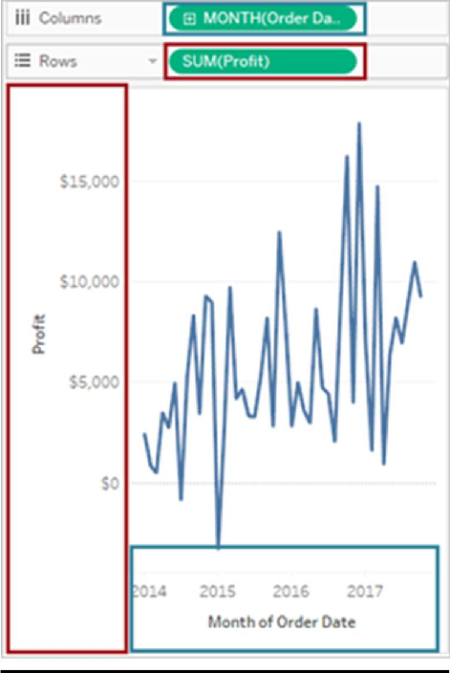When you add a continuous ﬁeld (a ﬁeld with a green background) to the Columns or Rows shelf, it adds an axis to the view. An axis shows data points that lie within a range of values. For each axis, you can specify the range, scale, and tick mark properties.

To edit an axis range, double-click the axis that you want to edit.

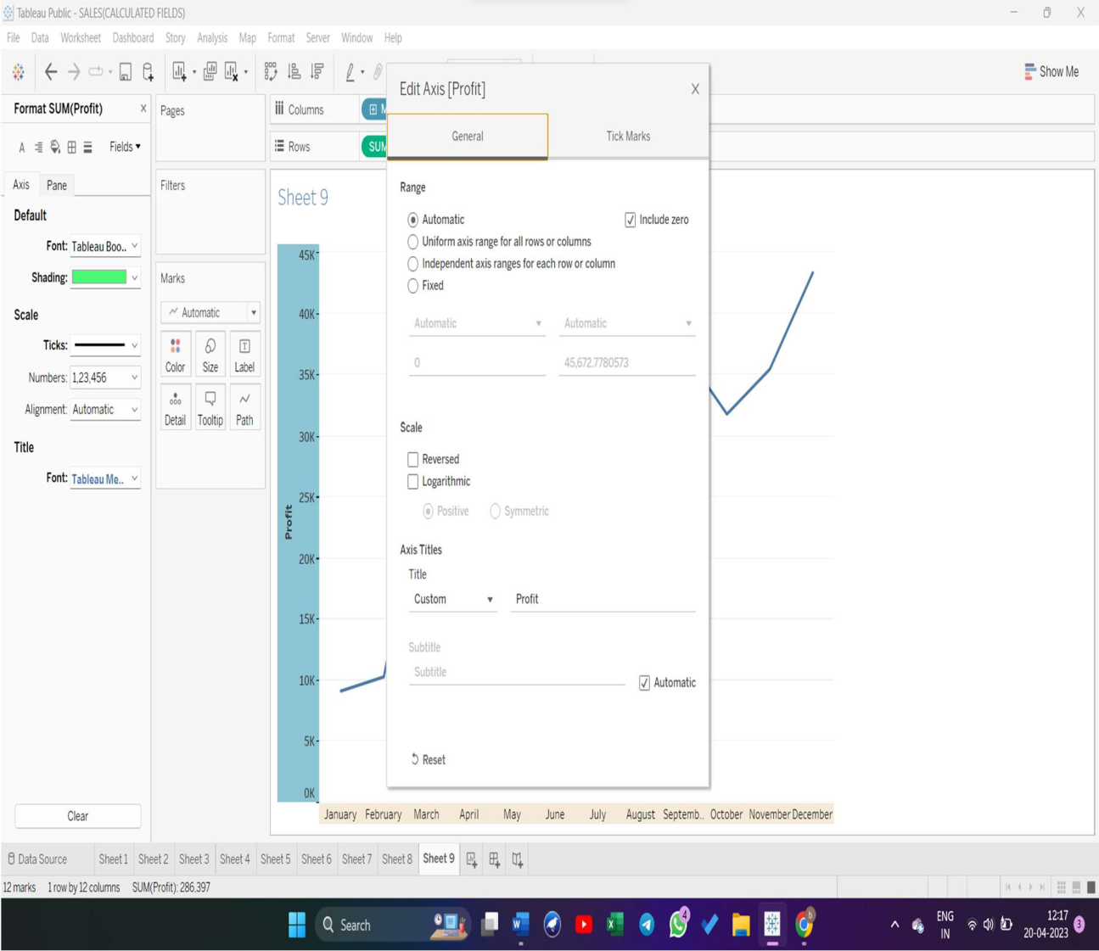

DATA MANIPULATION

### Multiple data manipulation operations can be carried out to make data fit for visualization in the data preview pane or the data pane in the worksheet view. The data manipulation options vary by the data type of the columns.

For example, the split option only comes up for string datatype columns, the create bins option only comes up for numeric datatype columns, etc.

*Note: All data manipulation is done at the metadata level, which is limited to Tableau only. The changes are not reflected in the original data file or data source.*

CHANGE THE DATATYPE

If Tableau has inferred a wrong data type for a column, the data type can be changed by clicking on the data type symbol in the column header, as shown below.

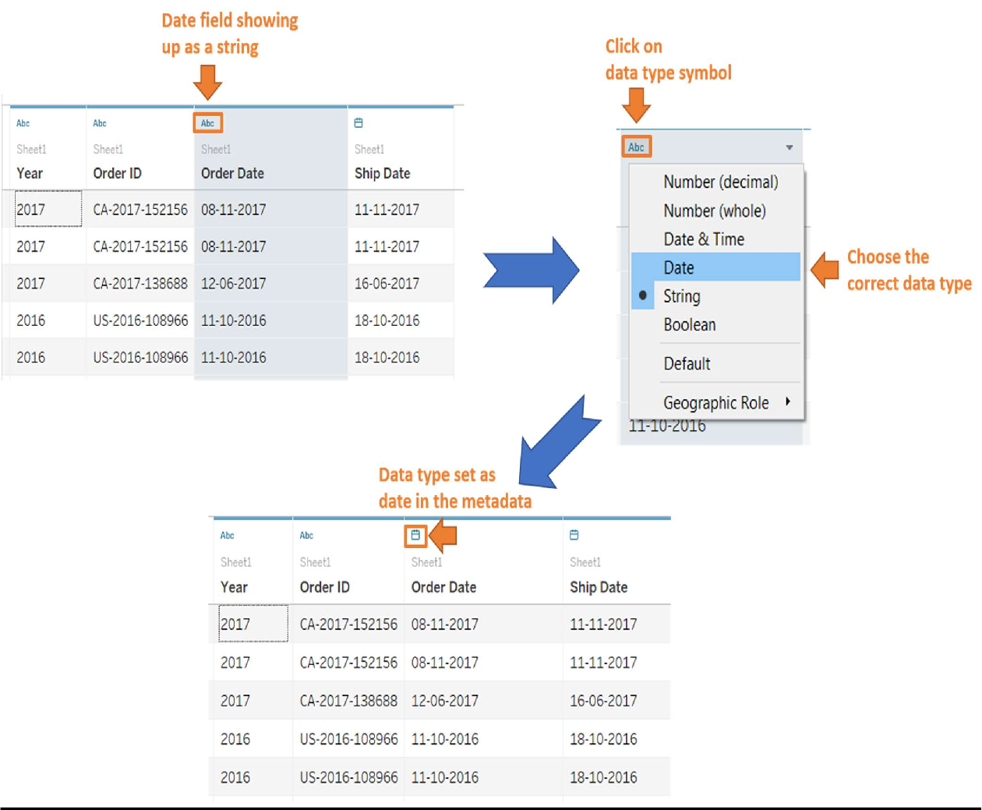

HIDE

Right-click on the column header and select hide to hide an unwanted column from the data view. It is best practice to hide unwanted columns before extract creation in order to reduce the data extract size and reduce latency in load time. Unwanted columns can also be hidden just to prevent any unwanted clutter in the data pane.

*Note: Multiple columns can be selected by holding the control key and left- clicking on the column header. If multiple columns are to be selected in a continuous sequence, hold the shift key and left-click on the first and last*

*column of the sequence. Next, right-click and choose hide to hide them collectively.*

ALIASES

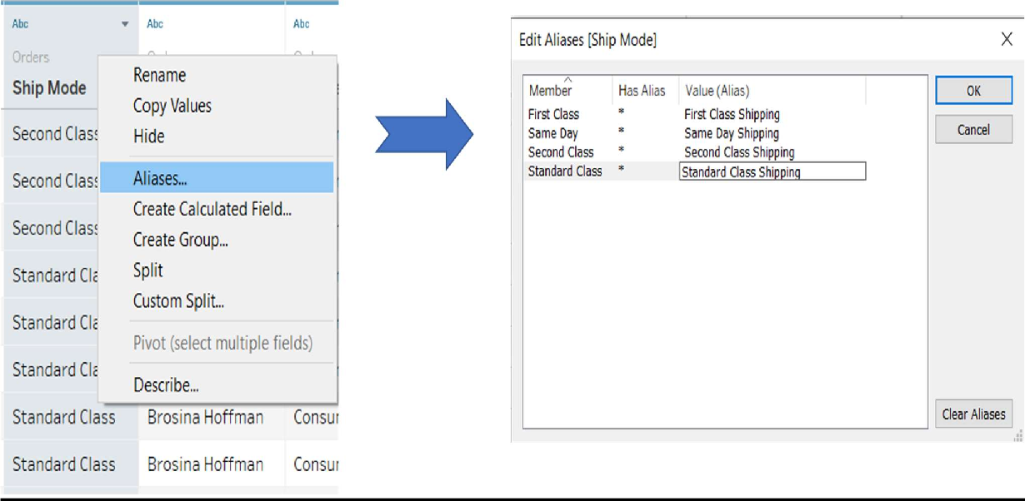If certain string data values are to be aliased for visuals to make them more intuitive, right-click on the header or the small downward arrow of the column in which data values are to be aliases and choose alias.

An edit alias window pops up showing the distinct values in the Member column, as shown above. You can add an alias for each member to the corresponding values column.

GROUP

Groups can be created in Tableau for string datatype column values in order to assign the same alias for multiple values or reduce the granularity of values for a column. To create a group for a column, right click on its header and choose create group. Next, a create group window pops up in which you can select multiple values. Then click on Group. This results in grouping those values with a common group name, which can be edited. Once you've finished creating the groups, click ok.

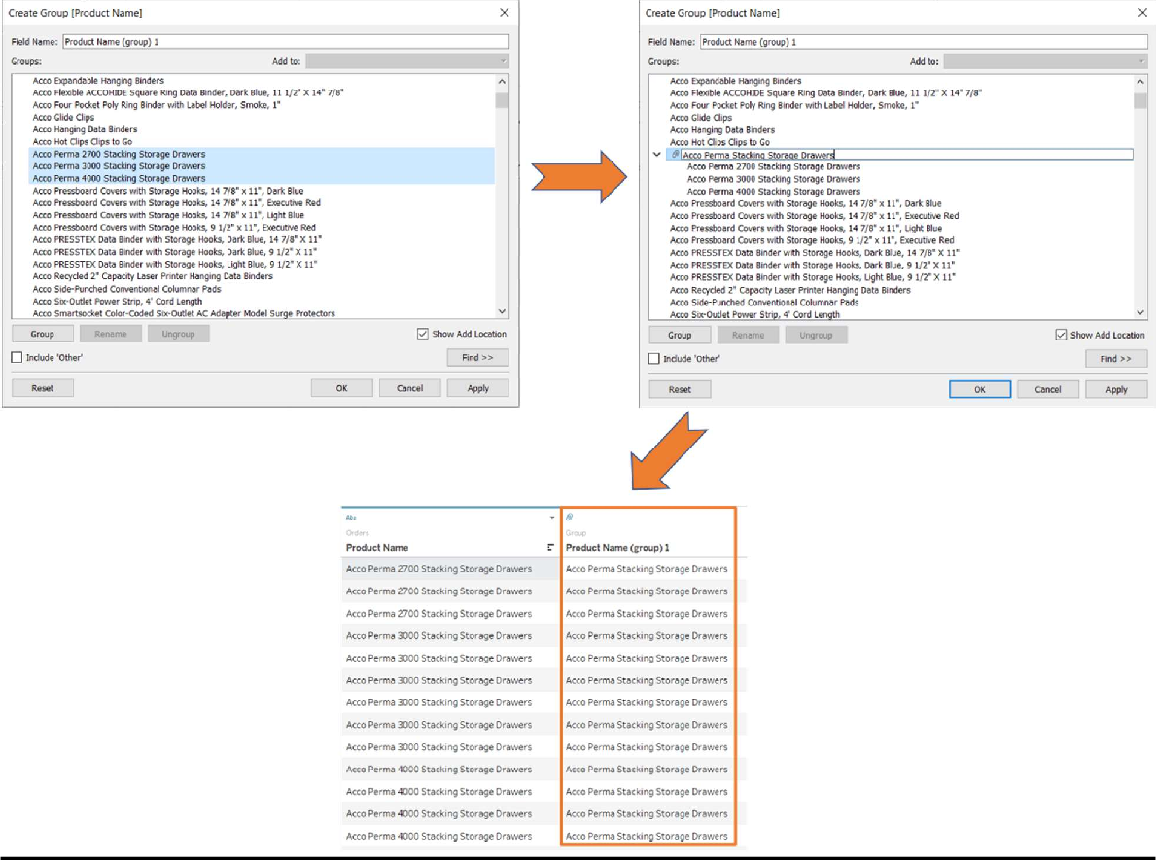

As shown above, a new column gets created with the datatype group. This new column with grouped values can be used in the visualization instead of the original column.

SPLIT

Columns consisting of string values can be easily split into multiple columns using the split or custom split options. For example, the name field can be split into two columns consisting of the first name and last name using split. Split automatically determines the space delimiter in the string value and splits the strings accordingly.

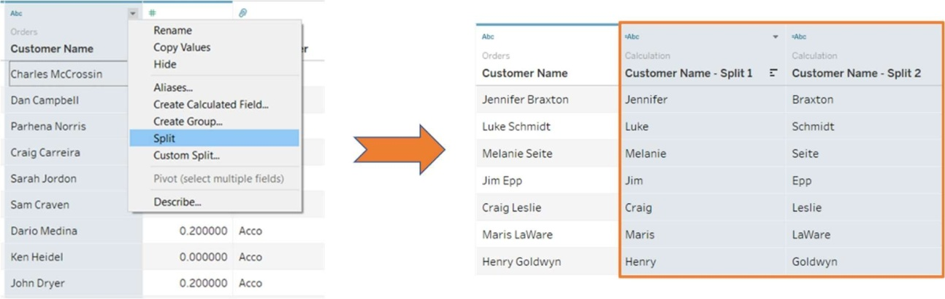

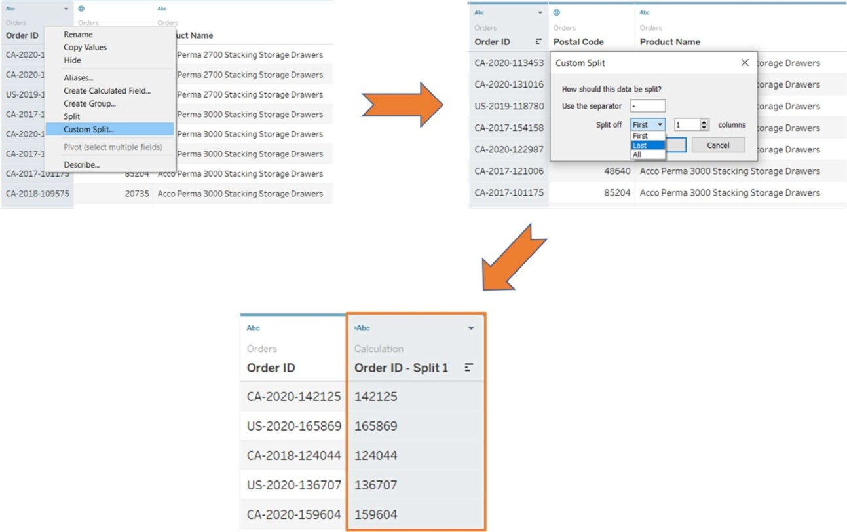If only a certain part of the string is required after splitting or a custom delimiter has been used in the string value, the custom split option can be used. For example, if the last part of the Order ID is required, right-click on the column header and select custom split. A custom split window pops up in which you can select the separator or delimiter and how many strings to split off from the beginning, end, or all positions.

BINS

The values of a numeric column can be grouped into bins. Bins are used to convert continuous numeric values into discrete sequences of range values. The bins are then used to visualize the trends in histograms. For example, consider the sales column, which can be converted into bins for plotting a histogram.

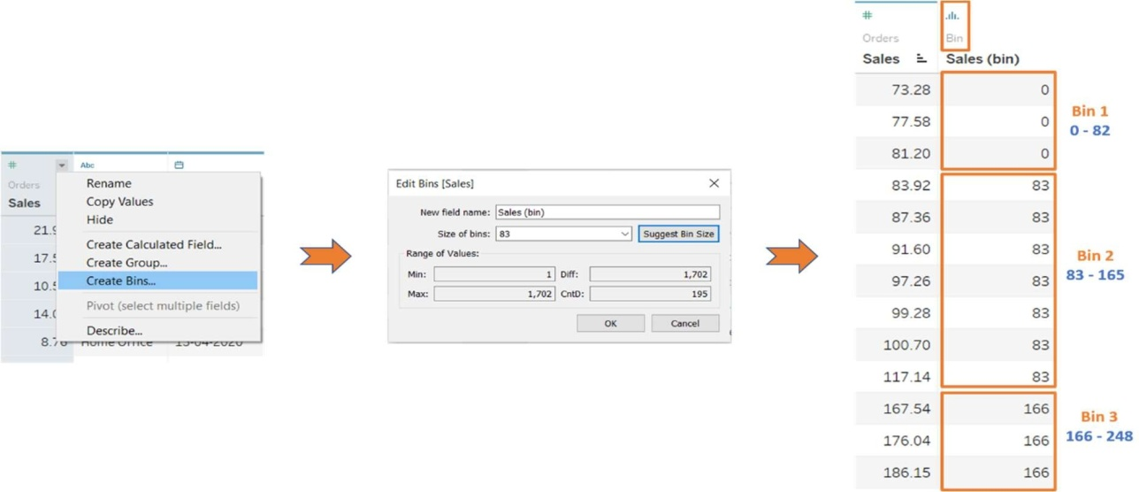

CALCULATED FIELD

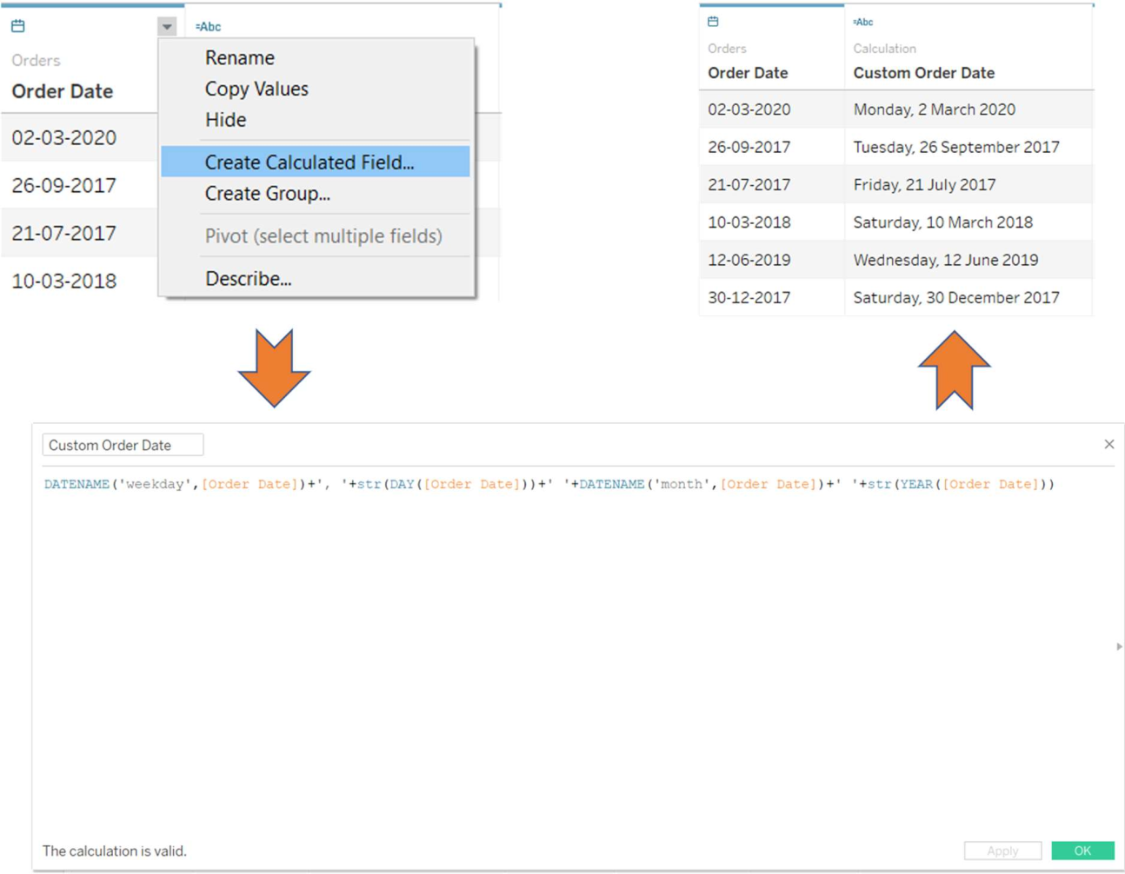Calculated fields can be used if you need to create customized logic for manipulating certain data types or data values. There are a large-range of functions available in Tableau that can used individually or collectively for data manipulation. For example, if you want the date format to include the weekday and month in separate columns, a calculated field will need to be created using the formula shown below.

PIVOT

Consider the pivoted dataset shown below. Since the dimension values for the year are the column headers, a chart based on years cannot be plotted. In order to convert this dataset from the pivoted, or wide, shape to the narrow shape, which is preferred for visualization, use the pivot option, as shown below.

Segment/Year 2013 2O›< zols z0›6 Rename

Fu n it ure

65 73 85 ' Hide

Off ice Su o plies Tec nr ology

216

68

213

54

252 ' Create Calcula ted F ield...

74 Pivot

Merge Mismatched Fields



|  |  |  |  |  |  |  |  |
| --- | --- | --- | --- | --- | --- | --- | --- |
| Pivot | Field | Name s | Pivot | FieId | Va lues |  | Segment/Year |
| 2013 |  | | | | | |  |
| 2014 | 73 | | | | | | F u nit u e |
| 2015 | 85 | | | | | | *u ni ture |
| 2016 | 109 | | | | | | F u•nit u e |
| 2013 | 216 | | | | | | Office Su p pl ies |

|  |  |  |  |
| --- | --- | --- | --- |
| Year | Sales |  | Segment/Year |
| 2013 |  | 65 | Fu niture |
| 2014 |  | 73 | L- u°n iture |
| 2015 |  | 8S | Fu nlture |
| 2016 |  | 109 | F u niture |



# WEEK – 6

STRUCTURE DATA FOR ANALYSIS

There are certain concepts that are fundamental to understanding data prep and how to structure data for analysis. Data can be generated, captured, and stored in a dizzying variety of formats, but when it comes to analysis, not all data formats are created equal.

Data preparation is the process of getting well formatted data into a single table or multiple related tables so it can be analyzed in Tableau. This includes both the structure, i.e. rows and columns, as well as aspects of data cleanliness, such correct data types and correct data values.

# HOW STRUCTURE IMPACT ANALYSIS

The structure of your data may not be something you can control. The rest of this topic assumes you have access to the raw data and the tools needed to shape it, such as Tableau Prep Builder. However, there may be situations when you can't pivot or aggregate your data as desired. It is often still possible to perform the analysis but you may need to change your calculations or how you approach the data. For an example of how to perform the same analysis with different data structures, see Tableau Prep Day in the Life Scenarios: Analysis with the Second Date in Tableau

Desktop(Link opens in a new window). But if you can optimize the data structure it will likely make your analysis much easier.

##### DATA STRUCTURE

Tableau Desktop works best with data that is in tables formatted like a spreadsheet. That is, data stored in rows and columns, with column headers in the first row. So what should be a row or column?

What is a row?

A row, or record, can be anything from information around a transaction at a retail store, to weather measurements at a specific location, or stats about a social media post.

It's important to know what a record (row) in the data represents. This is the *granularity* of the data.

Here each record is a day

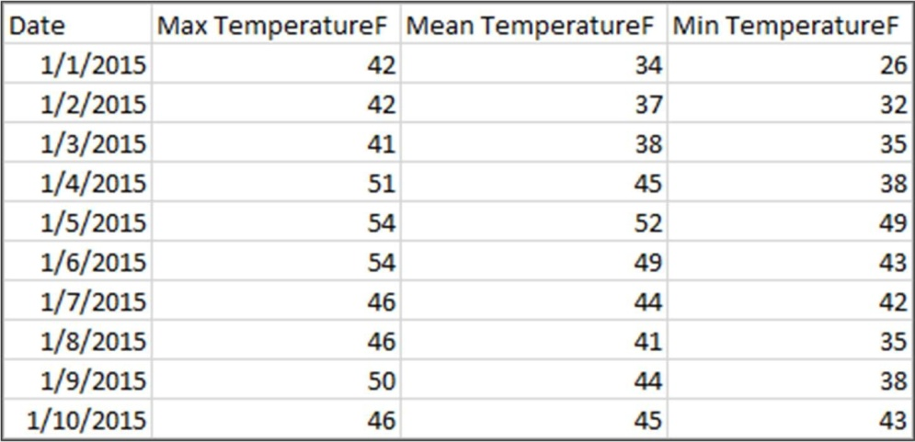

Here each record is a month

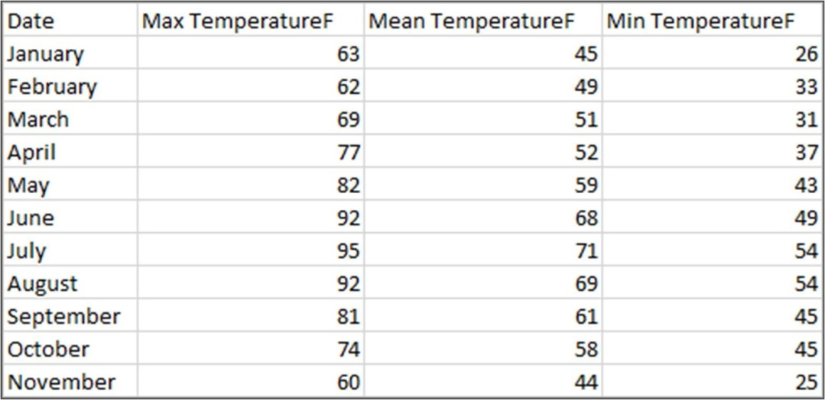

Try to make sure you can answer the question "What does a row in the data set represent?". This is the same as answering "What does the TableName(Count) field represent?". If you can't articulate that, the data might be structured poorly for analysis.

A concept related to what makes up a row is the idea of aggregation and granularity, which are opposite ends of a spectrum.

##### A ggregation

* refers to how multiple data values are brought together into a single value, such as counting all the Google searches for Pumpkin Spice or taking the average of all the temperature readings around Seattle on a given day.
* By default, measures in Tableau are always aggregated. The default aggregation is SUM. You can change the aggregation to options like Average, Median, Count Distinct, Minimum, etc.

##### Granularity

* refers to how detailed the data is. What does a row or record in the data set represent? A person with malaria? A provinces' total cases of malaria for the month? That's the granularity.
* Knowing the granularity of the data is crucial to working with level of detail (LOD) expressions.

Understanding aggregation and granularity is a critical concept for many reasons; it impacts things like finding useful data sets, building the visualization you want, relating or joining data correctly, and using LOD expressions.

What is column?

A *column* of data in a table comes into Tableau Desktop as a *field* in the data pane, but they are essentially interchangeable terms. (We save the

term *column* in Tableau Desktop for use in the columns and rows shelf and to describe certain visualizations.) A field of data should contain items that can be grouped into a larger relationship. The items themselves are

called *values* or *members* (only discrete dimensions contain members).

##### Data types

Databases, unlike spreadsheets, usually enforce strict rules on data types. Data types classify the data in a given field and provide information about how the data should be formatted, interpreted, and what operations can be done to that data. For example, numerical fields can have mathematical operations applied to them and geographic fields can be mapped.

Tableau Desktop assigns whether a field is a dimension or measure, but fields have other characteristics that depend on their data type. These are indicated by the icon each field has (though some types share an icon).

Tableau Prep uses the same data types. If data type is enforced on a column and an existing value doesn't match its assigned data type, it may be displayed as null (because "purple" doesn't mean anything as a number).

Some functions require specific data types. For example, you cannot use CONTAINS with a numerical field. Type functions are used to change the data type of a field. For example, DATEPARSE can take a text date in a

specific format and make it a date, thus enabling things like automatic drill down in the view.

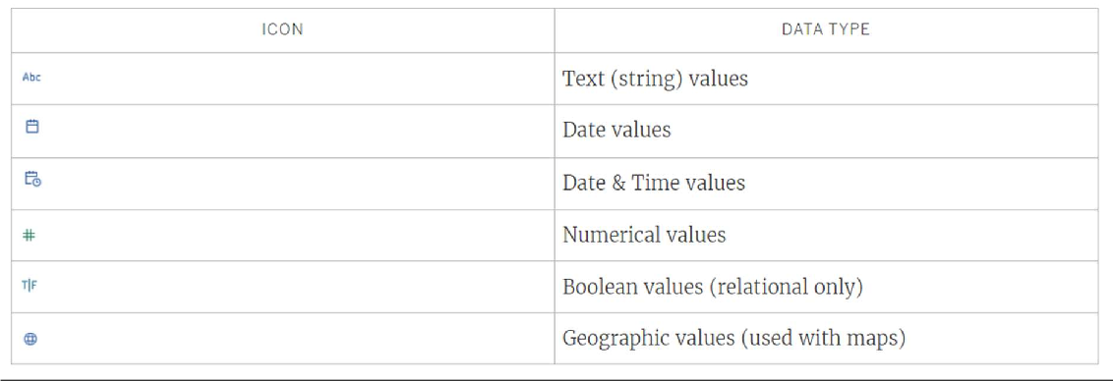

# Categorizing fields

Each column in the data table comes into Tableau Desktop as a field, which appears in the Data pane. Fields in Tableau Desktop must be either a dimension or measure (separated by a line within tables in the Data pane) and either discrete or continuous (color coded: blue fields are discrete and green fields are continuous).

* *Dimensions*are qualitative, meaning they can't be measured but are instead described. Dimensions are often things like city or country, eye color, category, team name, etc. Dimensions are usually discrete.
* *Measures*are quantitative, meaning they can be measured and recorded with numbers. Measures can be things like sales, height, clicks, etc. In Tableau Desktop, measures are automatically aggregated; the default aggregation is SUM. Measures are usually continuous.

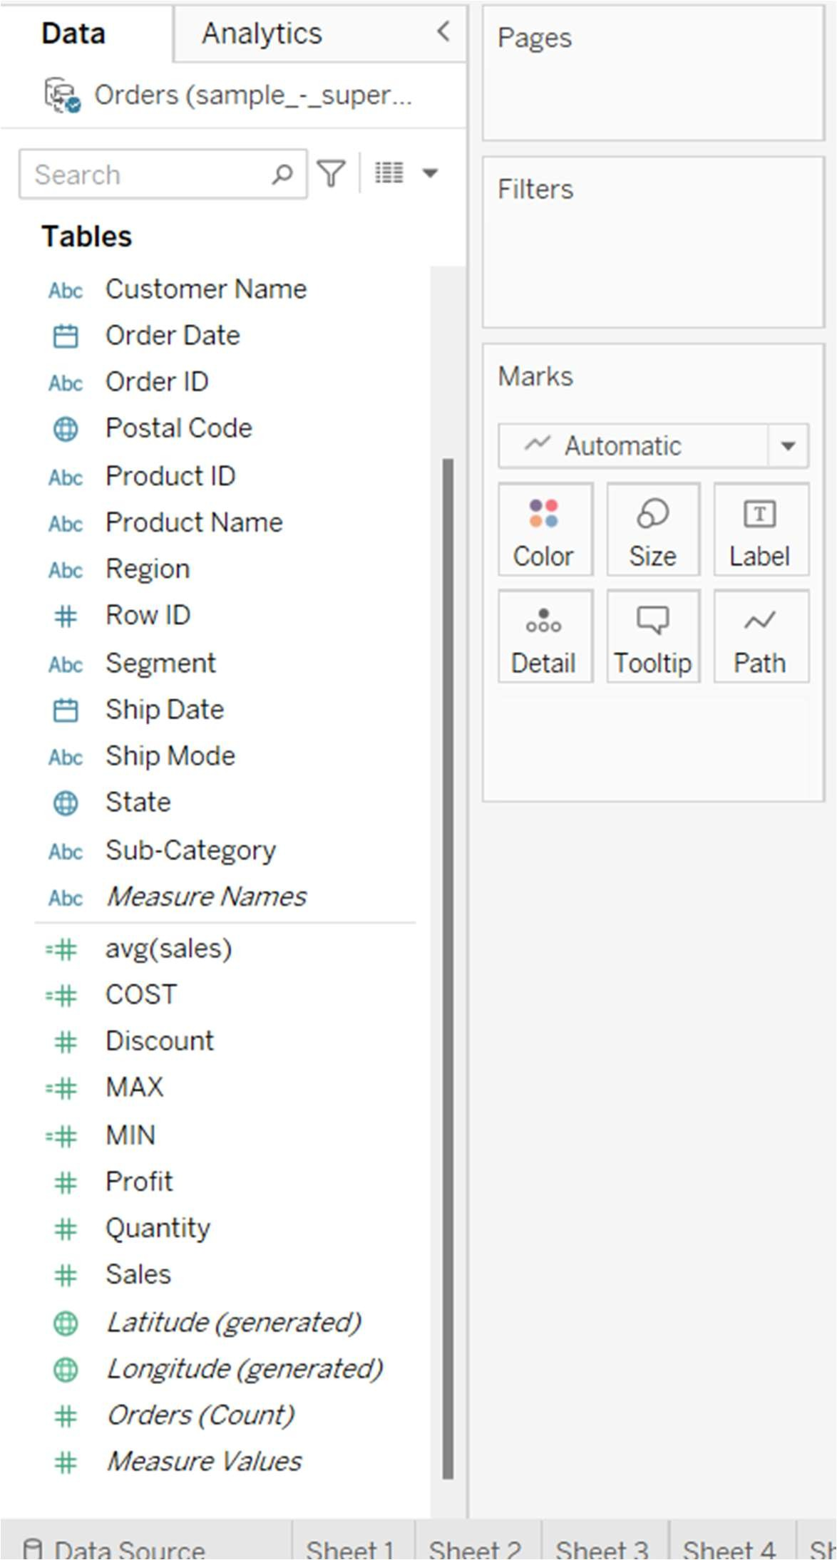

* *Discrete*means individually separate or distinct. Toyota is distinct from Mazda. In Tableau Desktop, discrete values come into the view as a label and they create panes.

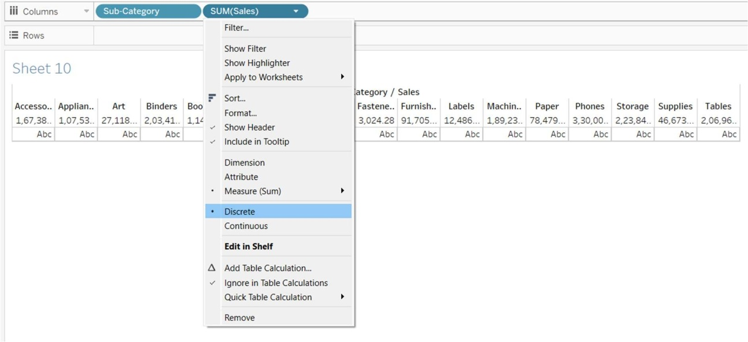

* *Continuous*means forming an unbroken, continuous whole. 7 is followed by 8 and then it's the same distance to 9, and 7.5 would fall midway between 7 and 8. In Tableau Desktop, continuous values come into the view as an axis.

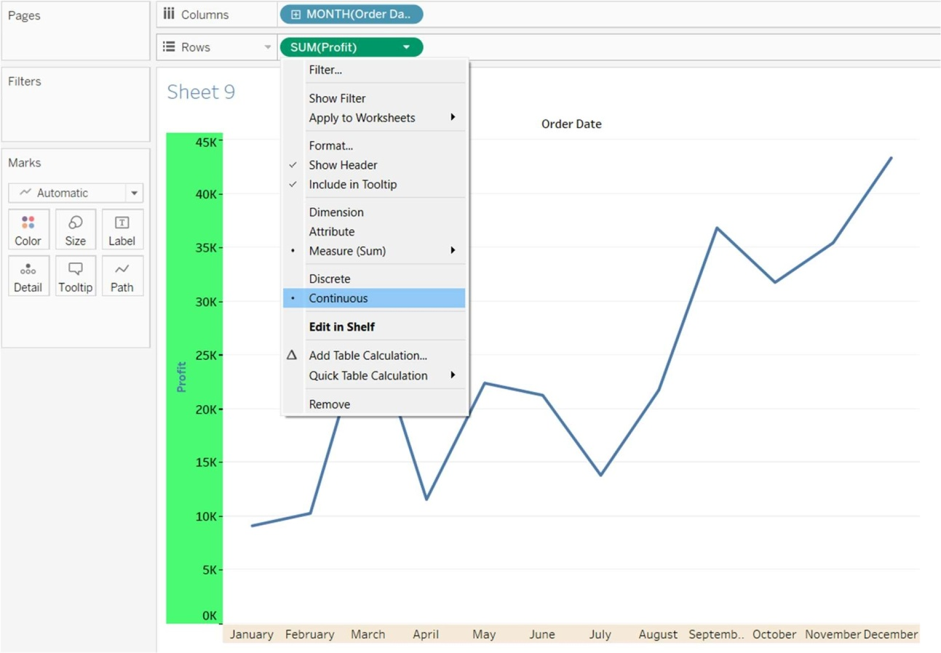

* Dimensions are usually discrete, and measures are usually continuous. However, this is not always the case. Dates can be either discrete or continuous.
  + Dates are dimensions and automatically come into the view as discrete (aka date parts, such as "August", which considers the month of August without considering other information like the year). A trend line applied to a timeline with discrete dates will be broken into multiple trend lines, one per pane.
  + We can chose to use continuous dates if preferred (aka date truncations, such as "August 2024", which is different than "August 2025"). A trend line applied to a timeline with continuous dates will have a single trend line for the entire date axis.

In Tableau Prep, no distinction is made for dimensions or measures. Understanding the concepts behind discrete or continuous are important, however, for things like understanding the detail versus summary presentation of data in the profile pane.

* Detail: the detail view shows every domain element as a discrete label and has a visual scrollbar to provide a visual overview of all the data.
* Summary: the summary view shows the values as binned on a continuous axis as a histogram.

JOIN YOUR DATA

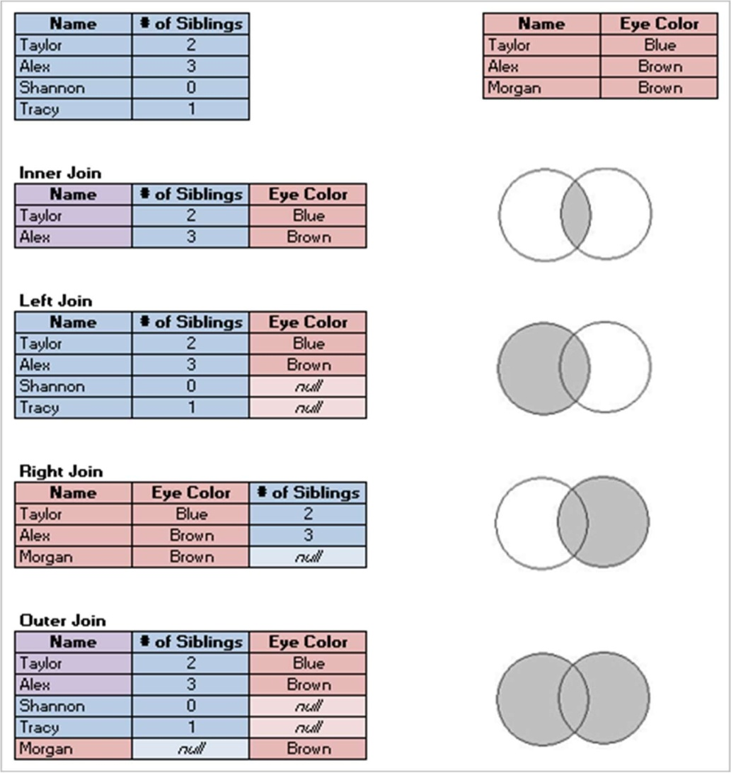It is often necessary to combine data from multiple places—di"erent tables or even data sources—to perform a desired analysis. Depending on the structure of the data and the needs of the analysis, there are several ways to combine the tables.

C REATE A JOIN

1. To create a join, connect to the relevant data source or sources. See Connect to Your Data.

These can be in the same data source (such as tables in a database or sheets in an Excel spreadsheet) or different data sources (this is known as a cross- database join). If you combined tables using a cross-database join, Tableau colors the tables in the canvas and the columns in the data grid to show you which connection the data comes from.

1. Drag the first table to the canvas.

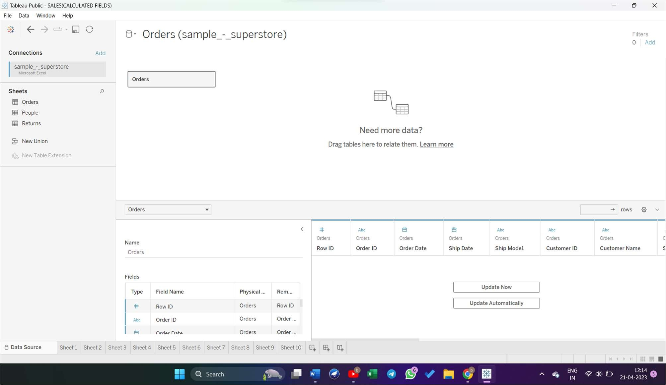

* 1. 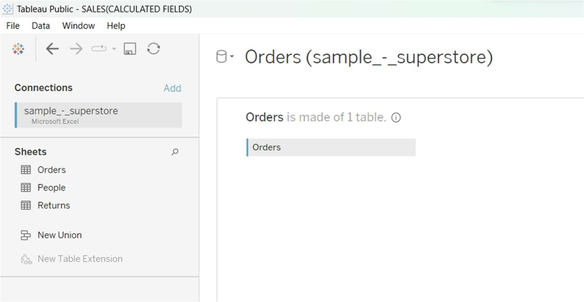Select Open from the menu or double-click the ﬁrst table to open the join canvas (physical layer).
  2. Double-click or drag another table to the join canvas.

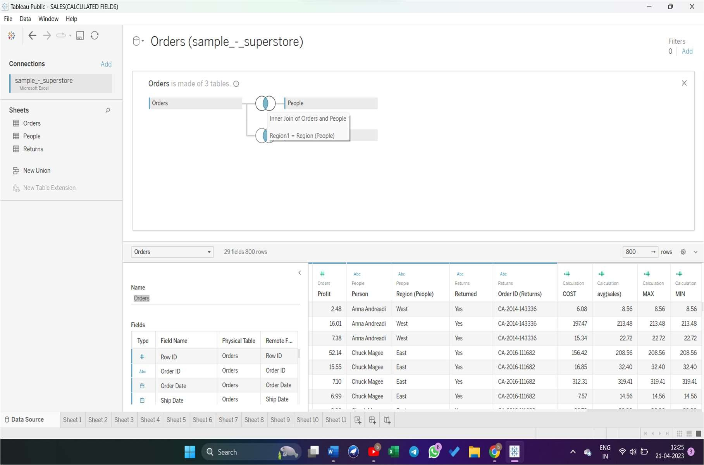

* 1. Click the join icon to configure the join. Add one or more join clauses by selecting a field from one of the available tables used in the data source, choosing a join operator, and a field from the added table.

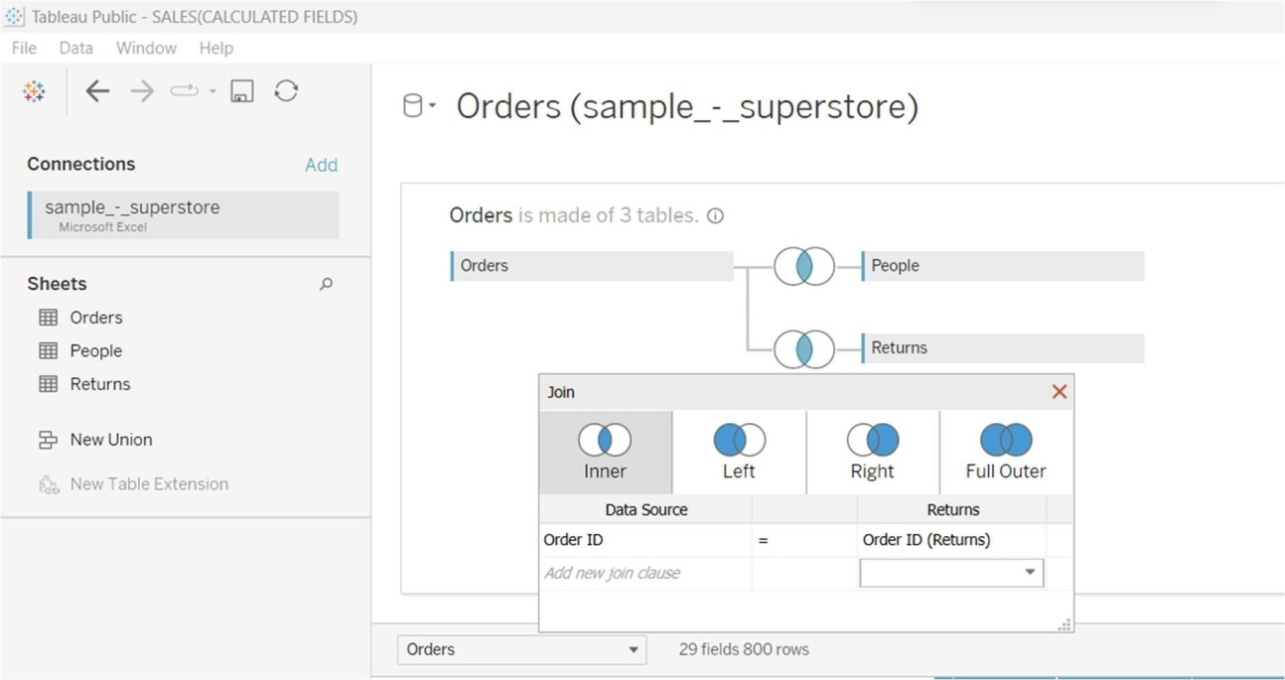

* 1. When finished, close the join dialog and join canvas.

# SORTING THE TABLEAU DATA

you can sort items in a table based on a measure used in the view. Sorting gives you control over the order that dimension members are listed in a table and can often reveal relationships between ﬁelds.

*To sort items in a table:*

1. Select the items you want to sort.
2. Click one of the sort buttons 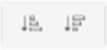 on the toolbar.

Note: The tool tips for the sort buttons tell you how the table is going to be sorted.

For example, click the Sort Ascending button to reorder the bars in the chart from lowest sales to highest sales, as shown below.

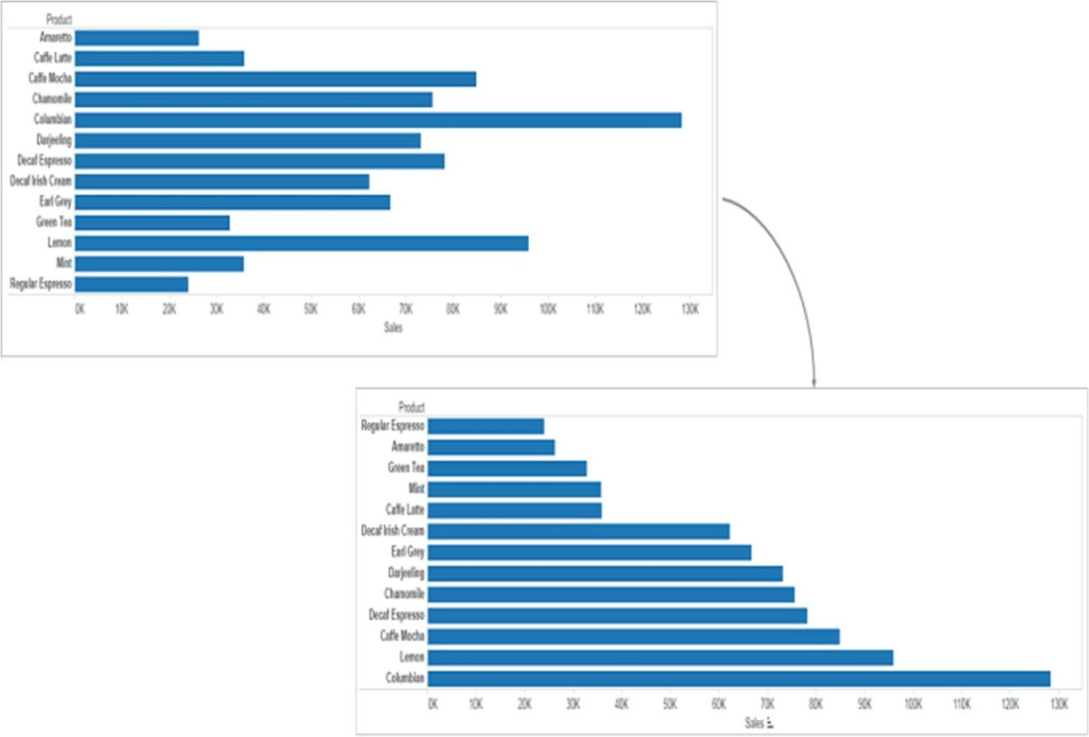

You can also sort items by dragging the ﬁeld labels in a column. In the example below, Regular Espresso is dragged to move below Mint. The new location is indicated by the black line.

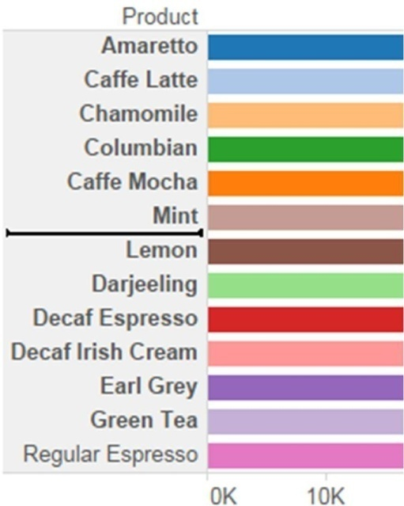

You can also manually sort items in the view using the Legend. To manually sort items do the following steps:

1. In the Legend, right-click anywhere in the white space and select Sort from the context menu.
2. In the Sort dialog, in the Manual section, select items that you want to reorder and then use the Up and Down buttons to move items in the list.

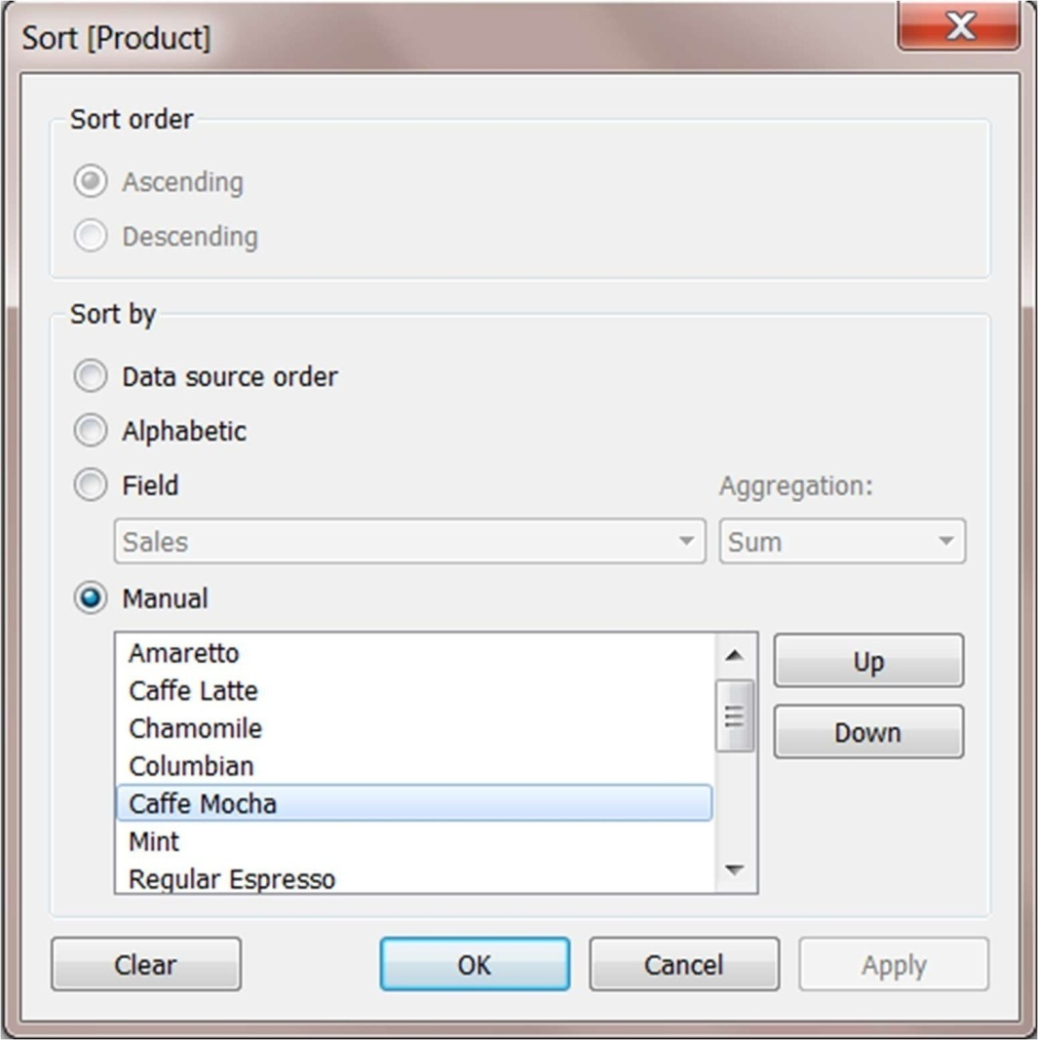

# RESETTING THE SORT ORDER

You can reset how a table is sorted by either clicking the Undo button or by reverting the workbook to its saved state.

##### FILTERING TABLEAU DATA (CATEGORICAL DATA)

Dimensions contain discrete categorical data, so filtering this type of field generally involves selecting the values to include or exclude.

When you drag a dimension from the Data pane to the Filters shelf in Tableau Desktop, the following Filter dialog box appears:

* General: Use the General tab to select the values you want to include or exclude.
* Wildcard (Tableau Desktop only): Use the Wildcard tab to define a pattern to filter on. For example, when filtering on email addresses you might want to only include emails from a specific domain. You can define a wildcard filter that ends with "@gmail.com" to only include Google email addresses.
* Condition: Use the Condition tab in the Filter dialog box to define rules to filter by. For example, in a view showing the average Unit Price for a collection of products, you may want to only show the Products that have an average unit price that is greater than or equal to $25. You can use the built-in controls to write a condition or you can write a custom formula.
* Top: Use the Top tab in the Filter dialog box to define a formula that computes the data that will be included in the view. For example, in a view that shows the average Time to Ship for a collection of products, you can decide to only show the top 15 (or bottom) products by Sales. Rather than having to define a specific range for Sales (e.g., greater than $100,000), you can define a limit (top 15) that is relative to the other members in the field (products).

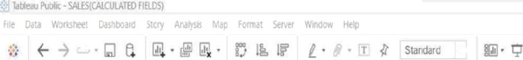 



Sheet I1



##### P ivoting and Unpivoting Data

People-friendly data is often captured and recorded in a wide format, with many columns. Machine-readable data, like Tableau prefers, is better in a tall format, with fewer columns and more rows.

W IDE DATA

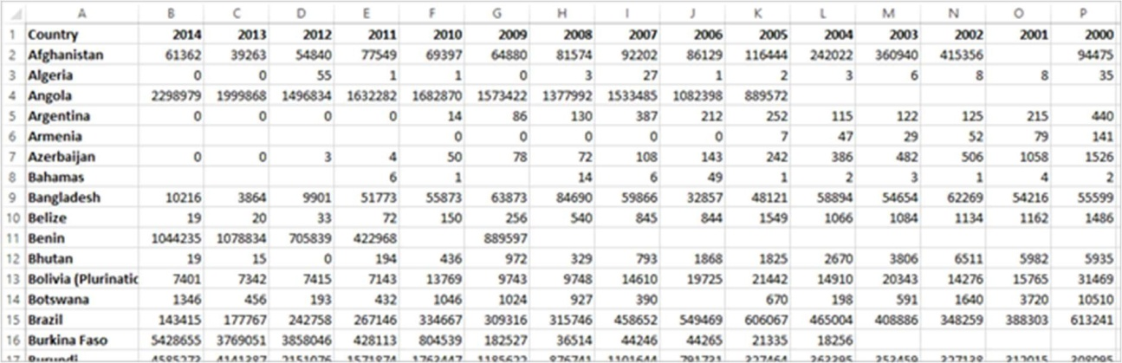

It's easy for a person to read and understand this format. However, if we were to bring this data into Tableau Desktop, we get a ﬁeld per column. We have a ﬁeld for 2000, a ﬁeld for 2001, a ﬁeld for 2002, etc.

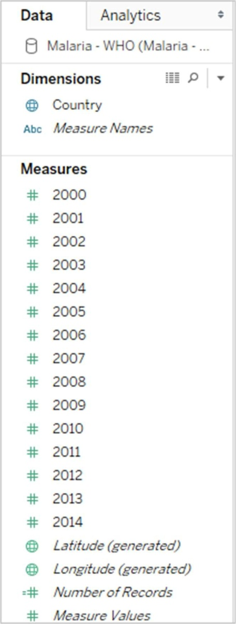

T ALL DATA

If we pivot the data, we reshape the data from wide to tall. Now, rather than having a column for each year, we have a single column, Year, and a new column, Reported Cases. In this format we have 1,606 rows and 3 columns. This data format is taller rather than wider.

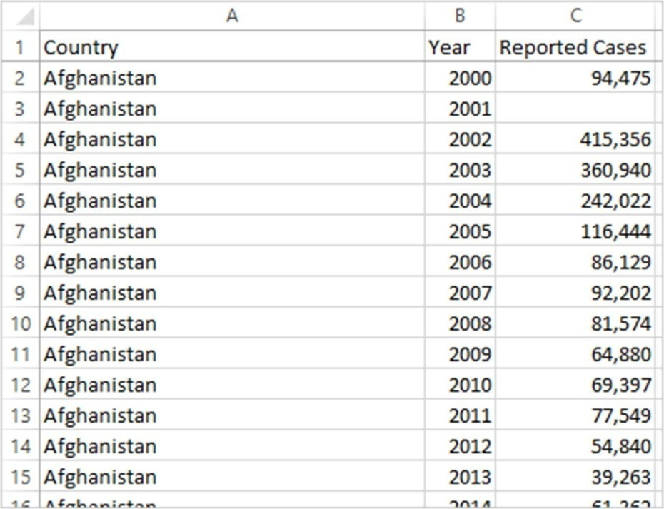

Now in Tableau Desktop, we have a field for Year and a field for Reported Cases as well as the original Country field. It's much easier to do analysis because each field represents a unique quality about the data set—location, time, and value.

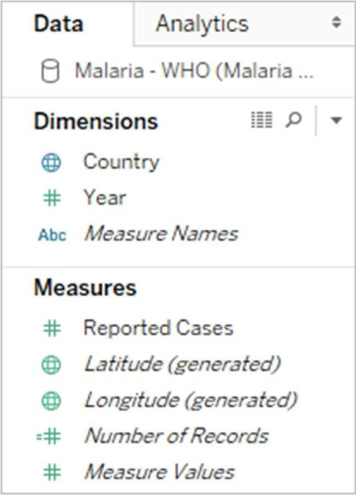

##### WEEK – 7

MARKS CARD

The Marks card is a key element for visual analysis in Tableau. As you drag fields to different properties in the Marks card, you add context and detail to the marks in the view.

You use the Marks card to set the mark type (see Change the Type of Mark in

the View), and to encode your data with color, size, shape, text, and detail. To change the mark settings, see Control the Appearance of Marks in the

View.

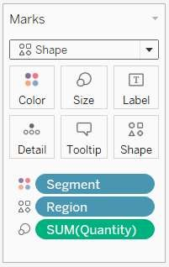

In this example, three different fields have been dragged to different properties in the Marks card. Segment is on Color, Region is on Shape, and Quantity is on Size.

After you add a field to the Marks card, you can click the icon next to the field to change the property it is using. You can also click the property buttons in the Marks card to change those settings.

##### U SING THE DETAIL PANEL

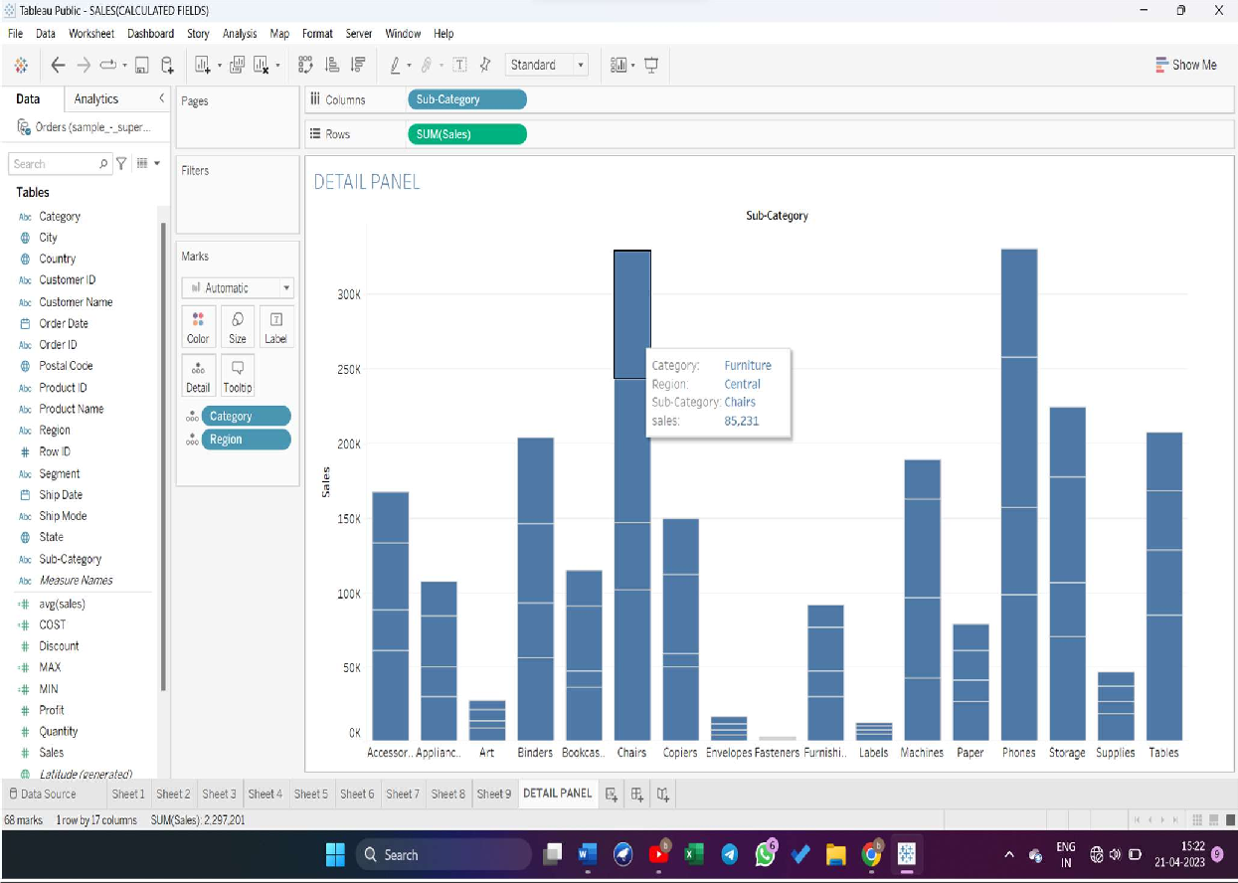

U SING SIZE PANEL

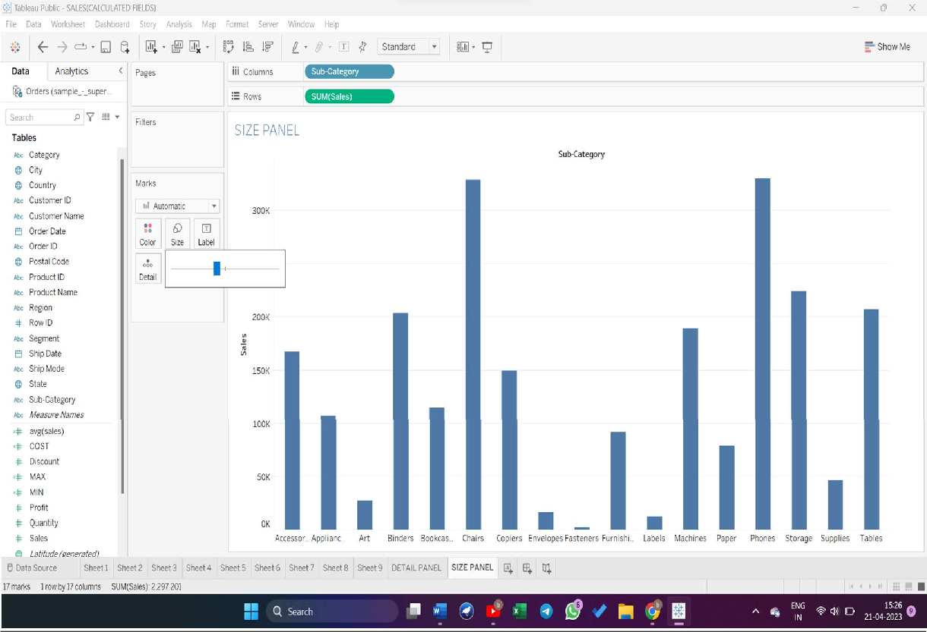

U SING COLOR PANEL

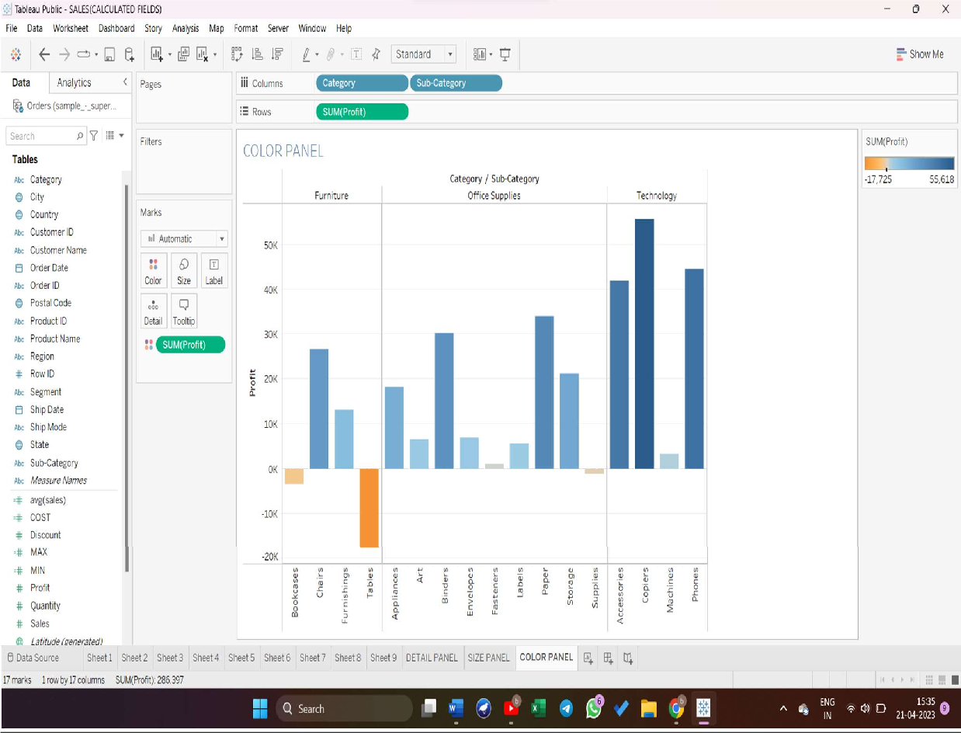

U SING CUSTIMIZING TOOLTIPS

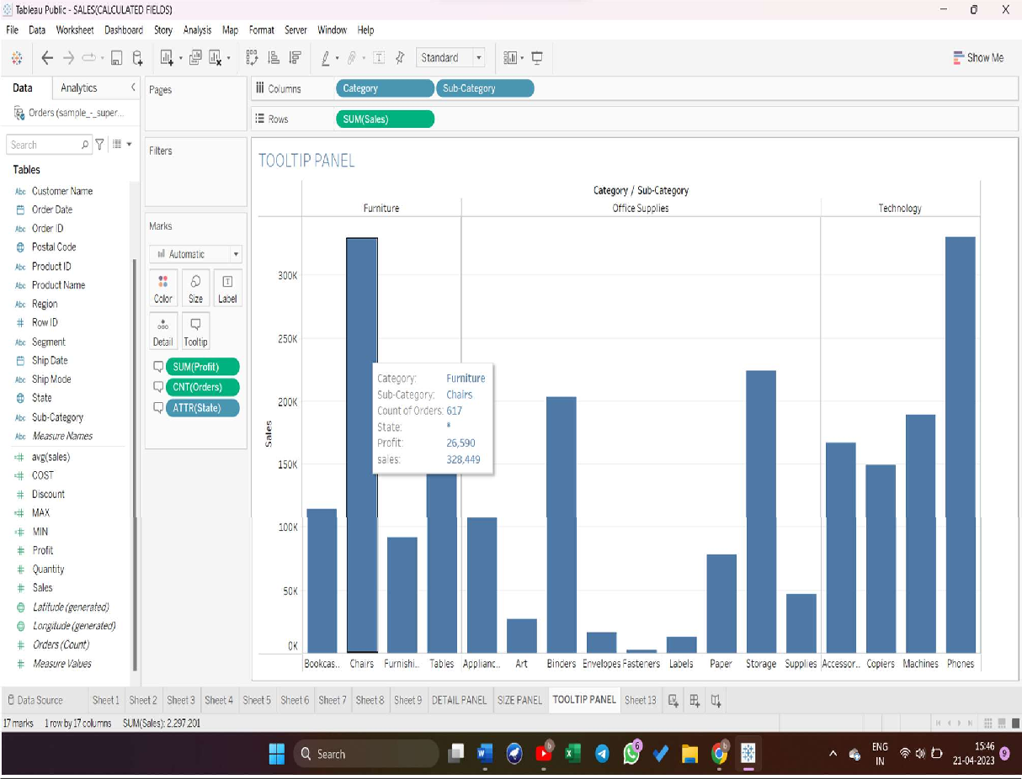

U SING LABEL PANEL

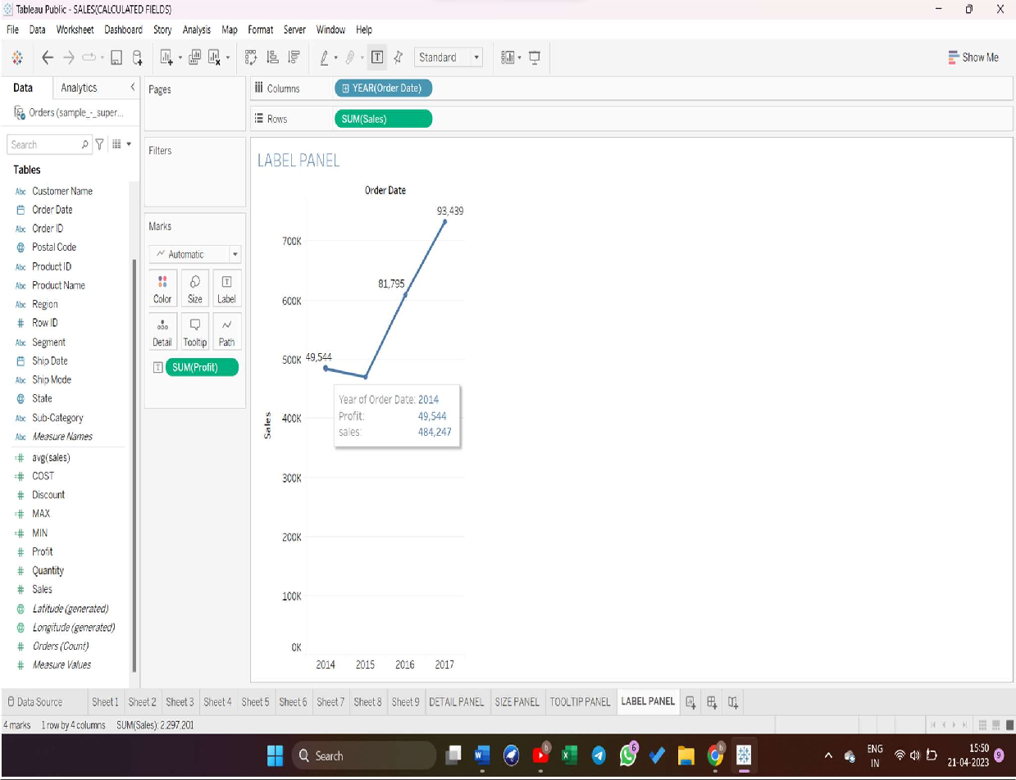

WEEK – 8

DASHBOARD IN TABLEAU

A dashboard is a collection of several views, letting you compare a variety of data simultaneously. For example, if you have a set of views that you review every day, you can create a dashboard that displays all the views at once, rather than navigate to separate worksheets.

Like worksheets, you access dashboards from tabs at the bottom of a workbook. Data in sheets and dashboards is connected; when you modify a sheet, any dashboards containing it change, and vice versa. Both sheets and dashboards update with the latest available data from the data source.

CREATE A DASHBORAD

After you've created one or more sheets, you can combine them in a dashboard, add interactivity, and much more.

Create a dashboard, and add or replace sheets

1. At the bottom of the workbook, click the New Dashboard icon:

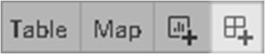

1. From the Sheets list at left, drag views to your dashboard at right.

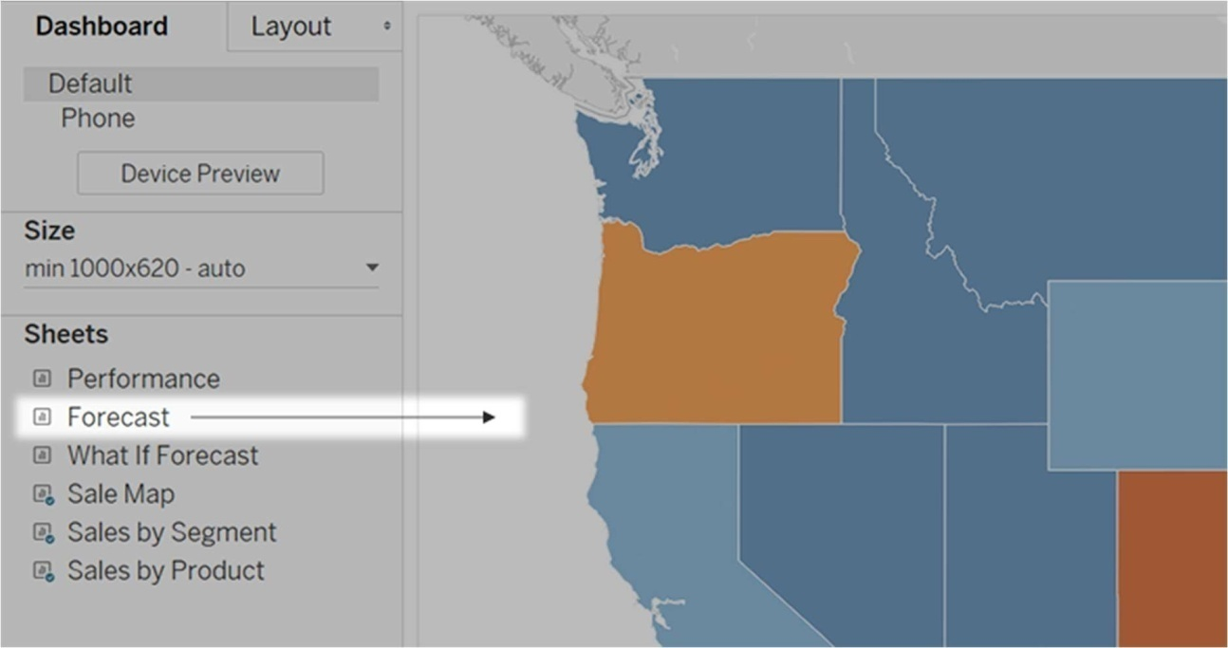

1. To replace a sheet, select it in the dashboard at right. In the Sheets list at left, hover over the replacement sheet, and click the Swap

Sheets button.

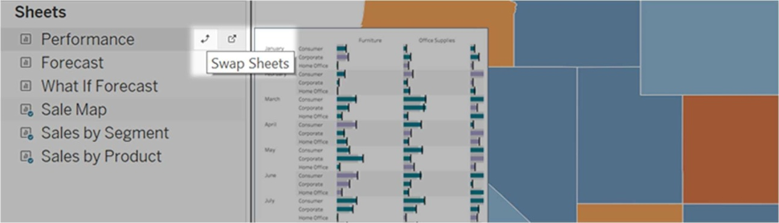

**Note:** When you replace a sheet, Tableau retains any padding, border, or background color. However, you may need to adjust sheet size if content differs significantly. You may also need to delete dashboard items specific to the previous sheet, such as filters, which become blank.

ADD INTERACTIVITY

You can add interactivity to dashboards to enhance users' data insights. Try these techniques:

* In the upper corner of sheet, enable the Use as Filter option to use selected marks in the sheet as ﬁlters for other sheets in the dashboard.

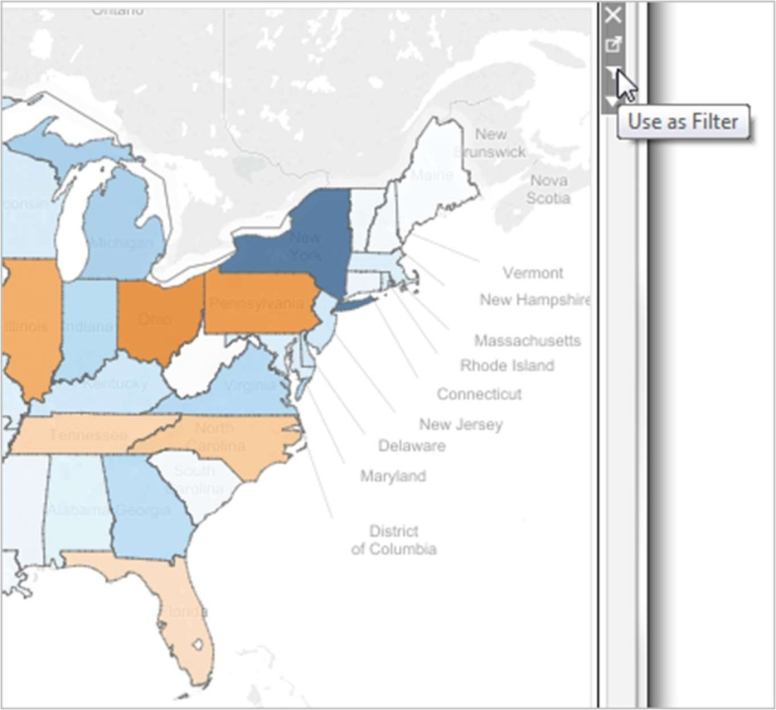

* When authoring in Tableau Desktop, add actions to use multiple sheets as ﬁlters, navigate from one sheet to another, display web pages, and more. For details, see A ctions and Dashboards.

##### A CTIONS AND DASHBOARD

Actions often have unique behavior when the source or destination is a dashboard. Because a dashboard can contain multiple views, a single filter or highlight action can have broad impact. Dashboards can also contain web page objects, which you can target with interactive URL actions.

#### Use a single view to filter other views in a dashboard

Imagine you have a dashboard that contains three views about profitability: a map, a bar chart, and a table of customer names. You can use a filter action to make one of the views in your dashboard, such as the map, the controlling view for the filter action. When your users select a region in the map, the data in the other views is filtered so that it relates to just that region.

1. On the dashboard, select the view you want to use as a filter.
2. On the view's shortcut menu, choose Use as Filter. You can perform the same action by clicking the Use as Filter icon .

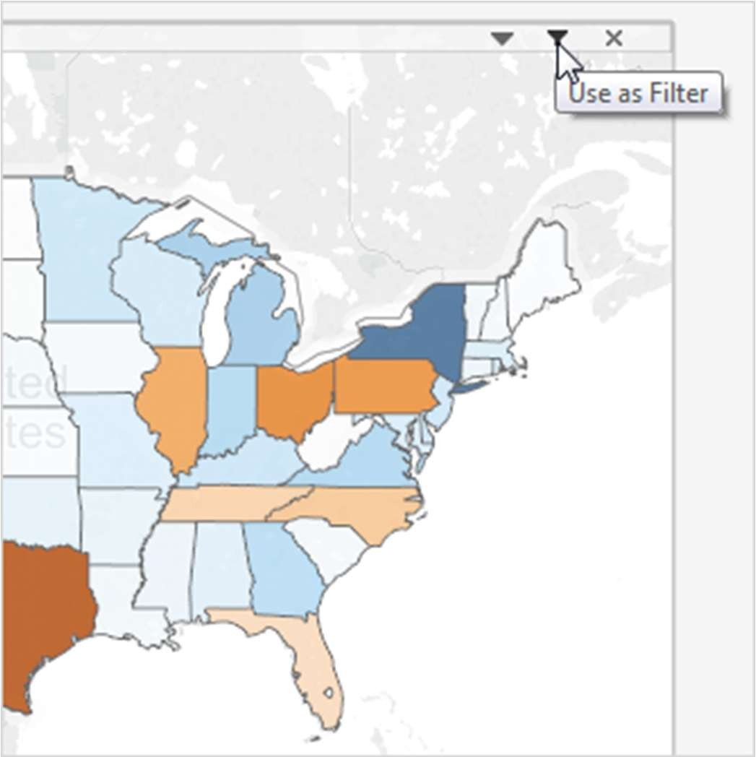

You can also use filter actions to filter the data on a dashboard when the data comes from multiple data sources. For more information, see F iltering A cross Multiple Data Sources Using a Parameter(Link opens in a new window) in the Tableau Knowledge Base.

For more information about filter actions, see F ilter Actions(Link opens in a new window).

#### Use multiple views to filter other views in a dashboard

Similar to how you can use a single view to filter other views in a dashboard, you can also use multiple views as a filter. The trick is to not only use these views as filters, but to also disable their ability to be filtered themselves.

1. Create or open a dashboard that has at least three views.

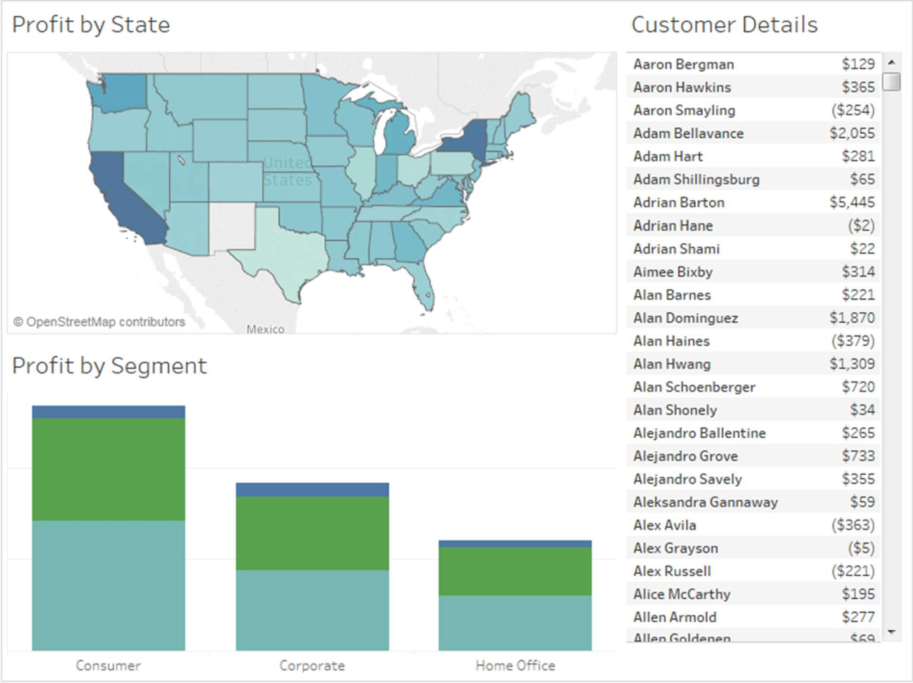

1. Select the first view that you want to use as a filter (such as a map), and from its shortcut menu, select Use as Filter.

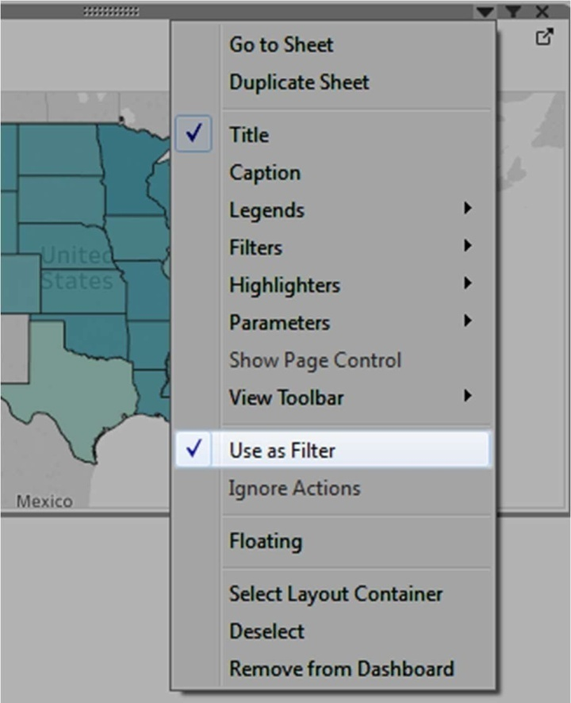

1. Open the same view's shortcut menu again and select Ignore Actions. This ensures that other filter actions, including the one you'll create next, will not affect this view.

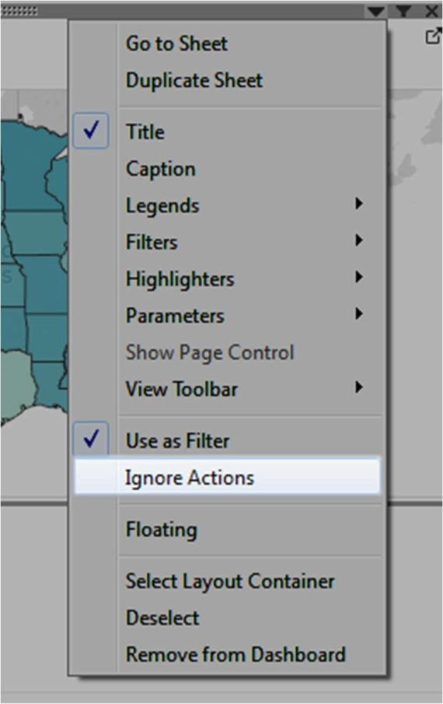

1. Repeat the steps 2 and 3 for any other views you want to use as a filter.

Now, selecting marks in these controlling views filters data in one or more detail views—all without affecting any other controlling views.

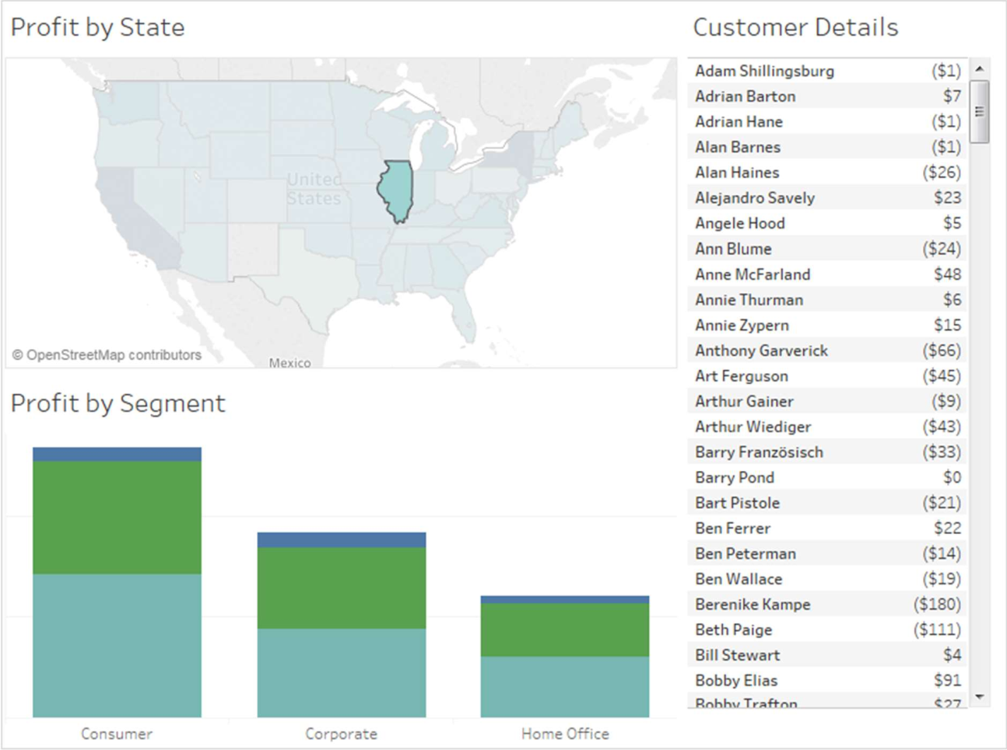

#### Navigate from one view to another view, dashboard, or story

Use the Go to Sheet action to let users quickly navigate to a related visualization—a dashboard, sheet, or story—when they click on a mark or a tooltip menu item in the original view.

**Note:** To simply navigate from one dashboard to another, without requiring users to interact with data, consider using t he Navigation object.

1. From your dashboard, select Dashboard > Actions.
2. In the Actions dialog box, click Add Action and then select Go to Sheet.

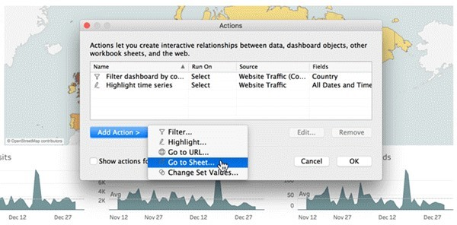

1. Specify a name for the action. (If you choose to run the action using a tooltip menu, the name you specify here is what the tooltip displays.)

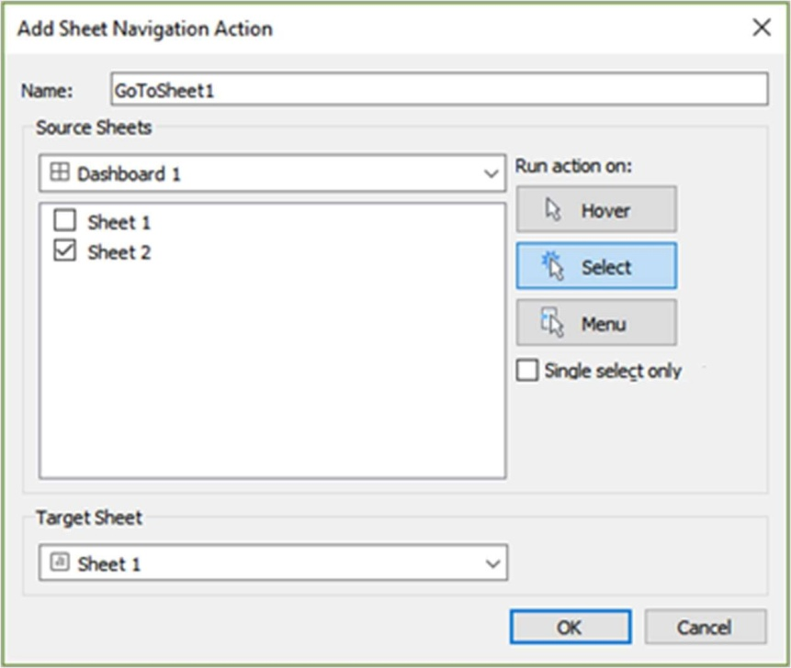

1. Select a source sheet that will initiate the action.
2. Specify how people viewing your dashboard will run the

action. Select or Menu are the best choices for a navigation action.

If you choose Select, consider selecting Single-select only so users won't navigate away from the view when multiple marks are selected.

1. For the target sheet, select the navigation destination that appears when users click marks or tooltip menu items in the source sheet. Then click OK.

#### Interactively display a web page in a dashboard (Create in Tableau Desktop)

To interactively display information from the web inside a dashboard, you can use a URL action with a web page object. For example, you might have a dashboard that shows profits by country. In addition to showing the profit data in your dashboard, you also want to display supplemental information about the countries from a web site.

**Tip:** To easily organize and target multiple web page objects in a dashboard, r ename them.

1. Drag a Web Page object onto your dashboard, and enter a URL.

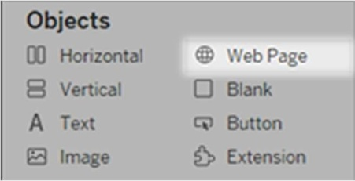

1. From your dashboard, select Dashboard > Actions.
2. In the Actions dialog box, click Add Action and then select Go to URL.
3. Specify a name for the link. If you choose to run the action using a menu, such as a menu option on a tooltip, the name you specify here is what's displayed.

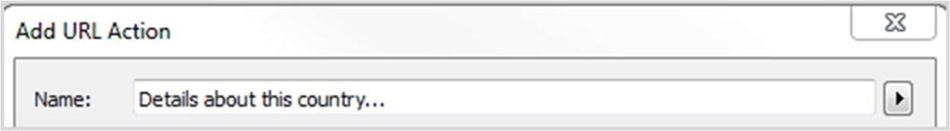

1. Under Source Sheets, select the view or data source that will initiate the action. For example, if you want the action to be initiated when a user clicks a link on a map's tooltip, select the map view.
2. Specify whether people viewing your dashboard will run the action on

hover, select, or menu. For details, see R unning Actions.

1. Enter the URL, starting with the http:// or https:// prefix, such as [http://www.example.com.](http://www.example.com/)

You can use field values as parameters in your URL. For example, if Country is a field used by a view in your dashboard, you can

use <Country> as a parameter in your URL. For details, see U RL

Actions(Link opens in a new window).

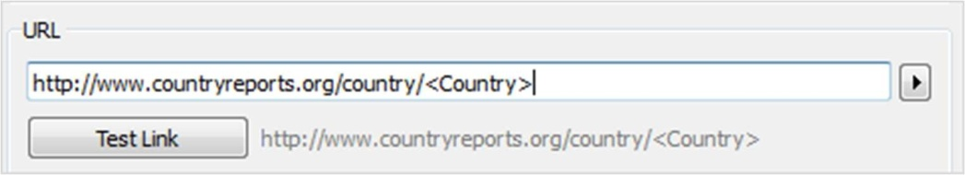

1. For URL Target, select Web Page Object, and select the object you created in step 1.

When you launch the action, a web page automatically loads within the dashboard rather than opening a separate browser window.

Mao - Profit by Country

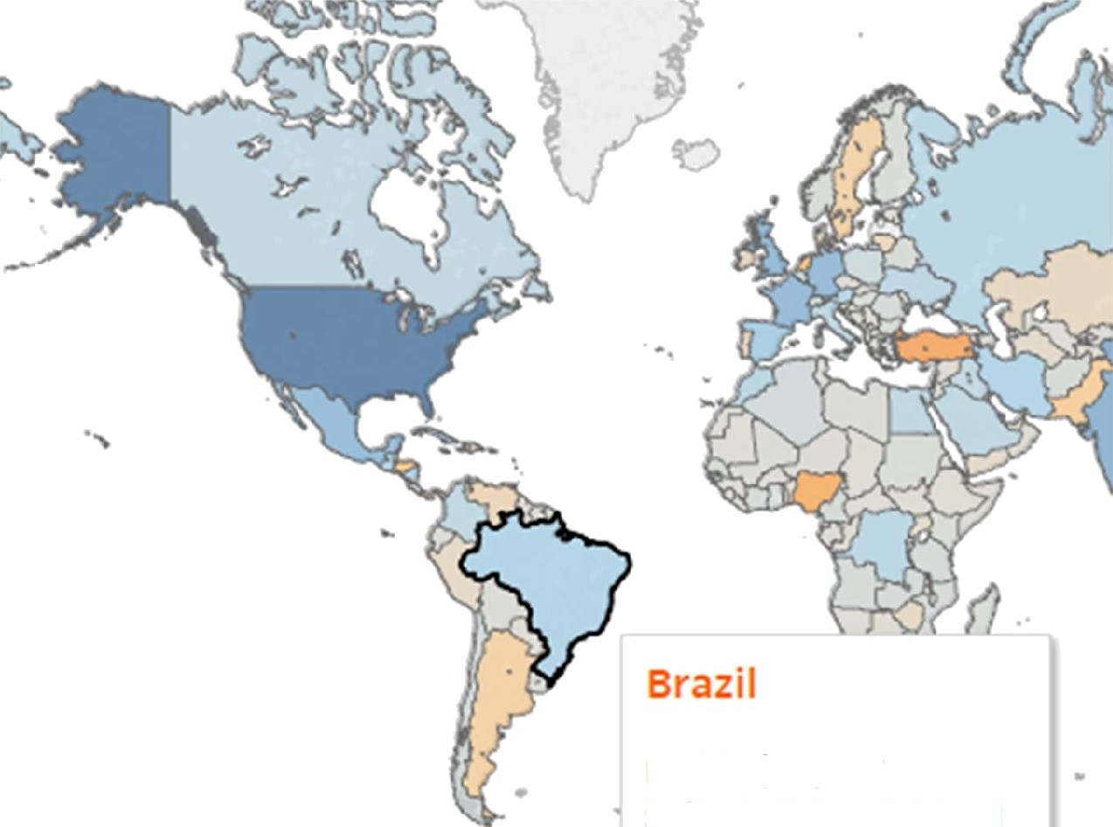

**Profit: $29,687**

**Sales territory:** LATAM

 More Lai Is...

Arocfe Talk Read

Brazil

w IK I PE DIA

F

'- "

k pedia , the free eneyHopedia '

The Fr e Enc yclO di *ThiS* a/Yic/e is adouf fhe *country. For otfier uses.* see *Brazil (disambiguation).*

Brazil (g#/bra zd/; Portuguese: *Brasil* [bra ziwt [ * 0t] socially the Federative

Contents Feature<l content Current events

Repubiic of Brazil (Portuguese: *Repñblica Federetiva* do Brash.

1. listen (help info/' 1!). is the largest country in both South America and Laun America. As the world's fifth-largest country by both area and population. a is the

##### S TORY

In Tableau, a story is a sequence of visualizations that work together to convey information. You can create stories to tell a data narrative, provide context, demonstrate how decisions relate to outcomes, or to simply make a compelling case.

##### C REATE A STORY

A story is a sheet, so the methods you use to create, name, and manage worksheets and dashboards also apply to stories (for more details,

see W orkbooks and Sheets). At the same time, a story is also a collection of

sheets, arranged in a sequence. Each individual sheet in a story is called a story point.

Use stories to make your case more compelling by showing how facts are connected, and how decisions relate to outcomes. You can then publish your story to the web, or present it to an audience.

Each story point can be based on a different view or dashboard, or the entire story can be based on the same visualization seen at different stages, with different filters and annotations.

Create a story point

* 1. Click the New Story tab.

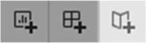

Tableau opens a new story as your starting point:

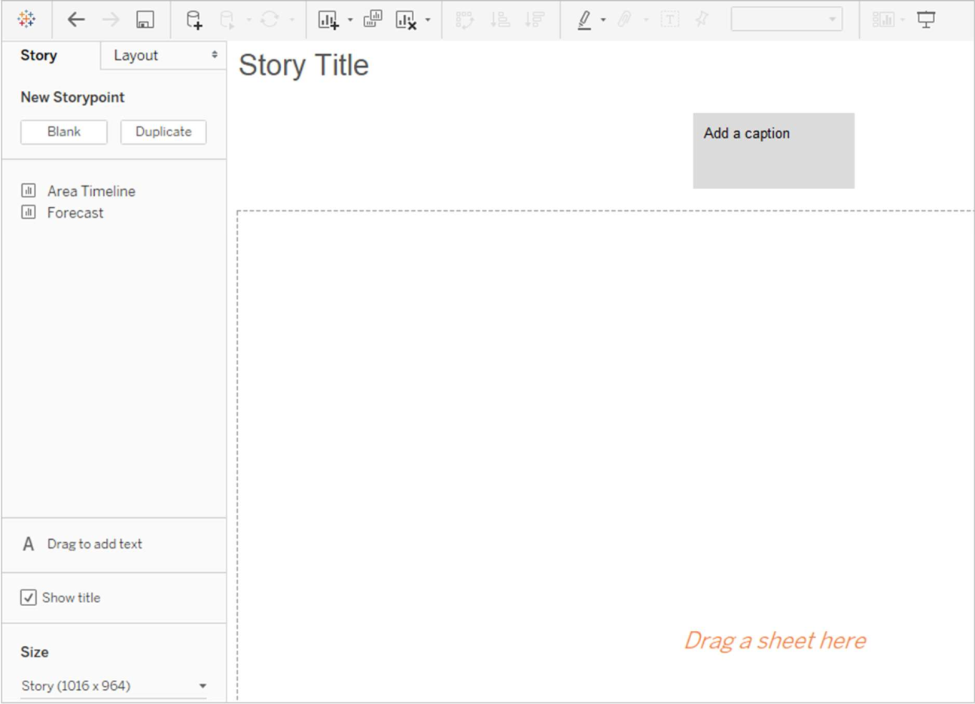

* 1. In the lower-left corner of the screen, choose a size for your story. Choose from one of the predefined sizes, or set a custom size, in pixels:

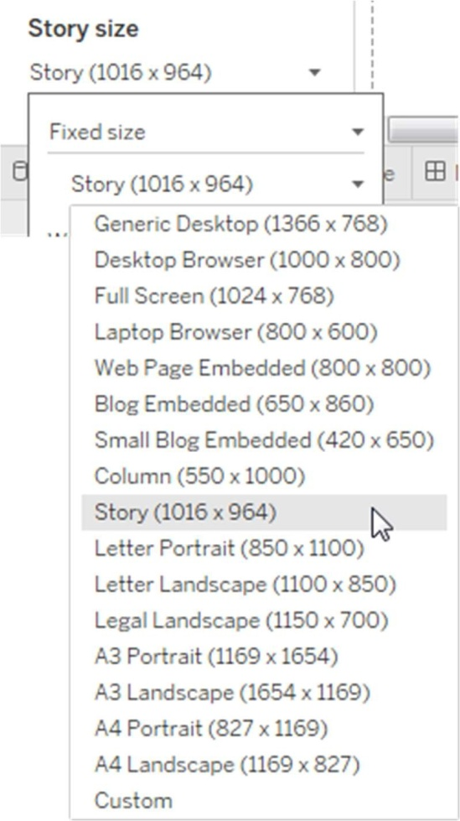

**Note:** Choose the size your story will be viewed at, not the size you're authoring in.

* 1. By default, your story gets its title from the sheet name. To edit it, right-click the sheet tab, and choose Rename Sheet.

If you're using Tableau Desktop, you can also rename a story by double-clicking the title.

* 1. To start building your story, double-click a sheet on the left to add it to a story point.

In Tableau Desktop, you can also drag sheets into your story point.

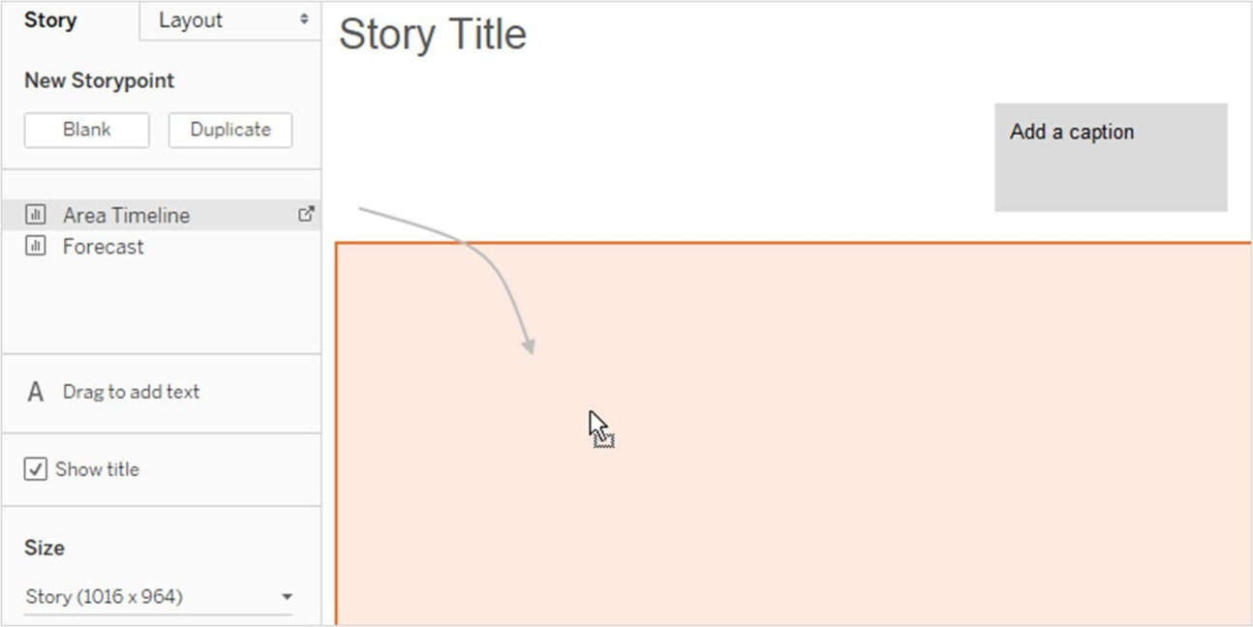

When you add a sheet to a story point, that sheet remains connected to the original sheet. If you modify the original sheet, your changes will automatically be reflected on the story points that use it.

If you are using Tableau Cloud to author on the web and the original sheet has **Pause Auto Updates** enabled, the story sheet will be blank until auto-updates are resumed.

* 1. Click Add a caption to summarize the story point.

In Tableau Desktop, you can highlight a key takeaway for your viewers by dragging a text object to the story worksheet and typing a comment.

* 1. To further highlight the main idea of this story point, you can change a filter or sort on a field in the view. Then save your changes by clicking Update on the story toolbar above the navigator box:

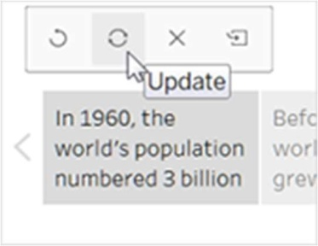

* 1. Add another story point by doing one of the following:
     + Click Blank to use a fresh sheet for the next story point.

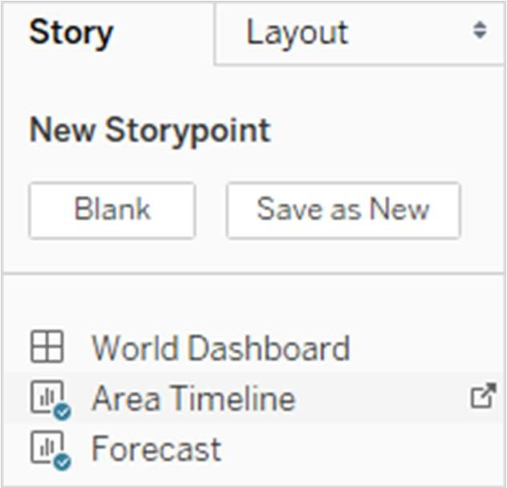

* + - Start customizing a story point and click Save as New on the toolbar above the navigator box.

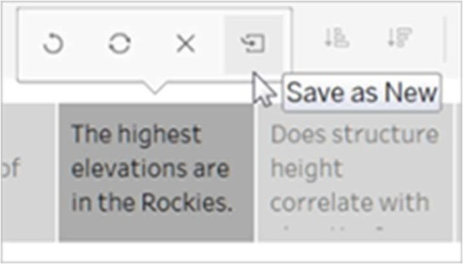

* + - Click Duplicate to use the current story point as the basis for a new one.

#### Explore layout options

You can refine the look of your story using the options on the Layout tab.

1. Click the Layout tab.
2. Choose a navigator style that best suits your story, and show or hide the next and previous arrows.

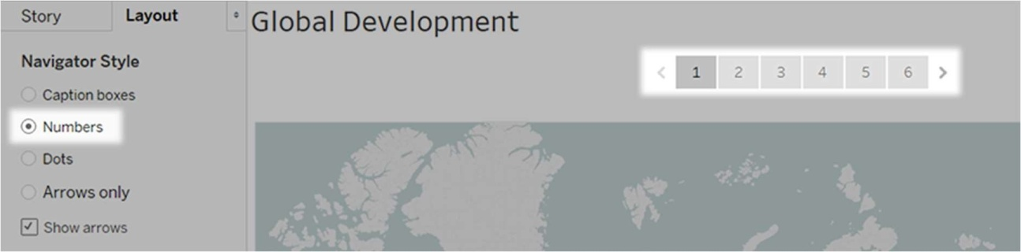

#### Format a story

##### Resize captions (Tableau Desktop only)

Sometimes the text in one or more of your captions is too long to fit inside the height of the navigator. In this case, you can re-size the captions vertically and horizontally.

1. In the navigator, select a caption.
2. Drag the border left or right to resize the caption horizontally, down to resize vertically, or select a corner and drag diagonally to resize the caption both horizontally and vertically.

All captions in the navigator update to the new size.

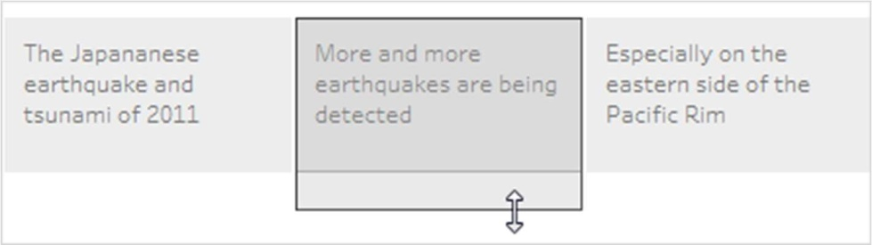

When you resize a caption, you can only select the left, right, or bottom border of the caption.

##### Fit a dashboard to a story

You can fit a dashboard to the exact size of a story. For example, if your story is exactly 800 by 600 pixels, you can shrink or expand a dashboard to fit inside that space.

Click the Size drop-down menu and select the story you want the dashboard to fit inside.

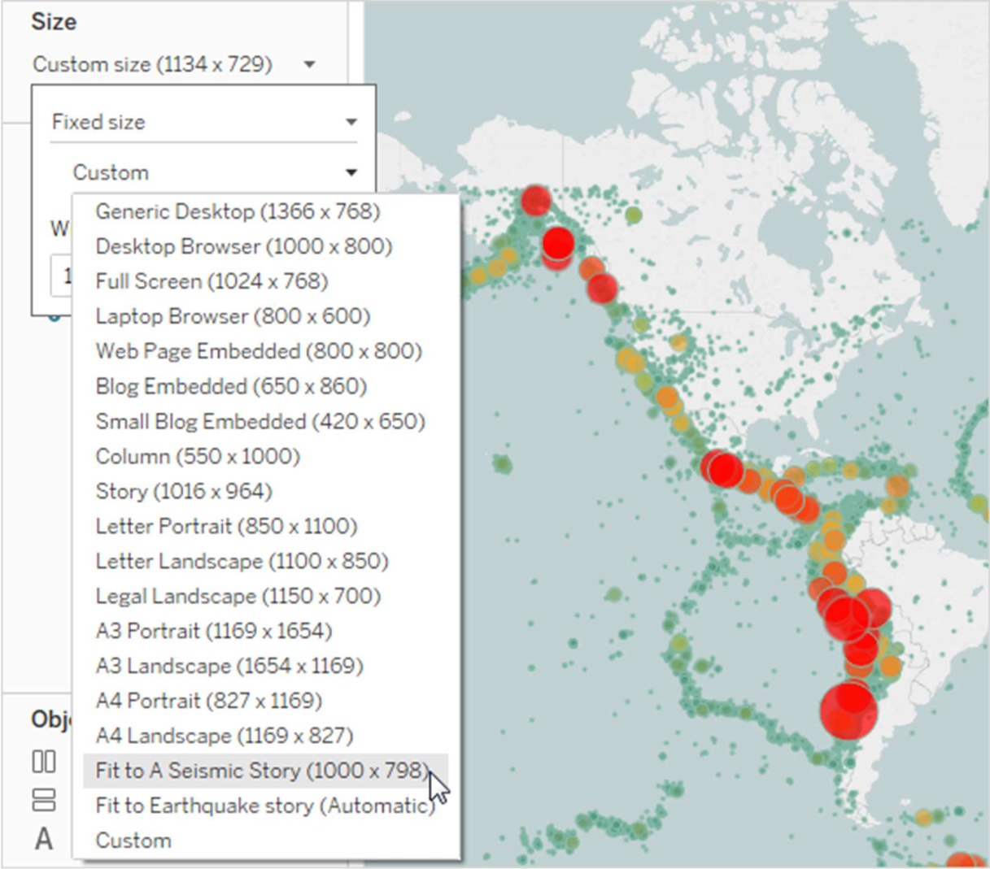

•

##### Format a story's shading, title, and text objects (Tableau Desktop only)

To open the Format Story pane, select Format > Story.

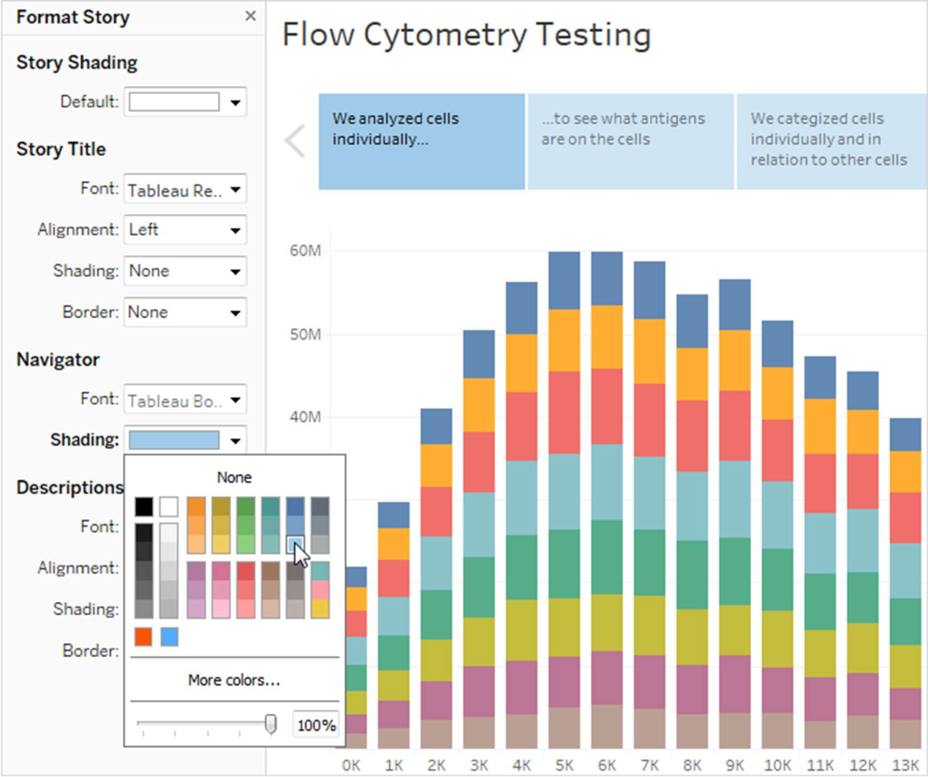

##### Clear all formatting (Tableau Desktop only)

* To reset a story to its default format settings, click the Clear button at the bottom of the Format Story pane.
* To clear a single format setting, right-click (Windows) or control- click (macOS) the format setting you want to undo in the Format Story pane. Then select Clear.

For example, if you want to clear the alignment of the story title, right-click (control-click on Mac) Alignment in the Title section, and then select Clear.

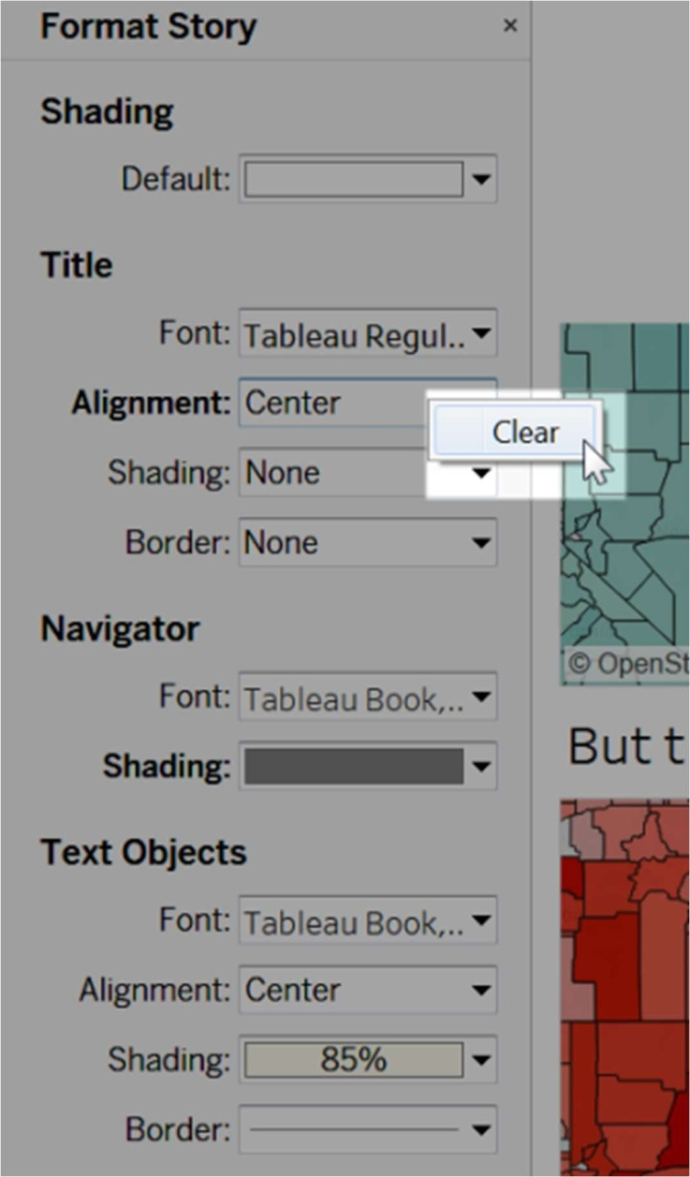

#### Delete a story point

Click the X in the toolbar above the point's caption:

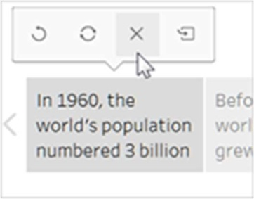

#### Present your story

1. In Tableau Desktop, click the Presentation Mode button 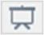 on the toolbar. Or, publish the story to Tableau Cloud or Tableau Server, and click the Full Screen button in the upper-right corner of the browser.
2. To step through your story, click the arrow to the right of the story points. Or, in Tableau Desktop, use the arrow keys on your keyboard.
3. To exit Presentation or Full Screen mode, press Esc.

##### PUBLISHING TO TABLEAU PUBLIC

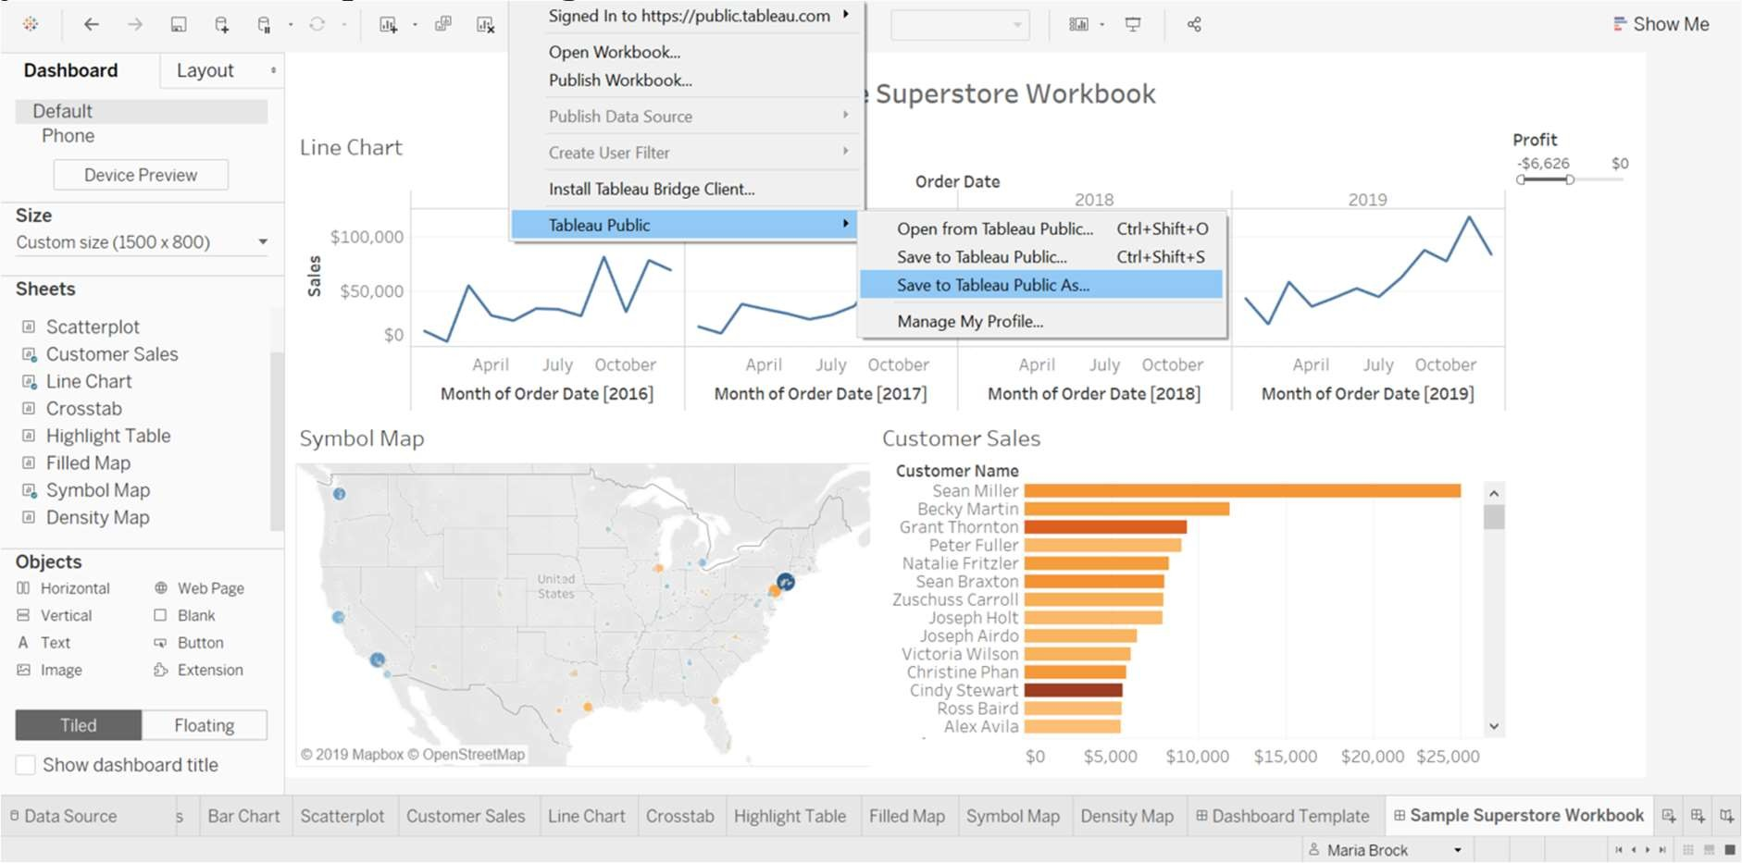

In this section I’ll walk you through how to publish your viz from Tableau Desktop to Tableau Public.

Once you’ve completed your dashboard, follow these steps:

**- Server, Tableau Public, Save to Tableau Public As**

*You may be prompted to log into your Tableau Public profile first if this is your first time publishing.

Next, fill out the title you want your viz to have and click “save”. Next you may see a message like this:

This message means that your connection to the Sample-Superstore data set is a live connection. Tableau Public cannot host live connections, so you’ll need to convert your connection to an extract (like a frozen screenshot of your data).

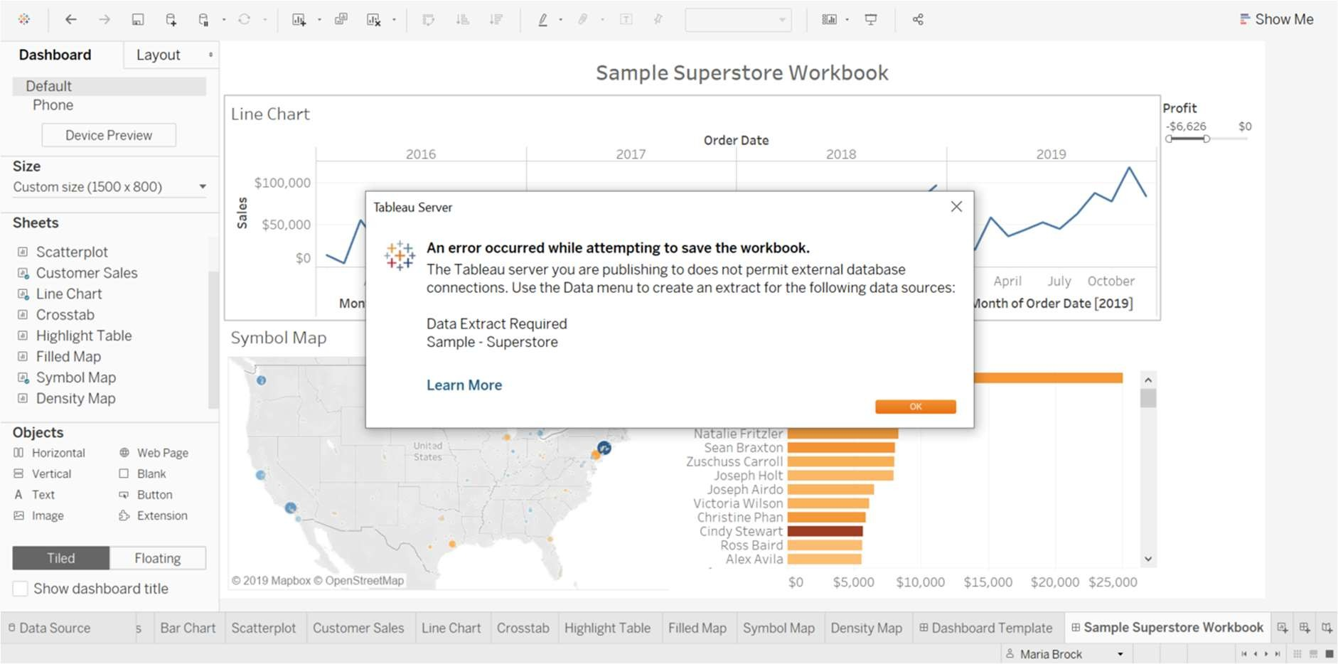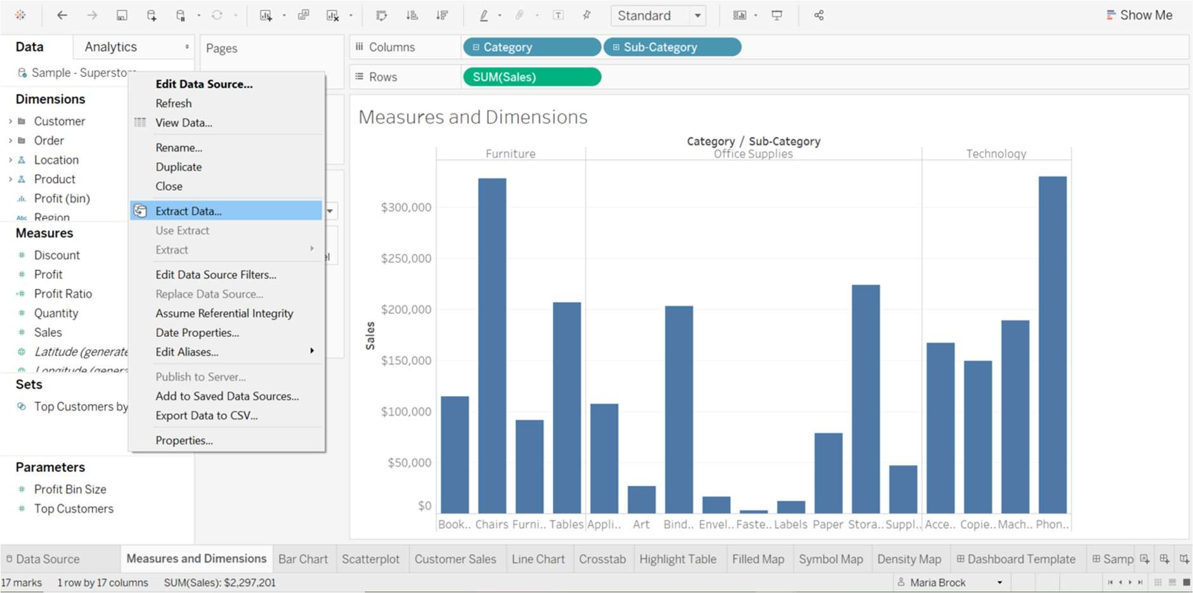

Go to one of your worksheets and follow these steps:

* Right click “Sample-Superstore” at the top left corner and select Extract Data

Hit extract again and return to your dashboard to follow the steps to publishing it again. Once you hit Save, you’ll be taken to your Tableau Public page.

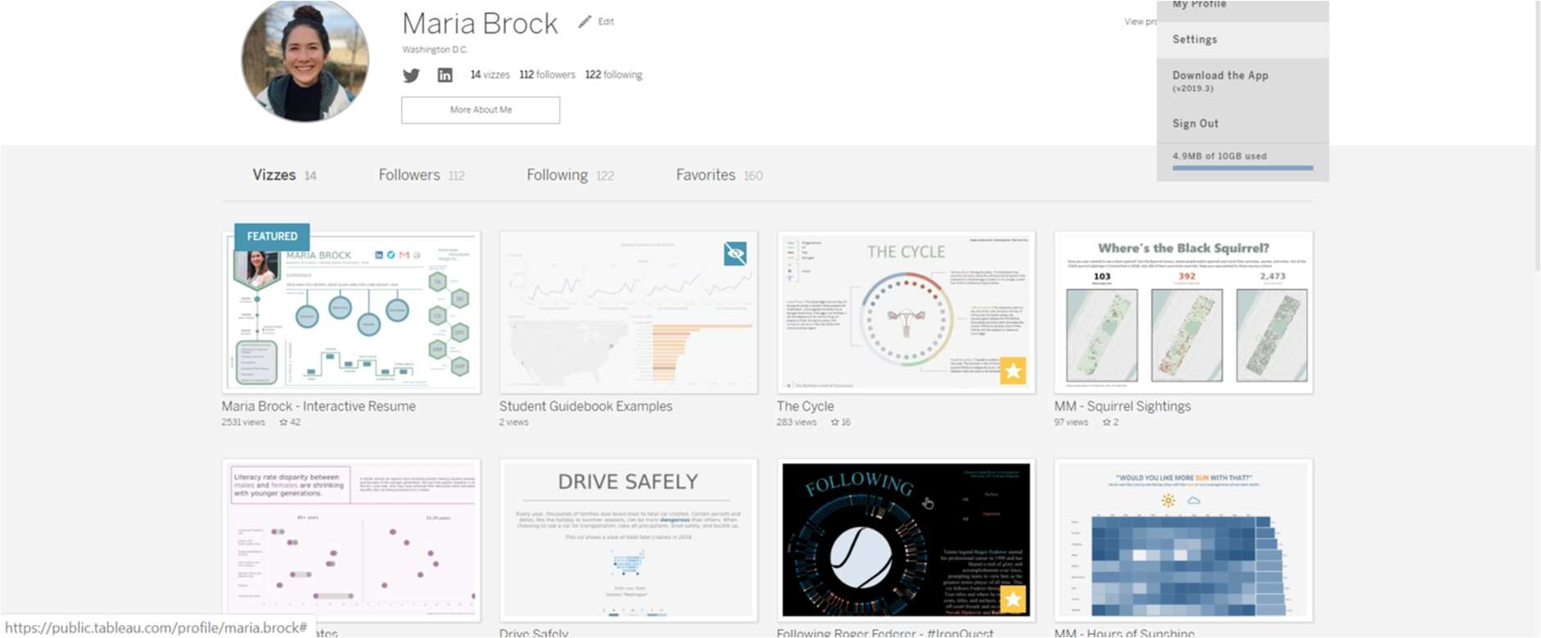

Here you see that my dashboard has been published. It is greyed out because I automatically set my vizzes to “hidden”. You can choose to do this or not by going to your settings page. I do this because if your viz isn’t hidden it will appear on your follower’s activity feed even if you delete it later. If you set it to automatically hide itself, you can edit it in the browser until you’re ready to unhide it by clicking the little eye icon.

WEEK - 9

You can save your work using several different Tableau specific file types: workbooks, bookmarks, packaged data files, data extracts, and data connection files. Each of these file types are described below. For related details, see Save Your Work.

* + Workbooks (.twb) – Tableau workbook files have the .twb file extension. Workbooks hold one or more worksheets, plus zero or more dashboards and stories.
  + Bookmarks (.tbm) – Tableau bookmark files have the .tbm file extension. Bookmarks contain a single worksheet and are an easy way to quickly share your work. For more information, see Save a

bookmark(Link opens in a new window).

* + Packaged Workbooks (.twbx) – Tableau packaged workbooks have the .twbx file extension. A packaged workbook is a single zip file that contains a workbook along with any supporting local file data and background images. This format is the best way to package your work for sharing with others who don’t have access to the original data. For more information, see Packaged Workbooks.
  + Extract (.hyper) – Tableau extract files have the .hyper extension. Extract files are a local copy of a subset or entire data set that you can use to share data with others, when you need to work offline, and improve performance. For more information, see Extract Your Data.
  + Data Source (.tds) – Tableau data source files have the .tds file extension. Data source files are shortcuts for quickly connecting to the original data that you use often. Data source files do not contain the actual data but rather the information necessary to connect to the actual data as well as any modifications you've made on top of the actual data such as changing default properties, creating calculated fields, adding groups, and so on. For more information, see Save Data

Sources.

* + Packaged Data Source (.tdsx) – Tableau packaged data source files have the .tdsx file extension. A packaged data source is a zip file that contains the data source file (.tds) described above as well as any local file data such as extract files (.hyper), text files, Excel files, Access files, and local cube files. Use this format to create a single file that you can then share with others who may not have access to the

original data stored locally on your computer. For more information, see Save Data Sources.

These files can be saved in the associated folders in the My Tableau Repository directory, which is automatically created in your My Documents folder when you install Tableau. Your work files can also be saved in other locations, such as your desktop or a network directory.

##### P UBLISH WORKBOOK TO TABLEAU ONLINE

1. In Tableau Desktop, open the workbook you want to publish.
2. Select Server > Publish Workbook.

If the Publish Workbook option does not appear on the Server menu, make sure a worksheet or dashboard tab is active (not the Data Source tab).

If necessary, sign in to a server. For Tableau Cloud,

enter https://online.tableau.com. For more information, see Sign in

to Tableau Server or Tableau Cloud.

1. In the Publish Workbook dialog box, select the project, enter a name for the workbook, and add search tags.

Tags help users find related workbooks when they browse the server. Separate tags using a comma or space. To add a tag that contains a space, put the tag in quotation marks.

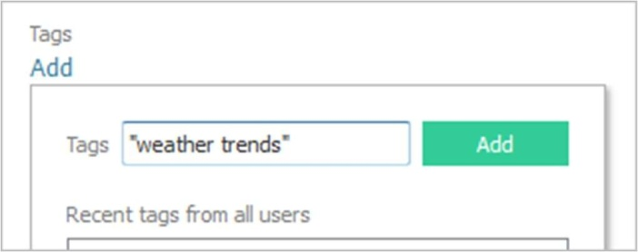

1. For Permissions, accept the default project settings.

Generally, a site administrator manages permissions on the server. If you think your workbook is an exception, work with your administrator to determine the best course of action, and see S et

Permissions as You Publish a Data Source or Workbook.

1. For Data Sources, select Edit if you want to change whether the data is embedded in the workbook or published separately, or change how people authenticate with data sources.
   * If you’re publishing an extract and want to set up a refresh schedule, you must select Embed password or Allow refresh access.
   * If your workbook connects to a Tableau data source, we recommend embedding the password. If you instead choose to prompt users, they'll need additional permissions on the data source.

For more information, see Set Credentials for Accessing Your

Published Data.

1. Configure Variable publishing options that are available for this workbook.
2. Click Publish.
3. (Optional) Set up a refresh schedule for each extract you published.

The publishing workflow guides you through these steps. For some data types you publish to Tableau Cloud, the publishing process starts Tableau Bridge on your computer.

##### EXPORTING DATA

You can either copy a selection of data from a view to use in another application or you can export all the data from the worksheet to an Access database.

*To copy data to the Clipboard:*

1. Select the data in the view that you want to copy.
2. Right-click (Control-click on Mac) the selection and select Copy > Data.
3. Open another application such as MS Word or MS Excel and select Edit > Paste.

Note: You can also copy the data as a cross-tab for use in Microsoft Excel. Select Copy > Crosstab on the context menu.

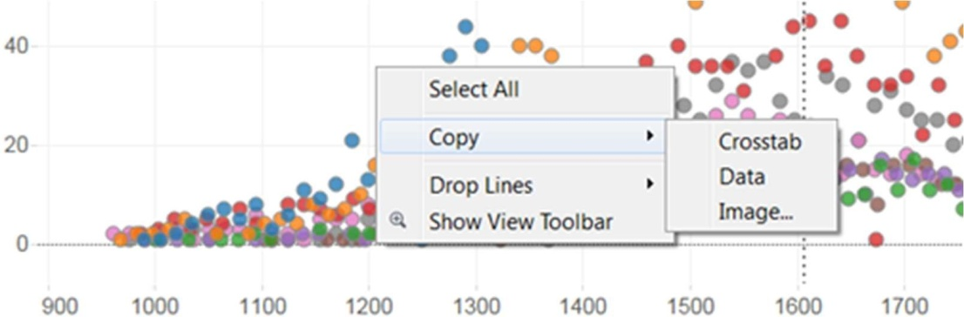

*To export data to Microsoft Access:*

1. Select Worksheet > Export > Data.

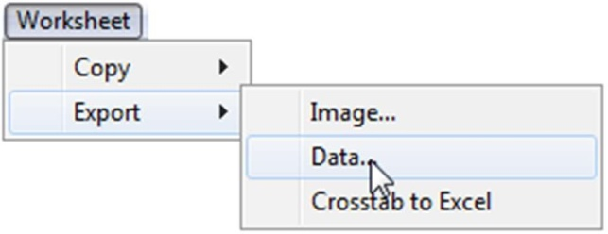

1. Enter a location and name for the Access database, and then click Save.
2. In the Export Data to Access dialog box, specify a database name and what data to export, and then click OK.

#### Exporting a view as an image

You can either copy the view for use in another application or you can export the view as an image file.

*To copy the view to the Clipboard:*

* 1. Select Worksheet > Copy > Image.
  2. In the Copy Image dialog box, select the contents you want to include and the legend layout if the view contains a legend.

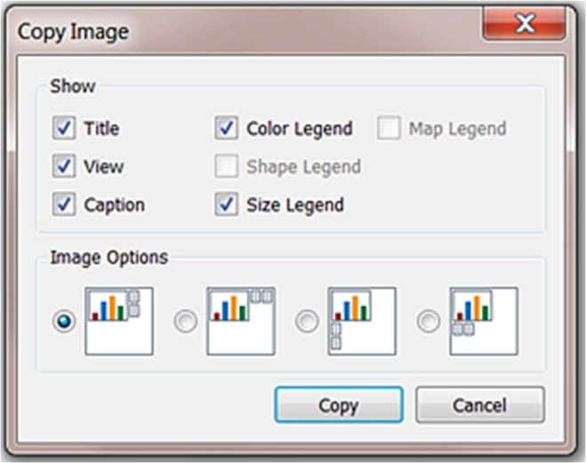

* 1. Click Copy.
  2. Open another application such as MS Word or MS Excel and select Edit > Paste.

Note: In some applications you can select Paste Special and specify a format for the image.

*To export a view to an image file:*

1. Select Worksheet > Export > Image.

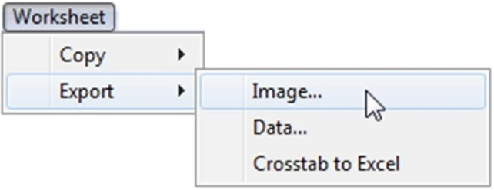

1. In the Export Image dialog box, select the contents to include and the legend layout if the view contains a legend, and then click Save.
2. When finished, click Save.
3. In the Save Image dialog box, navigate to where you want to save the image file and type a file name into the text box. Select a file format from the Save as type drop-down list. When finished, click Save.

##### P RINT VIEWS FROM TABLEAU DESKTOP

Print to PDF

In Tableau Desktop, you can save views as PDF files rather than printing them as hard copies. You do not need to have Adobe Acrobat installed on your computer.

When you print an individual sheet to PDF, filters in the view are not included. To show filters, create a dashboard containing the sheet and export the dashboard to PDF.

##### Print to PDF using a Windows computer

1. Specify p age setup options for each sheet in your workbook.
2. Select File > Print to PDF.

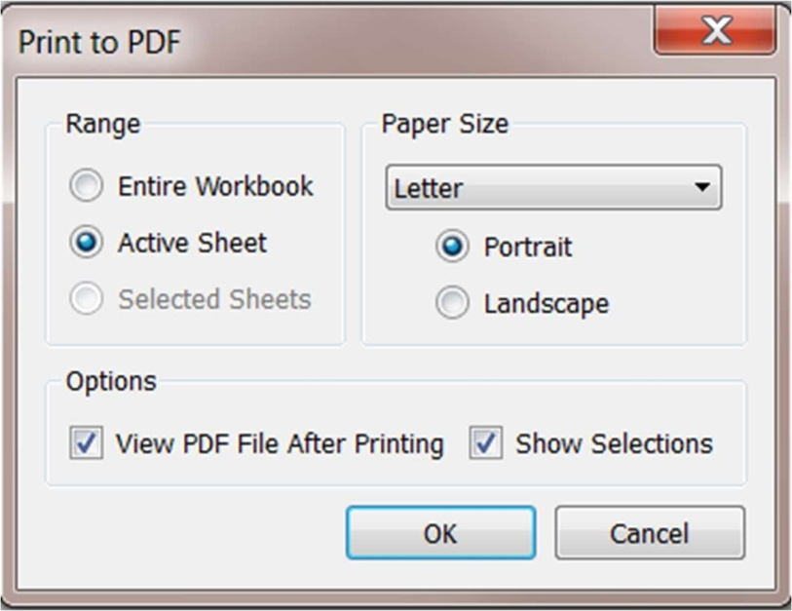

1. In the Print to PDF dialog box, select the print Range:
   * Entire Workbook - Publishes all the sheets in the workbook.
   * Active Sheet - Publishes only the sheet currently displayed in the workbook.
   * Selected Sheets - Publishes the selected sheets. To select multiple sheets in a Tableau workbook, hold down the Ctrl key as you select sheet tabs along the bottom of the Tableau workbook.
2. Select a Paper Size. If you select Unspecified, the paper size will expand to the necessary size to fit the entire view on a single page.

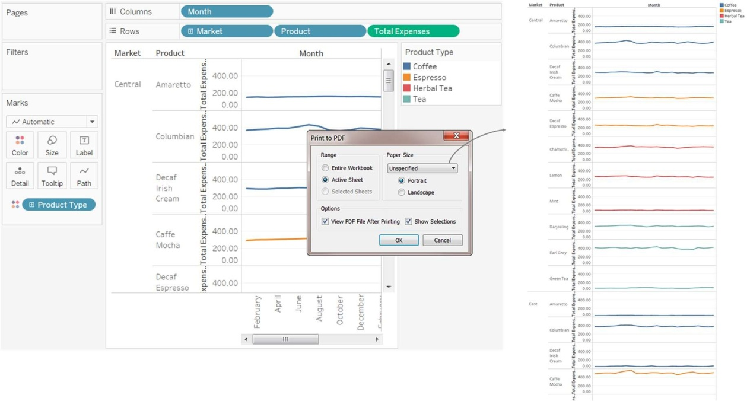

1. Select View PDF File After Printing if you want to automatically open the PDF after creating it. This option is only available if you have Adobe Acrobat Reader or Adobe Acrobat installed on your computer.
2. Select whether to Show Selections. When this option is selected the selections in the views are maintained in the PDF.
3. Click OK and specify where you want to save the PDF. Then click Save.

##### Print to PDF using a Mac computer

1. Specify p age setup options for each sheet in your workbook.
2. Select File > Print.
3. In the Print dialog box, click Show Details to select a print range:
   * Entire Workbook - Publishes all the sheets in the workbook.
   * Active Sheet - Publishes only the sheet currently displayed in the workbook.
   * Selected Sheets - Publishes the selected sheets. To select multiple sheets in a Tableau workbook, hold down the Command key as you select sheet tabs along the bottom of the Tableau workbook.
4. Click PDF > Save as PDF.

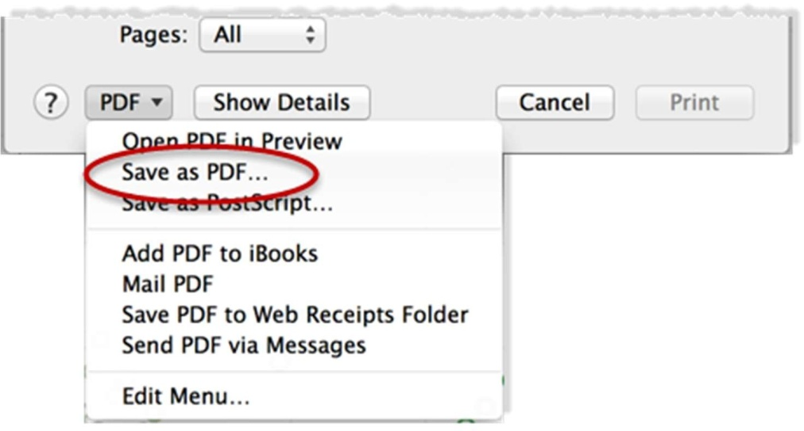

1. Specify where you want to save the PDF, then click Save.

##### WEEK – 10

CREATING DUAL AXIS CHART

A dual axis chart is used to present the relationship between two variables. More specifically, these charts are useful for demonstrating the relationship between two or more measures with different amplitude and scale. The dual axis charts help in presenting plenty of information in the limited space present on your dashboard and also allows you to understand the trends, you may have missed otherwise.

For example, in our US Super Store dataset, we have the Profit and Sales measures. These two measures have different magnitude and scale. Let’s directly dive into the implementation in a stepwise manner.

Here, for our visualization, we are going to use three attributes Sub-Category from the dimensions and two measures i.e. Profit and Sales.

STEPS TO CREATE A DUAL AXIS CHART:

1. Open a new worksheet and add the Sub-category from the dimension pane to the Columns shelf.

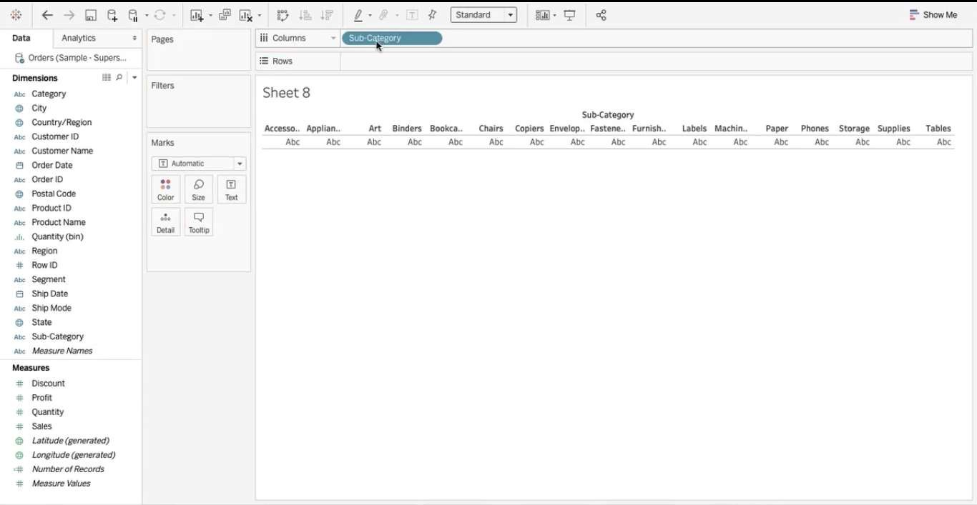

1. 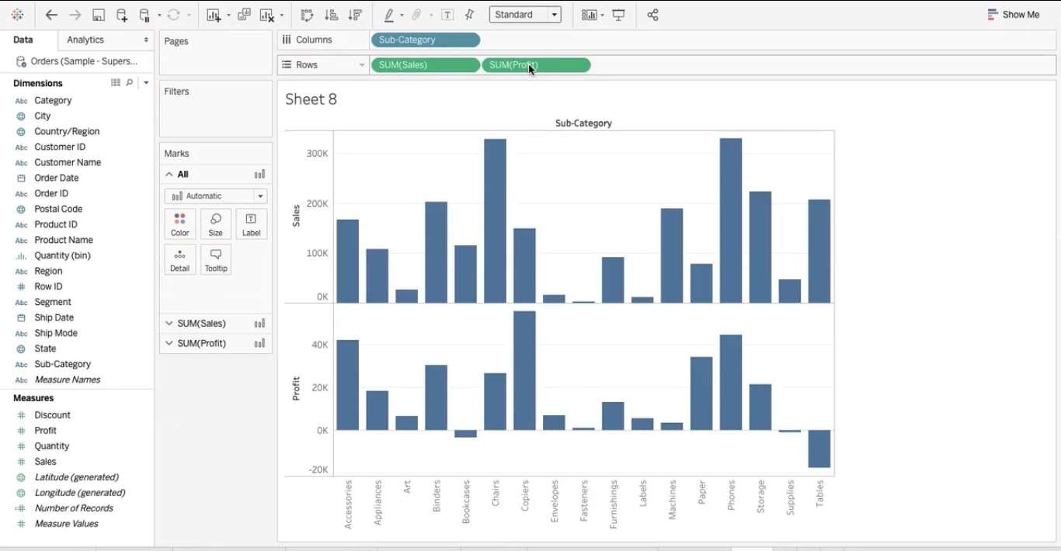Now pick Sales from the Measures pane and drop in the Row shelf below the Sub-Category. Similarly, Select Profit measure and drop next to the Sales in Row shelf. After this step, your visualization will look as shown in the image below.

Here we have two charts present on multiple axes. The next step is to convert these two different charts into a dual axis chart. For this click on the triangle present on the profit pill in the rows shelf.

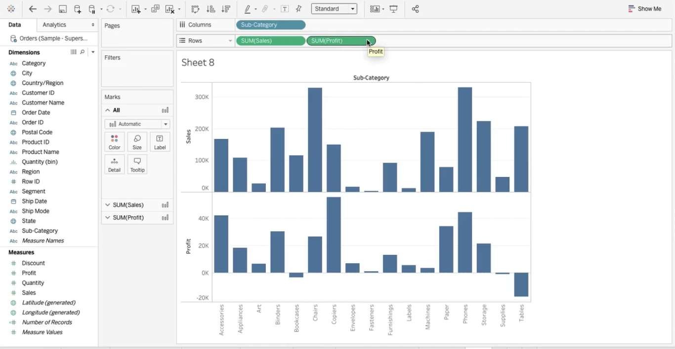

1. 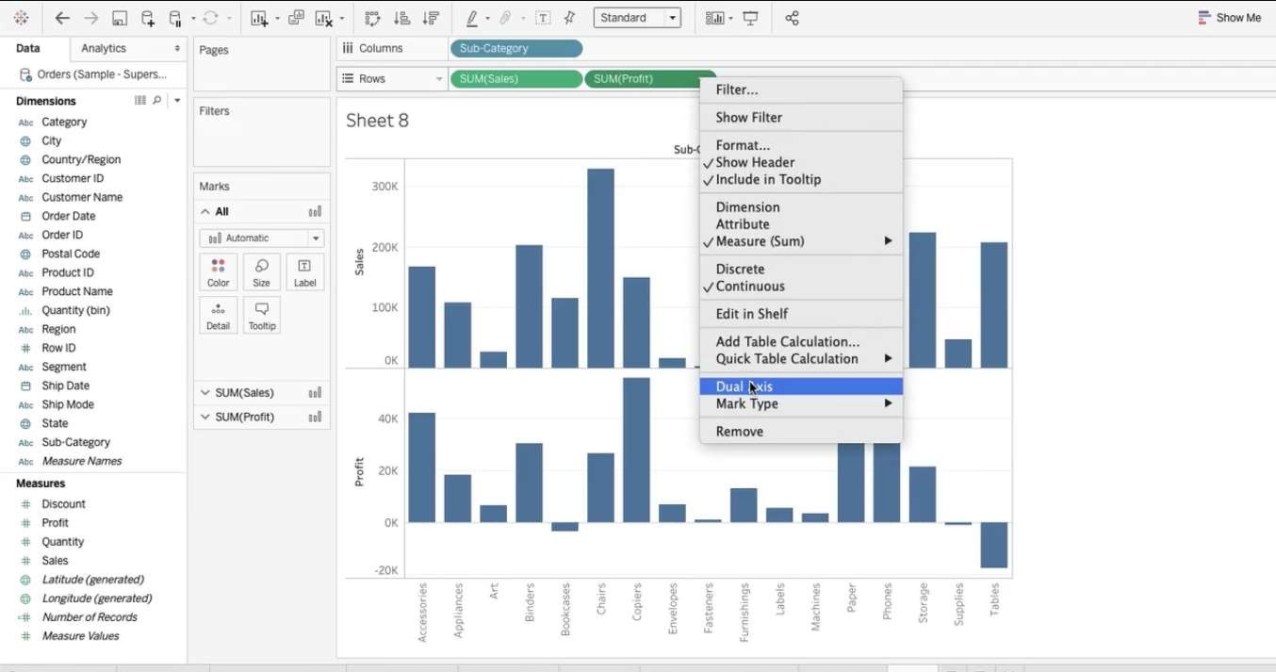Hereafter, you will have a drop-down menu just select the Dual axis option from that.
2. Once you select the Dual axis boom! your visualization changes completely. Like this

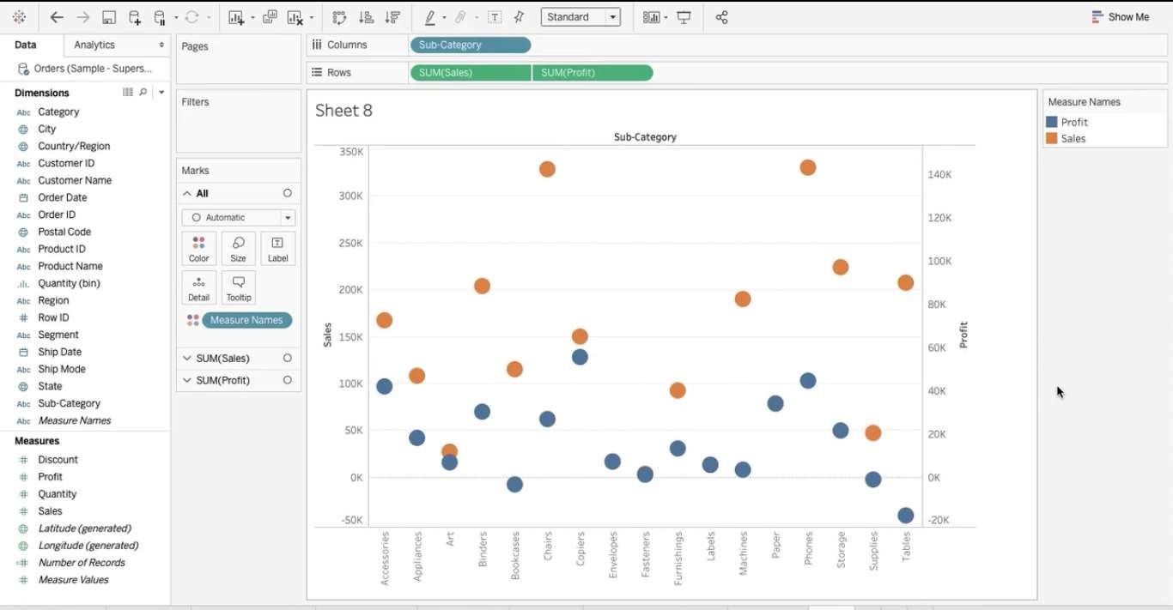

1. 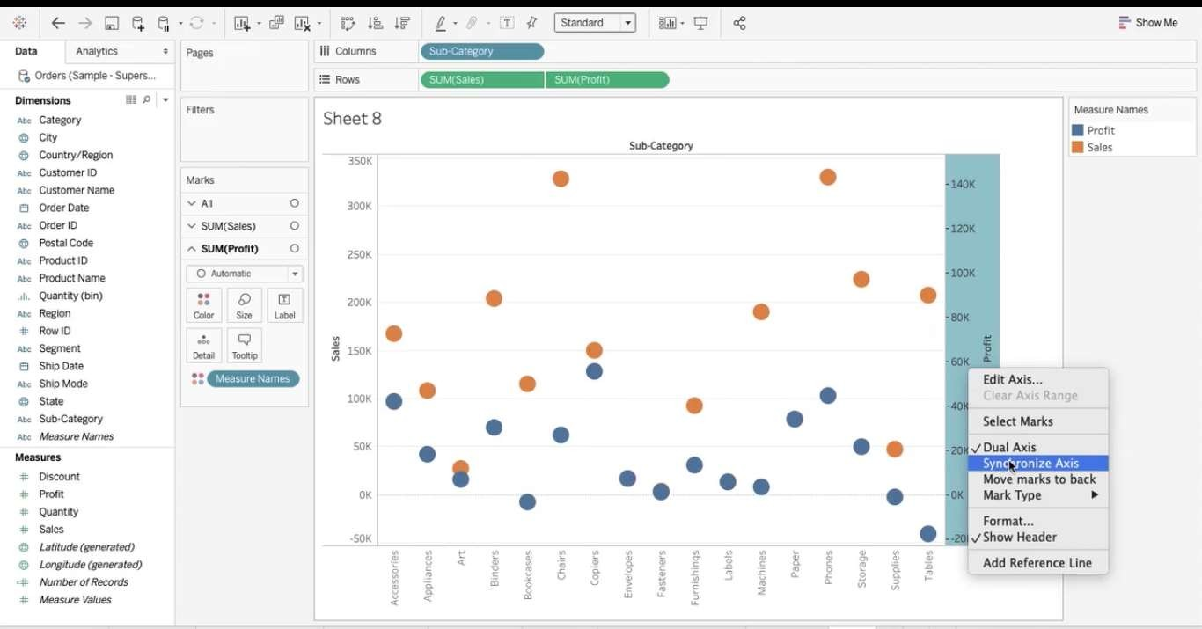Although you have a dual axis visualization, they are on different scales. Now there is a need to bring both measures on the same scale using synchronize axis. For this right-click on any axis Profit or Sales and select synchronize axis from the menu. As shown in the following image.

Here is the result you have your Dual axis chart with synchronized axes.

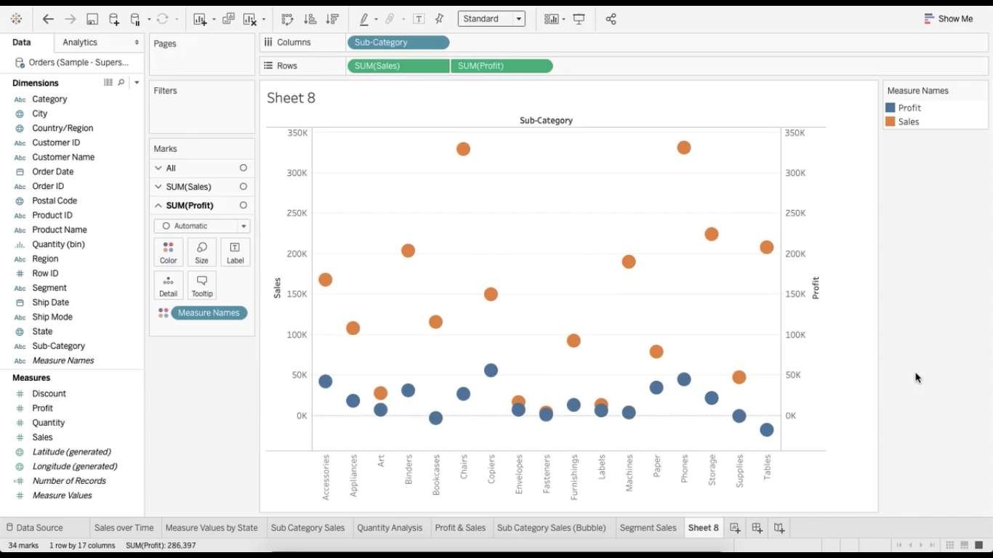

1. 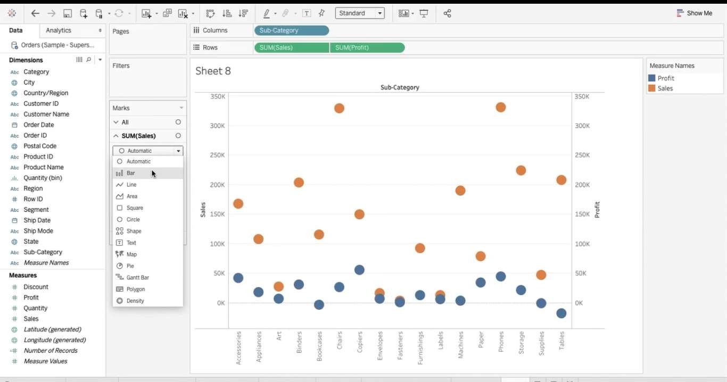To make it more interesting you can further play around with it. Like changing the shape of Sales from Automatic to bar in the markets card or changing the respective colors, adding borders.
2. Similarly, you can go to Profit and change its shape to a line. Your final visualization will look like this. Interesting right!





8 Co0N

